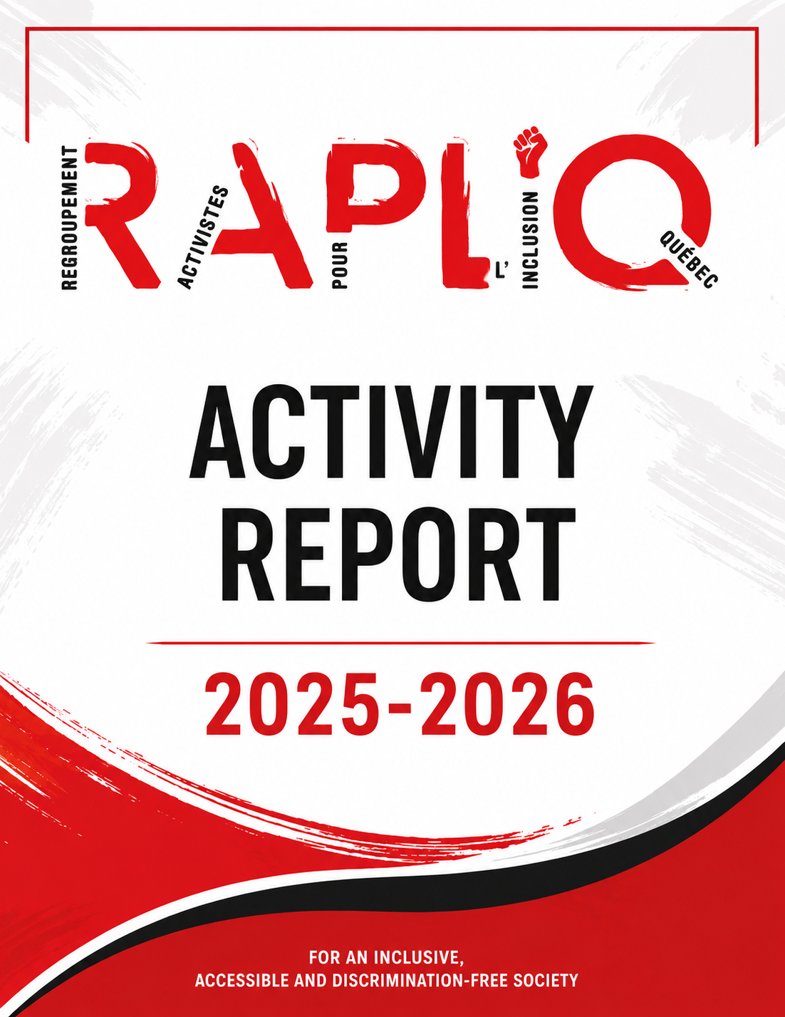

Table des matières
Message from the President 5
Message from the General manager 6
Message from the Executive Director 6
Board of Directors 7
Acknowledgements 7
Members 8
Democratic Governance 8
Annual General Meeting 8
Board Meetings 9
Regular Board Meetings 9
Special Board Meetings 9
Governance 9
A Committed, Advocacy-Based and Strategic Governance Model 9
Active Complaints 10
In Memoriam 10
In Loving Memory of 10
Honorary Mentions 10
MAJOR ISSUES 11
A Year of Mobilization, Resistance and Influence 11
Rights Advocacy and Public Debate 11
Political and Institutional Representation 12
Universal Accessibility 12
Troubling Budgetary Setbacks 12
Fighting Systemic Discrimination 13
Service Cuts Affecting Persons with Disabilities 14
Home Support: Living at Home with Dignity 14
When the Government Talks About “Reassessment”: 15
RAPLIQ Denounces the Erosion of Home Support for Persons with Disabilities in Quebec 15
The Home Adaptation Program (PAD): A Perfect Example of the Current Reality 15
RAPLIQ Says NO 16
We Call For: 16
We Will Not Remain Silent 16
Women with Disabilities Experiencing Intimate Partner Violence: 17
A Reality That Remains Too Invisible 17
IVAC: Toward Real Justice and Meaningful Compensation 18
Terraces and Accessibility: 18
Too Many Closed Doors 18
Accessible Transportation, Accessibility and Mobility: 19
Ongoing Concerns 19
Public Transit Class Action 20
The REM and Emergency Evacuation Procedures 20
Access to Health Care and Public Services: 21
Too Many Barriers Remain 21
RISBOd 22
Intersectoral Network for Sustainable Oral and Bone Health Research 22
Follow-up on the Class Action 22
Persons with Disabilities and Employment Discrimination 23
Sexual Assistance, the Toucher Series and International Reflection 23
Home Support 24
Camilien-Houde Road Closure 25
Continuing Education and Capacity Building 25
Lafortune Formation – Legal Training 25
Productivity and Advanced Technology Tools 25
Artificial Intelligence and Automation 26
SPGQ 26
Reimagining Work With and For Persons with Disabilities 26
“Rethinking Work With and For Persons with Disabilities” 26
Collaborations 26
Partnership with the Network for Peace and Social Harmony 26
“Building the Future: Social Engagement, Resilience and Well-Being” 27
Global Disability Rights Conference 28
Institutional Representation and External Committees 28
Centraide Annual Fundraising Campaign 30
The Impact of RAPLIQ 30
RAPLIQ et les médias: 31
Action Planning: 31
Toward a Stronger and More Influential RAPLIQ 31
2026–2027 Action Plan 31
Strategic Orientation 1 31
Defending the Rights of Persons with Disabilities 31
Strategic Orientation 2 32
Influencing Public Policy 32
Strategic Orientation 3 32
Improving Universal Accessibility 32
Strategic Orientation 4 33
Strengthening Communications and Mobilization 33
Objective 33
Planned Actions 33
Indicators 33
Strategic Orientation 5 33
Ensuring Organizational Growth and Sustainability 33
Objective 33
Planned Actions 33
Indicators 33
Strategic Orientation 6 34
Developing National and International Partnerships 34
Objective 34
Planned Actions 34
Indicators 34
Conclusion 34
Together, let us no longer accept the unacceptable. 34
États financiers 35
Prévisions budgétaires 45

Message from the President
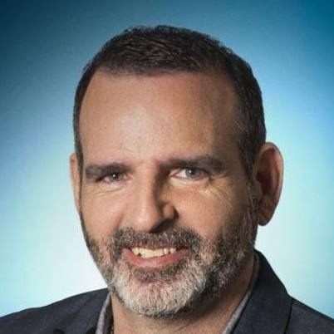Dear Members,
It is with deep gratitude that I address you as President of the RAPLIQ Board of Directors.
The 2025–2026 year was marked by significant achievements, fruitful collaborations, and challenges that we faced together with determination.
Our unwavering commitment to inclusion and the rights of persons with disabilities was reflected through concrete actions. We continued our advocacy and awareness-raising efforts with decision-makers and partners to promote a more accessible and inclusive society.
The year was also marked by the judgment rendered in RAPLIQ's class action against the STM and other public transit organizations. Although the action was not entirely successful, the Court recognized the existence of discrimination against persons with disabilities in access to public transportation. This recognition represents an important milestone in our mission and encourages us to continue advancing universal accessibility. The fight is not over.
We also remained vigilant regarding developments in paratransit services and the accessibility of the regular public transit network, ensuring that the needs of persons with disabilities remain at the heart of decisions affecting them.
These actions reflect our ongoing commitment to defending the rights of persons with disabilities and promoting a more inclusive society.
I would like to express my gratitude to Linda, Steven, and all the volunteers serving on our Board of Directors. Their unwavering dedication lies at the heart of our achievements and our ability to meet the challenges before us.
Together, we will continue working toward a Quebec free of barriers and discrimination.
In solidarity,

Sylvain Plourde

Message from the General manager


Message from the Executive Director
Dear Members, Partners and Allies,
The year 2025–2026 was a year of challenges, but above all, a year of action.
Across Quebec, persons with disabilities continued to face significant barriers. Whether through cuts to home support services, ongoing challenges in paratransit, the lack of accessibility in many living environments, or the many forms of discrimination that persist, there was unfortunately no shortage of reasons to act.
Faced with this reality, RAPLIQ remained true to its mission. We supported individuals in defending their rights, brought their concerns and demands before decision-makers, denounced injustices whenever they arose, and proposed practical solutions to build a more inclusive society.
This year also demonstrated that the voices of persons with disabilities must be heard wherever decisions affecting them are made. Whether in the media, before governments, within national coalitions, or on international platforms, RAPLIQ continued to promote the principle that guides all of our actions:
“Nothing About Us Without Us.”
I am particularly proud of the work accomplished by our team, Linda Gauthier, our Board of Directors, our volunteers, our partners, and all those who place their trust in us. The progress achieved is the result of a collective effort driven by a shared conviction: the rights of persons with disabilities are fundamental human rights that must be fully respected.
This report is the product of that collective effort.
Of course, our work is far from finished. The challenges remain numerous and the needs immense. However, the progress made over recent years demonstrates that it is possible to change attitudes, influence public policy, and transform advocacy into meaningful change.
On behalf of RAPLIQ, I sincerely thank everyone who supports us in this mission. Your trust, commitment, and solidarity enable us to continue this fight with determination.
Together, let us no longer accept the unacceptable.

Steven Laperrière
Board of Directors
As of March 31, 2026, the Board of Directors was composed of:

- Sylvain Plourde, président ;
- Christophe Bedos, vice-président ;
- Laurent Morissette, secrétaire-trésorier ;
- Linda Gauthier, administratrice ;
- Jacques Bisson, administrateur ;
- Amélie Allard, administratrice ;
- Emmanuelle Champagne, administratrice ;
- Manon Brière, administratrice ;
- Yves Plourde, administrateur ;
- Marjolaine Gravel, administratrice.

Michel Pigeon stepped down during the year.

Acknowledgements
Our volunteers and partners are among our greatest strengths.
Thank you all for your invaluable support!

- Renée Caron;
- Christian Vaillant;
- Lise Gervais;
- Louise Harel ;
- Me Paul-Claude Bérubé ;
- Vincent Martin, Ana Rodriguez, Ariane Corbeil, Vicky Auger, Kevin Mc Lean et toute l’équipe de Club des personnes handicapées du Lac St-St-Louis
- Andrea Morrison ;
- Martine Lévesque;
- Michel Bédard :
- Dr. Pierre Duquette ;
- Line Bergeron ;
- Martin Dion ;
- Sarina Ferrara-Santone ;
- Fondation famille Brian Bronfman ;
- Michelle Turenne ;
- Simon Wong ;
- Véronique Vézina ;
- Charline Savard ;
- Our 2026 UQAM Social Work Interns:
- Stella Tremblay
- Joey Wilson
- Marianne Desjardins
As well as the teaching team that supervised and supported them

Members

RAPLIQ benefits from the support of 199 individual members and 10 organizational members:

- RAAMM
- Fondation CNIB INCA
- Main Forte Montréal Inc.
- Amalgame
- Vie Autonome Montréal
- ROP-03
- Maison des Femmes Sourdes de Montréal
- L’AMASQ
- Réseau pour la Paix et l'Harmonie Sociale
- AMEIPH

Thank you to each and every one of you.
Your commitment allows us to give our very best. Together, we drive change and contribute to building a more equitable and inclusive society.

Democratic Governance

Annual General Meeting
The Annual General Meeting was held on May 31, 2025.
A total of 22 members participated, either in person or by videoconference.

Board Meetings

Regular Board Meetings
- May 1, 2025
- September 3, 2025
- October 30, 2025
- January 15, 2026
- March 12, 2026

Special Board Meetings
- June 26, 2025
- July 15, 2025
- October 2, 2025
- October 21, 2025
- December 12, 2025

Governance

A Committed, Advocacy-Based and Strategic Governance Model
RAPLIQ continues to grow through an active, rigorous governance structure deeply rooted in the values of collective advocacy for the rights of persons with disabilities.
Throughout 2025–2026, the Board of Directors maintained close oversight of the organization's priority issues in a particularly demanding social and political context.
Board members contributed to strategic reflection, the analysis of emerging issues, and RAPLIQ's public positioning on major concerns, including:
- Home support services;
- Paratransit services;
- Universal accessibility;
- Health care;
- Fundamental rights of persons with disabilities.
In accordance with recognized nonprofit governance best practices, the Board ensured:
- Sound organizational management;
- Continuity of the mission;
- Financial sustainability;
- Adherence to RAPLIQ's strategic directions.
RAPLIQ benefits from a Board of Directors that is engaged, diverse, representative, and highly aware of the realities and discrimination experienced by persons with disabilities. This enables the organization to remain a credible, influential, and mobilizing voice within Quebec society.

Active Complaints

When an individual seeks our assistance in pursuing a complaint, RAPLIQ prepares the complaint formally and submits it on behalf of the complainant before the appropriate authority.
As of March 31, 2026, RAPLIQ was mandated in 36 active complaints, distributed as follows:
- 28 before the Quebec Human Rights and Youth Rights Commission (CDPDJ);
- 1 before the Small Claims Court;
- 1 before the Canadian Human Rights Commission;
- 2 before the Canadian Transportation Agency;
- 3 before the Superior Court;
- 1 before the Court of Appeal.
Since its founding, RAPLIQ has handled 984 complaints.
Currently, two RAPLIQ officers, Linda Gauthier and Steven Laperrière, provide support and guidance to complainants.
This number does not include the many cases resolved through intervention, mediation, negotiation, or advocacy without the need for a formal complaint.

In Memoriam

In Loving Memory of

Serge Bélisle

Honorary Mentions
The RAPLIQ wishes to recognize the outstanding contribution and support of:
- Catherine Roy

MAJOR ISSUES

A Year of Mobilization, Resistance and Influence

The year 2025–2026 was marked by an intensification of RAPLIQ's actions on several major fronts directly affecting the rights, dignity, and quality of life of persons with disabilities.
In a context marked by budget cuts, administrative reforms, and challenges to long-standing social gains, RAPLIQ continued to serve as:
- a watchdog;
- a public voice;
- and an agent of social change.
Our efforts focused on several key priorities:
- Home support and essential services;
- Paratransit and public transportation;
- Universal accessibility;
- The rights of women with disabilities;
- Access to health care and public services;
- The fight against systemic discrimination;
- Political and institutional representation.
RAPLIQ also strengthened its presence in strategic consultation, advocacy, and decision-making spaces, convinced that the defense of rights must take place not only in the streets, the media, and the courts, but also wherever decisions are made.

Rights Advocacy and Public Debate
Throughout 2025–2026, RAPLIQ continued to play a leading role in defending the rights of persons with disabilities through public, media, and political advocacy aimed at denouncing setbacks, advancing social debate, and influencing government decisions.
In a context marked by cuts to essential programs and ongoing debates surrounding medical assistance in dying, home support, universal accessibility, and public transportation, RAPLIQ maintained a strong presence in both public and media spheres.
Our interventions highlighted the very real human impacts of certain political decisions and reinforced the message that accessibility and inclusion cannot be treated as secondary issues.
During the year, RAPLIQ also strengthened its presence in consultation and representation forums at the municipal, provincial, and federal levels, further consolidating its reputation as a key advocate for the collective rights of persons with disabilities.
Through its positions, partnerships, and awareness-raising activities, RAPLIQ continues to help shape a society that is more equitable, inclusive, and respectful of human rights.

Political and Institutional Representation
RAPLIQ actively pursues political and institutional advocacy to defend the rights of persons with disabilities directly within decision-making spaces.
During the year, RAPLIQ participated in numerous committees, consultation tables, and advisory bodies addressing:
- Human rights;
- Universal accessibility;
- Public and paratransit transportation;
- Education;
- Health care;
- The built environment;
- Public policies related to disability.
RAPLIQ also maintains close collaborations with numerous organizations and institutions, including:
- The Quebec Human Rights and Youth Rights Commission (CDPDJ);
- COPHAN;
- Public transit authorities;
- Community organizations;
- Government partners.
Through these efforts, RAPLIQ seeks not only to denounce discrimination experienced by persons with disabilities, but also to influence policies, standards, and practices so that accessibility and inclusion become genuine and lasting priorities throughout Quebec.

Universal Accessibility

Troubling Budgetary Setbacks
The 2025–2026 year will be remembered as a deeply troubling period regarding the City of Montreal's commitment to universal accessibility.
Despite repeated public commitments and inclusive rhetoric, funding allocated to accessibility projects was virtually eliminated for the current year and the following year, placing essential projects for persons with disabilities at serious risk.
RAPLIQ is outraged.
While the City continues to make public announcements, projects identified as priorities have been postponed, delayed, or abandoned altogether.
Once again, persons with disabilities are paying the price of budgetary decisions and political priorities.
Universal accessibility cannot be treated as a financial adjustment variable.
It is not:
- a luxury;
- an optional enhancement;
- or a favour granted when finances permit.
It is a moral, social, and legal obligation.
These budget cuts directly threaten:
- Access to municipal buildings;
- Sports and cultural infrastructure;
- Safe mobility;
- The full participation of persons with disabilities in Montreal society.
RAPLIQ will continue to denounce the growing gap between inclusive discourse and the reality experienced on the ground.

Fighting Systemic Discrimination
Since its founding, RAPLIQ has made the fight against disability-based systemic discrimination one of its central priorities.
For us, discrimination is not limited to isolated incidents. It is embedded within many of the structures that shape daily life:
- Public transportation;
- Health care;
- Employment;
- Housing;
- Access to businesses;
- Public services.
Over the years, RAPLIQ has:
- Initiated strategic legal actions and complaints;
- Publicly denounced exclusion;
- Participated in public consultations;
- Submitted numerous briefs and policy recommendations;
- Called for a strong and enforceable universal accessibility law in Quebec.
The class action against STM, Exo, ARTM, and the City of Montreal remains one of the most significant examples of this work.
This historic case helped establish that lack of accessibility is not merely poor customer service—it may constitute systemic discrimination based on disability.
RAPLIQ also continues to denounce systemic discrimination affecting persons with disabilities in:
- Health care;
- Employment;
- Urban planning;
- Public spaces;
- Cultural participation.

Service Cuts Affecting Persons with Disabilities

Home Support: Living at Home with Dignity
Throughout 2025–2026, RAPLIQ continued its advocacy efforts regarding all issues related to home support for persons with disabilities. Far beyond administrative programs, this issue directly affects the dignity, autonomy, safety, and social participation of thousands of individuals.
RAPLIQ repeatedly emphasized that meaningful home support goes beyond simply remaining physically in one’s home. It also requires access to:
- Appropriate care and services;
- An accessible and safe living environment;
- Adequate human resources;
- Measures that help prevent forced institutionalization.
RAPLIQ also participated in discussions surrounding the new National Home Support Policy, Mieux chez soi (“Better at Home”), while raising concerns about several blind spots regarding the specific realities faced by persons with disabilities.
A dedicated section of this report is devoted to the Home Adaptation Program (PAD), an issue that generated significant concern and mobilization over the past year.

When the Government Talks About “Reassessment”:

RAPLIQ Denounces the Erosion of Home Support for Persons with Disabilities in Quebec
For several months, the Regroupement des activistes pour l’inclusion au Québec (RAPLIQ) has been sounding the alarm: services that enable persons with disabilities to remain safely and dignifiedly in their homes are being weakened across Quebec.
Behind terms such as “reassessment,” “optimization,” and “budgetary adjustment” lie essential programs that are being slowed down, suspended, or made increasingly difficult to access.
Home support, which has been presented as a government priority for decades, now appears to be increasingly undermined in practice.

The Home Adaptation Program (PAD): A Perfect Example of the Current Reality
When the government speaks of “reassessment,” RAPLIQ sees the gradual erosion of home support for persons with disabilities in Quebec.
For several months, RAPLIQ has been sounding the alarm: the services that allow persons with disabilities to remain safely and independently in their homes are being weakened throughout Quebec.
Behind terms such as reassessment, optimization, and budgetary adjustment lie essential programs that are being slowed, suspended, or made increasingly difficult to access.
Although home support has long been presented as a government priority, the reality on the ground tells a different story.
The Home Adaptation Program (PAD) illustrates this situation perfectly.
Designed to allow persons with disabilities to enter, leave, and move about their homes safely and independently, the program has seen thousands of applications delayed or placed on hold.
Many municipalities and regional county municipalities (MRCs) have confirmed that requests were suspended or postponed due to insufficient funding.
Although additional funding was later announced for 2025–2026 and 2026–2027, the situation remains alarming. Many individuals continue to wait months—or even years—before receiving the adaptations they require.
During this time, many are forced to live in homes that have become:
- Unsafe;
- Inaccessible;
- Incompatible with their physical condition.
For some, this means:
- Losing their independence;
- Becoming increasingly dependent on family members;
- Being forced to relocate;
- Considering premature institutionalization.
RAPLIQ refuses to accept that persons with disabilities become the silent victims of accounting decisions.
Home support is not a luxury.
It is not a favour.
It is a matter of human dignity, autonomy, and fundamental rights.
Furthermore, it costs the government far less to support someone at home than in an institution.
RAPLIQ will continue to oppose any measure that weakens the ability of persons with disabilities to live safely and with dignity in their communities.

RAPLIQ Says NO
NO to disguised cuts hidden behind words such as reassessment, optimization, or budgetary adjustment.
NO to a system that weakens home support and transforms fundamental rights into budgetary variables.
NO to endless waiting, uncertainty, and abandonment experienced by thousands of people who simply wish to live safely and independently in their own homes.
NO to the silent dismantling of the Home Adaptation Program (PAD), one of the most important tools for autonomy and social participation.

We Call For:
- A clear and lasting commitment to home support for persons with disabilities;
- Full and sustainable restoration of PAD funding;
- A human-centred vision of home support based on autonomy, safety, and dignity;
- Meaningful consultation with organizations led by and for persons with disabilities before reforms affecting their living conditions;
- Full recognition of the right of persons with disabilities to live within their communities with the supports they require.

We Will Not Remain Silent
More actions are underway and others will follow.
Demonstrations, mobilization campaigns, open letters, and legal actions will continue to ensure that the voices of those who are too often unheard are brought forward.
We also call upon the solidarity of the public, caregivers, professionals, and community organizations.
We will not allow our autonomy to die in indifference.

Women with Disabilities Experiencing Intimate Partner Violence:

A Reality That Remains Too Invisible
Throughout 2025–2026, RAPLIQ continued its efforts to raise awareness about the unique realities faced by women with disabilities who experience intimate partner violence.
These women often face a double vulnerability.
In addition to the violence itself, they frequently encounter:
- Social isolation;
- Physical or financial dependency;
- Communication barriers;
- Inaccessible support services.
Research continues to demonstrate that women with disabilities are significantly more likely to experience psychological, physical, sexual, and economic violence than women without disabilities.
During the year, RAPLIQ:
- Continued collaborations with community and institutional partners;
- Participated in discussions regarding the accessibility of shelters and emergency housing;
- Helped raise awareness among police officers and community workers;
- Denounced the severe shortage of truly accessible services for Deaf women, women with reduced mobility, and women living with invisible disabilities.
RAPLIQ will continue to remind decision-makers that no woman should ever be forced to choose between violence and inaccessible services.
And when we say “no woman,” we most certainly include women with disabilities.

IVAC: Toward Real Justice and Meaningful Compensation
The reform of Quebec’s compensation system for victims of crime (IVAC), which came into force on October 13, 2021 through the adoption of the Act to Assist Persons Who Are Victims of Criminal Offences and to Facilitate Their Recovery (LAPVIC), introduced several positive measures.
These included:
- The elimination of several time limits for victims of sexual and domestic violence;
- An expansion of eligible offences;
- Improved recognition of psychological injuries.
However, RAPLIQ remains deeply concerned about several negative consequences of the reform, particularly for persons with disabilities.
Financial assistance related to disabilities and loss of income is now limited in many situations to two or three years.
For victims already living with permanent disabilities or significant functional limitations, these changes have often resulted in:
- Loss of income;
- Interruption of treatments and rehabilitation;
- Deterioration of mental health;
- Increased poverty and isolation.
RAPLIQ believes that many victims with disabilities are now being re-victimized by a system that has become overly bureaucratic, rigid, and disconnected from the realities of long-term trauma.
While governments may wish to prevent abuse and improve program oversight, nothing justifies systematically questioning the good faith of people seeking assistance.
Behind every application is a human being—often already vulnerable physically, psychologically, or financially.
Access to support should never become an exhausting administrative ordeal requiring victims to repeatedly prove that their suffering is real or that they deserve help.

Terraces and Accessibility:

Too Many Closed Doors
In 2025–2026, the issue of accessible outdoor terraces remained one of the most visible symbols of the exclusion experienced daily by persons with disabilities, both in Montreal and throughout Quebec.
Despite the existence of standards, municipal guidelines, and awareness initiatives, far too many terraces remain difficult—or even impossible—to access for wheelchair users and people living with various disabilities.
RAPLIQ is deeply concerned by the lack of genuine commitment demonstrated by many businesses and public authorities.
Too often, universal accessibility is treated as an administrative burden rather than a fundamental right.
In Montreal and elsewhere in Quebec, many establishments continue to:
- Create pathways that are too narrow;
- Use furniture that cannot be navigated around safely;
- Install bistro-style tables that cannot accommodate wheelchair users;
- Provide inaccessible entrances and circulation routes;
- Force persons with disabilities to request humiliating accommodations.
RAPLIQ will continue to challenge this normalized exclusion and remind decision-makers that, in 2026, no one should have to call ahead simply to determine whether they can enjoy a coffee or share a meal with friends and family.

Accessible Transportation, Accessibility and Mobility:

Ongoing Concerns
The year 2025–2026 was marked by significant discussions regarding the future of paratransit services and the accessibility of public transportation within the Greater Montreal area.
RAPLIQ closely monitored the consolidation of certain paratransit services under the coordination of the ARTM and STM.
While we were reassured that planning, organization, and overall responsibility remain under STM authority, we expressed serious concerns regarding:
- Driver training quality;
- Passenger safety;
- Preservation of a genuinely human-centred and adapted service;
- Potential impacts on the “zero-refusal” policy.
We call upon the STM and all responsible authorities to ensure that this reorganization does not compromise the rights, dignity, and safety of paratransit users.
RAPLIQ will continue to monitor developments closely and collaborate with stakeholders to ensure that the rights of persons with disabilities are fully respected, particularly regarding the future of the Zero Refusal Policy, which remains at risk beyond 2027.

Public Transit Class Action
At the same time, RAPLIQ continued its efforts surrounding the class action against the STM, ARTM, Exo, and the City of Montreal.
Although the Superior Court ultimately dismissed the class action, the judgment nevertheless recognized the existence of systemic discrimination affecting persons with disabilities in access to public transportation.
This recognition represents a significant advancement.

For RAPLIQ, lack of accessibility can no longer be viewed merely as poor customer service or an operational inconvenience.
It must be understood as a matter of:
- Equality rights;
- Human dignity;
- Non-discrimination.
Accessibility is not an act of goodwill.
It is a human rights obligation.

The REM and Emergency Evacuation Procedures
RAPLIQ also intervened repeatedly regarding problems affecting the REM, including:
- Service interruptions;
- Inadequate emergency procedures;
- Wayfinding challenges;
- Accessibility barriers affecting many persons with disabilities.
Particular concerns were raised regarding emergency evacuation procedures.
Recent incidents demonstrated that existing protocols remain insufficiently adapted to the realities of persons with disabilities.
Several issues remain troubling:
- Assistance for passengers with reduced mobility;
- Accessible emergency communications;
- Accessibility of evacuation routes;
- Coordination of emergency measures.
RAPLIQ believes that a truly accessible transportation system must also be capable of ensuring the safe and dignified evacuation of all passengers during major incidents.
Finally, chronic underfunding of paratransit services continues to raise serious concerns about the future sustainability of the service.

Access to Health Care and Public Services:

Too Many Barriers Remain
The year 2025–2026 once again demonstrated that, despite ongoing commitments to inclusion, persons with disabilities continue to face significant barriers when accessing health care and essential public services.
RAPLIQ was called upon to intervene in numerous situations involving:
- Access to physicians and specialists;
- Emergency rooms and hospitals;
- Mammography clinics;
- Dental services;
- Optometry and vision clinics;
- Accessible communications;
- Physical accessibility of public facilities.
Far too often, persons with disabilities are still required to:
- Explain or justify their needs;
- Endure inadequate facilities;
- Cope with inaccessible equipment;
- Forgo services due to a lack of reasonable accommodations.
RAPLIQ believes it is unacceptable that, in 2026, access to basic health care can still depend on the nature of a person's disability or their ability to adapt to the system rather than the system adapting to them.
Although many institutions have adopted accessibility action plans, the gap between policy and lived reality remains substantial.
RAPLIQ will continue advocating to ensure that universal accessibility is recognized as a fundamental obligation in all public services—not as an optional measure.
RAPLIQ was alerted by several members regarding the physical and logistical inaccessibility of a number of breast cancer screening clinics.
As a result, démarches were undertaken with the Ministry of Health and Social Services to identify accessibility shortcomings and demand corrective action.
A collaborative process remains underway between RAPLIQ and the managers of Quebec’s Cancer Screening Program. We are optimistic that these efforts will lead to meaningful improvements in the near future.
Ensuring equal access to preventive health care is not optional—it is a fundamental right.

RISBOd

Intersectoral Network for Sustainable Oral and Bone Health Research
Linda Gauthier has served on the Steering Committee of RISBOd (Quebec Intersectoral Network for Sustainable Oral and Bone Health Research) since April 2023.
On behalf of RAPLIQ, she participates as a community partner representative, promoting the importance of universal accessibility and social inclusion throughout the research process.
“We are honoured to collaborate with RISBOd in promoting research practices that are inclusive and accessible to everyone.”
— Linda Gauthier
Through this partnership, RAPLIQ helps ensure that disability perspectives are incorporated into scientific research and knowledge development.

Follow-up on the Class Action
As of May 2026, the class action filed against the STM, ARTM, Exo, and the City of Montreal continues to shape discussions surrounding public transportation accessibility in Quebec.
Although the Court ultimately dismissed the class action, the case produced significant outcomes.
Over many years, hundreds of testimonies documented repeated situations of systemic discrimination experienced by persons with disabilities, including:
- Service denials;
- Delays;
- Accessibility barriers;
- Restrictions on social participation.
Beyond the legal outcome, RAPLIQ remains convinced that this action successfully highlighted a reality that had too often been minimized:
For many persons with disabilities, access to public transportation remains unreliable, precarious, and unequal.
One particularly important aspect of the judgment is that accessibility barriers are no longer viewed solely as operational shortcomings or customer service issues.
They are increasingly recognized as issues of discrimination based on disability.
For RAPLIQ, this recognition is fundamental.
It confirms that universal accessibility is not a courtesy or an act of goodwill—it is a human rights obligation.
And our efforts are far from over.

Persons with Disabilities and Employment Discrimination
Despite government commitments and employment equity programs, persons with disabilities continue to face persistent prejudice, hidden hiring barriers, and systemic discrimination in many workplaces.
Throughout the year, RAPLIQ supported numerous individuals who experienced discrimination during hiring processes or while maintaining employment.
We also continued our discussions with the Quebec Human Rights and Youth Rights Commission (CDPDJ) regarding accessibility and equality in employment.
For RAPLIQ, workplace inclusion cannot be reduced to statistical targets.
It must result in:
- Concrete change;
- Sustainable practices;
- Human-centred workplaces;
- Measurable employment outcomes.
Inclusion requires action—not merely statements of intent disguised as action plans.

Sexual Assistance, the Toucher Series and International Reflection
During 2025–2026, RAPLIQ continued its efforts to raise awareness about the emotional, relational, and sexual rights of persons with disabilities—an issue that remains largely taboo in our society.
RAPLIQ actively promoted the documentary series Toucher, broadcast on AMI-télé, which addresses issues related to intimacy, sexuality, and sexual assistance with sensitivity and dignity.
Steven Laperrière, Executive Director of RAPLIQ, participated in both the premiere and final episodes as a guest expert and commentator.
He discussed:
- Sexual assistance;
- Social perceptions of disability and sexuality;
- The lived realities of persons with disabilities in Quebec.
RAPLIQ also supported the promotion of the documentary film Invisibles, a powerful work addressing disability, sexuality, intimacy, and specialized sex work for persons with disabilities.
At the same time, RAPLIQ continued examining international models of sexual assistance, particularly those found in:
- Switzerland;
- The Netherlands;
- Germany;
- Denmark.
Through this work, RAPLIQ seeks to foster respectful social dialogue centred on dignity, autonomy, and the fundamental rights of persons with disabilities.

Home Support
The year 2025–2026 was marked by a significant shift in government policy regarding home support services through the launch of the national policy Mieux chez soi (Better at Home).
While RAPLIQ welcomes increased investments in home support and caregiver assistance, we remain extremely vigilant regarding the real-life impacts of these reforms on persons with disabilities.
Particular concerns include:
- The transition from the Chèque emploi-service program to the new Home Autonomy Allowance;
- Uncertainty surrounding service access;
- Continuing delays in the Home Adaptation Program (PAD);
- Growing pressure placed on caregivers and community organizations.
For this reason, RAPLIQ remained actively involved in both the Coalition Solidarité Santé and the Coalition Services en péril.
Our vision of home support is based on four fundamental principles:
- Dignity;
- Self-determination;
- Universal accessibility;
- The right to live within one's community.
RAPLIQ will continue to remind governments that no reform can be considered progress if it results in greater exclusion, longer delays, or increased precarity for the people who need support most.

Camilien-Houde Road Closure
The proposed closure of Camilien-Houde Road to automobile traffic was ultimately postponed by the City of Montreal.
Originally planned for 2027, the project has been delayed due to the complexity of the redevelopment work and the consultation process surrounding the future of the area.
RAPLIQ welcomes this postponement.
However, it remains only a postponement—not a cancellation.
We will continue to monitor the situation closely to ensure that the mobility needs of persons with disabilities remain fully considered in all future planning decisions.

Continuing Education and Capacity Building
Throughout 2025–2026, RAPLIQ continued investing in professional development and organizational capacity-building to strengthen its advocacy efforts and better respond to evolving disability-rights issues.

Lafortune Formation – Legal Training
RAPLIQ participated in a series of legal training sessions provided by Lafortune Formation focusing on:
- Disability rights;
- Human rights complaints and remedies;
- Legal obligations of public and private institutions;
- Administrative law;
- Collective advocacy strategies.
These sessions enhanced our team's expertise and strengthened our ability to support individuals facing discrimination.

Productivity and Advanced Technology Tools
In its ongoing effort to improve organizational effectiveness, RAPLIQ also completed training related to:
- Collaborative work tools;
- Task automation;
- Digital communication optimization;
- Strategic monitoring and information management.
The objective is to maximize the impact of our interventions while ensuring responsible use of organizational resources.

Artificial Intelligence and Automation
RAPLIQ continued exploring emerging technologies, including artificial intelligence, as tools to improve:
- Administrative efficiency;
- Research capacity;
- Communications;
- Knowledge management;
- Service delivery.
These technologies are viewed as complements to human expertise and not replacements for lived experience, advocacy, or community engagement.

SPGQ

Reimagining Work With and For Persons with Disabilities
RAPLIQ had the privilege of collaborating with the SPGQ (Syndicat de professionnelles et professionnels du gouvernement du Québec) through activities aimed at raising awareness of the realities experienced by persons with disabilities in the workplace.
In December 2025, Steven Laperrière and Linda Gauthier co-hosted a webinar entitled:

“Rethinking Work With and For Persons with Disabilities”
The webinar addressed:
- Ableism in the workplace;
- Employment barriers;
- Invisible disabilities;
- Best practices for creating truly inclusive work environments.
This collaboration aligns directly with RAPLIQ's mission to promote inclusion, universal accessibility, and the fight against systemic discrimination.

Collaborations

Partnership with the Network for Peace and Social Harmony
RAPLIQ continued its collaboration with the Network for Peace and Social Harmony, an organization dedicated to fostering dialogue, inclusion, and social cohesion throughout Quebec society.
As part of this collaboration, Steven Laperrière was invited to speak at the event:

“Building the Future: Social Engagement, Resilience and Well-Being”
held on February 23, 2026, at the MEM – Centre des mémoires montréalaises in Montreal.
The event was organized as part of the inaugural 365 Days of Peace programming.
During his address, Steven Laperrière emphasized:
- The importance of social engagement;
- Collective resilience;
- The full participation of persons with disabilities in civic life.
His presentation reinforced a key message:
Inclusion cannot be achieved without meaningful recognition of the realities experienced by persons with disabilities and their active participation in decision-making processes.
The event also provided an opportunity to raise awareness among leaders from various sectors regarding disability rights, universal accessibility, and the fight against discrimination.

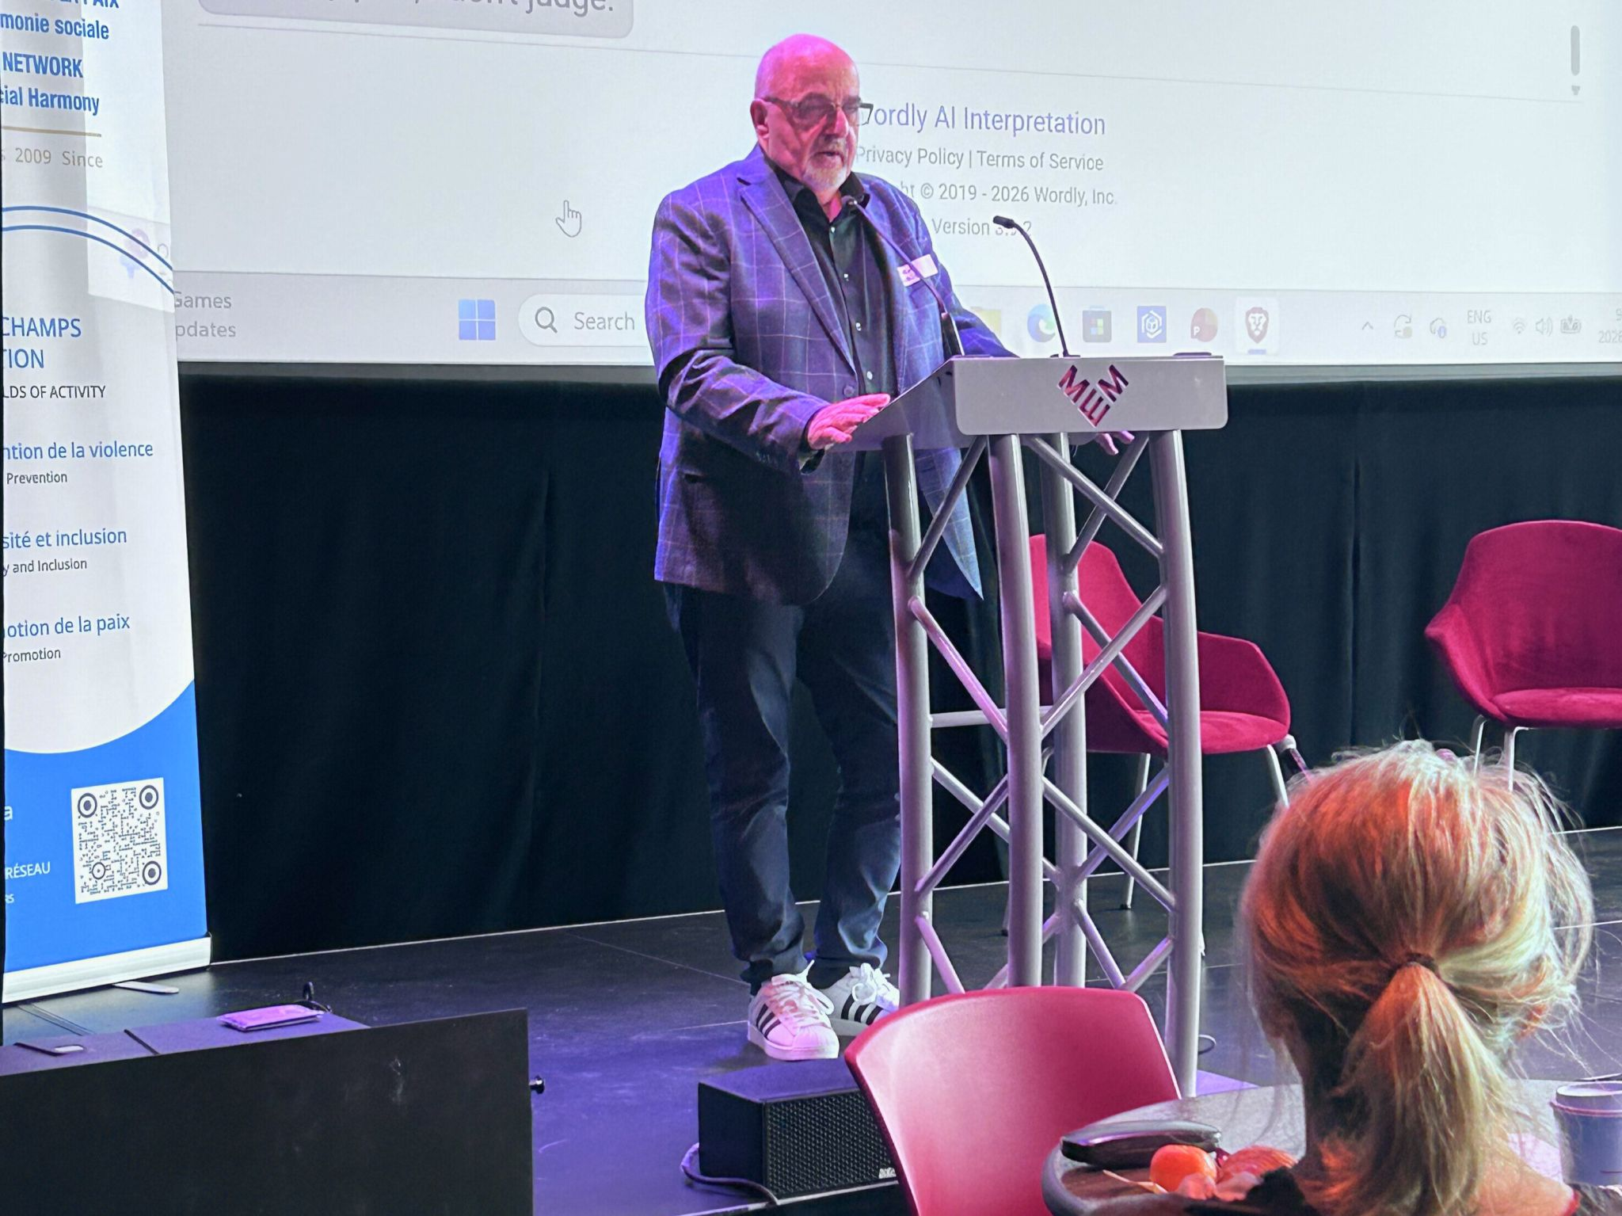

You will find the text of Steven’s presentation, as well as those of the other speakers, in the document below, along with other important and relevant information.

https://www.thepeacenetwork.ca/2020/sitepad-data/uploads/2026/04/Rapport-du-23-f%C3%A9vrier-2026-FR.pdf

Global Disability Rights Conference
RAPLIQ continued its international outreach through participation in the Global Disability Rights Conference 2025.
The conference brought together advocates, organizations, and experts from around the world to discuss:
- Disability rights;
- Ableism;
- Social inclusion;
- Accessibility;
- Equality.
Both Linda Gauthier and Steven Laperrière were invited speakers.
Their presentations highlighted the realities faced by persons with disabilities in Quebec and Canada, including challenges related to:
- Transportation;
- Housing;
- Health care;
- Employment;
- Civic participation.
Steven Laperrière presented an overview of the systemic barriers that continue to affect persons with disabilities despite existing legal protections.
Linda Gauthier emphasized the importance of recognizing disability rights as fundamental human rights and the need for continued advocacy, awareness-raising, and political action.
The conference enabled RAPLIQ to:
- Share its expertise internationally;
- Strengthen relationships with global partners;
- Contribute to international discussions on inclusion and equality.
It also reinforced the reality that the issues faced by persons with disabilities in Quebec are part of a broader global movement for dignity, equality, and full social participation.

Institutional Representation and External Committees
Throughout 2025–2026, RAPLIQ remained actively involved in numerous consultation tables and advisory committees to ensure that the voices of persons with disabilities are heard directly within decision-making bodies.
Linda Gauthier, co-founder of RAPLIQ, represented our organization on several key committees:
- The OPHQ consultation table as part of the Accessible Small Establishments Program (PEA), promoting meaningful and sustainable accessibility in local businesses with a floor area of less than 300 square metres.
- The Quebec Building Authority (RBQ) consultation committee (OPHQ/RBQ), where she raised practical issues related to the implementation and interpretation of building and design standards concerning universal accessibility and safety.
- Dr. Christophe Bedos, Associate Professor at McGill University's Faculty of Dental Medicine, Director of the Quebec Oral and Bone Health Research Network (RISBOd), and Vice-President of RAPLIQ, invited RAPLIQ to join the RISBOd Steering Committee as a community partner. Linda Gauthier, RAPLIQ Co-Founder and Senior Advisor, represents the organization on the RISBOd Steering Committee.
- The Canadian Transportation Agency Advisory Committee.
Steven Laperrière, Executive Director of RAPLIQ, represented our organization on several key committees:
- The Advisory Committee for Students with Disabilities or Learning Difficulties (CCSEDHAA), contributing to the advancement of a truly inclusive and equitable education system.
- The Community Partners Subcommittee (SCPMA) of the Réseau de transport de la Capitale (RTC), where he advocates for the interests of passengers with reduced mobility in the development of accessible policies and infrastructure.
- RAPLIQ also sits on the Coalition Santé en péril (Health Services at Risk Coalition), which brings together community organizations committed to defending a public, accessible, universal, and equitable healthcare system.
Our participation reflects a strong commitment to ensuring that the voices of persons with disabilities are included in broader social justice movements and that their specific realities are fully considered in collective advocacy efforts.
Through participation in mobilization activities, political consultations, public advocacy initiatives, and monitoring efforts, RAPLIQ contributes to building meaningful alliances and strengthening its impact in support of a truly inclusive Quebec.
In addition, Linda Gauthier and Steven Laperrière alternate their participation on the consultation table of the Quebec Human Rights and Youth Rights Commission (CDPDJ), where RAPLIQ actively contributes to the analysis of systemic discrimination issues, the development of recommendations, and the evaluation of public policies from the perspective of the rights of persons with disabilities.
Through its ongoing participation in these various bodies, RAPLIQ continues its mission of strategic and influential representation, helping to shape policies, practices, and standards in pursuit of social justice and substantive equality.

Centraide Annual Fundraising Campaign
As it does every year, RAPLIQ proudly participated in the annual fundraising campaign of Centraide of Greater Montreal.
We had the privilege of speaking on two occasions before institutions and partners committed to social change in order to highlight the importance of their support.
Steven Laperrière, Executive Director of RAPLIQ, represented the organization during events hosted by the Caisse de dépôt et placement du Québec and Valero Energy.
“Centraide is not simply a funder for us—it is a partner, a catalyst for connections, and an amplifier of impact. Thanks to its support, we can go further and reach people who are too often left behind.”
— Steven Laperrière
These presentations helped put a human face on the tangible impact of donations, highlight the inequalities still experienced by persons with disabilities, and sincerely thank those who choose to make a difference.
RAPLIQ will continue to actively support initiatives that strengthen our social fabric and make our work possible.

The Impact of RAPLIQ
Beyond reports, briefs, political representations, media interventions, and legal actions, RAPLIQ’s true impact is measured by its ability to ensure that the voices of persons with disabilities are heard where they were once absent.
Over the past year, RAPLIQ contributed to advancing public discussions on:
- Universal accessibility;
- Paratransit and public transportation;
- Home support;
- The fight against discrimination;
- Health care;
- Housing;
- Civic participation.
Through advocacy with decision-makers, public institutions, municipalities, and media outlets, RAPLIQ helped ensure that the realities experienced by persons with disabilities were considered in decision-making processes.
RAPLIQ also continued its core mission of rights advocacy by supporting hundreds of individuals facing discrimination, exclusion, or violations of their rights.
Every intervention—whether individual or collective—helps build a more inclusive and equitable society.
The organization strengthened strategic partnerships throughout the community, institutional, and political sectors, ensuring that disability issues remain visible and continue to move forward.
Ultimately, RAPLIQ’s impact lies in its ability to transform individual concerns into collective issues, expose injustice, and promote practical solutions.
Every right recognized, every barrier removed, every service improved, and every individual supported represents a victory—not only for persons with disabilities, but for Quebec society as a whole.

RAPLIQ et les médias:

To view RAPLIQ's media appearances, interviews, reports, and public interventions, please visit our Linktree page:

https://linktr.ee/RAPLIQ

Media visibility remains one of RAPLIQ's most important tools for raising awareness, influencing public opinion, and advancing the rights of persons with disabilities.

Action Planning:

Toward a Stronger and More Influential RAPLIQ

2026–2027 Action Plan

Strategic Orientation 1

Defending the Rights of Persons with Disabilities
Objective
Increase RAPLIQ's impact in combating discrimination.
Planned Actions
- Support persons with disabilities who experience discrimination.
- Pursue strategic legal actions when necessary.
- Produce briefs, opinions, and recommendations for public decision-makers.
- Monitor emerging issues affecting disability rights.
Indicators
- Number of cases handled.
- Number of complaints supported.
- Number of public interventions completed.

Strategic Orientation 2

Influencing Public Policy
Objective
Position RAPLIQ as an essential partner and stakeholder for governments.
Planned Actions
- Participate in government consultations.
- Meet with ministers, elected officials, and senior public servants.
- Monitor government commitments affecting persons with disabilities.
- Maintain active participation in national coalitions.
Indicators
- Number of political meetings.
- Number of briefs submitted.
- Number of recommendations adopted.

Strategic Orientation 3

Improving Universal Accessibility
Objective
Advance accessibility in public and private environments.
Planned Actions
- Continue advocacy related to paratransit and transportation.
- Address accessibility barriers in buildings, businesses, and events.
- Raise awareness among municipalities and developers.
Indicators
- Number of interventions carried out.
- Number of accessibility improvements obtained.
- Number of stakeholders reached.

Strategic Orientation 4

Strengthening Communications and Mobilization

Objective
Increase RAPLIQ’s visibility and raise awareness of the issues experienced by persons with disabilities.

Planned Actions
- Expand RAPLIQ’s presence on social media;
- Develop public awareness campaigns;
- Continue producing and distributing the podcast and newsletter;
- Increase media coverage of priority issues.

Indicators
- Number of followers and subscribers;
- Number of publications and campaigns;
- Number of media interviews and appearances;
- Audience engagement levels.

Strategic Orientation 5

Ensuring Organizational Growth and Sustainability

Objective
Strengthen RAPLIQ’s human, financial, and organizational resources.

Planned Actions
- Diversify funding sources;
- Expand the activities of the Fondation Décliq;
- Develop relationships with new funding partners;
- Modernize administrative and technological tools;
- Improve organizational efficiency and long-term sustainability.

Indicators
- Amount of self-generated revenue;
- Number of new funding partners;
- Organizational growth and development milestones achieved;
- Completion rate of strategic organizational projects.

Strategic Orientation 6

Developing National and International Partnerships

Objective
Increase RAPLIQ’s influence in Quebec, across Canada, and internationally.

Planned Actions
- Participate in international conferences and events;
- Strengthen relationships with disability rights organizations;
- Develop joint initiatives with strategic partners;
- Promote Quebec expertise in disability rights advocacy and universal accessibility;
- Expand international collaboration opportunities.

Indicators
- Number of active partnerships;
- Number of conferences and events attended;
- Number of collaborative projects completed;
- Growth in RAPLIQ’s national and international presence.

Conclusion
The 2025–2026 year demonstrated once again that meaningful progress is achieved through perseverance, collaboration, and collective action.
Throughout the year, RAPLIQ continued to support persons with disabilities facing discrimination, advocate for systemic change, influence public policy, challenge injustice, and promote a more accessible and inclusive Quebec.
While many challenges remain, the organization enters the coming year with determination, strengthened partnerships, and a clear vision for the future.
Together, we will continue working toward a society where accessibility, equality, dignity, and full participation are realities for all.

Together, let us no longer accept the unacceptable.

États financiers
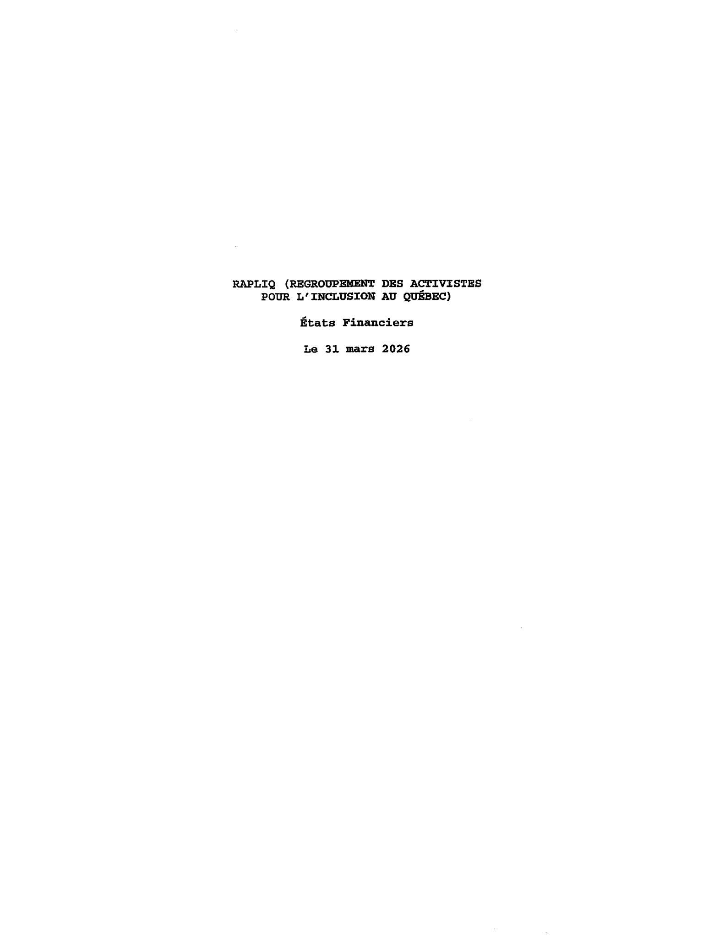

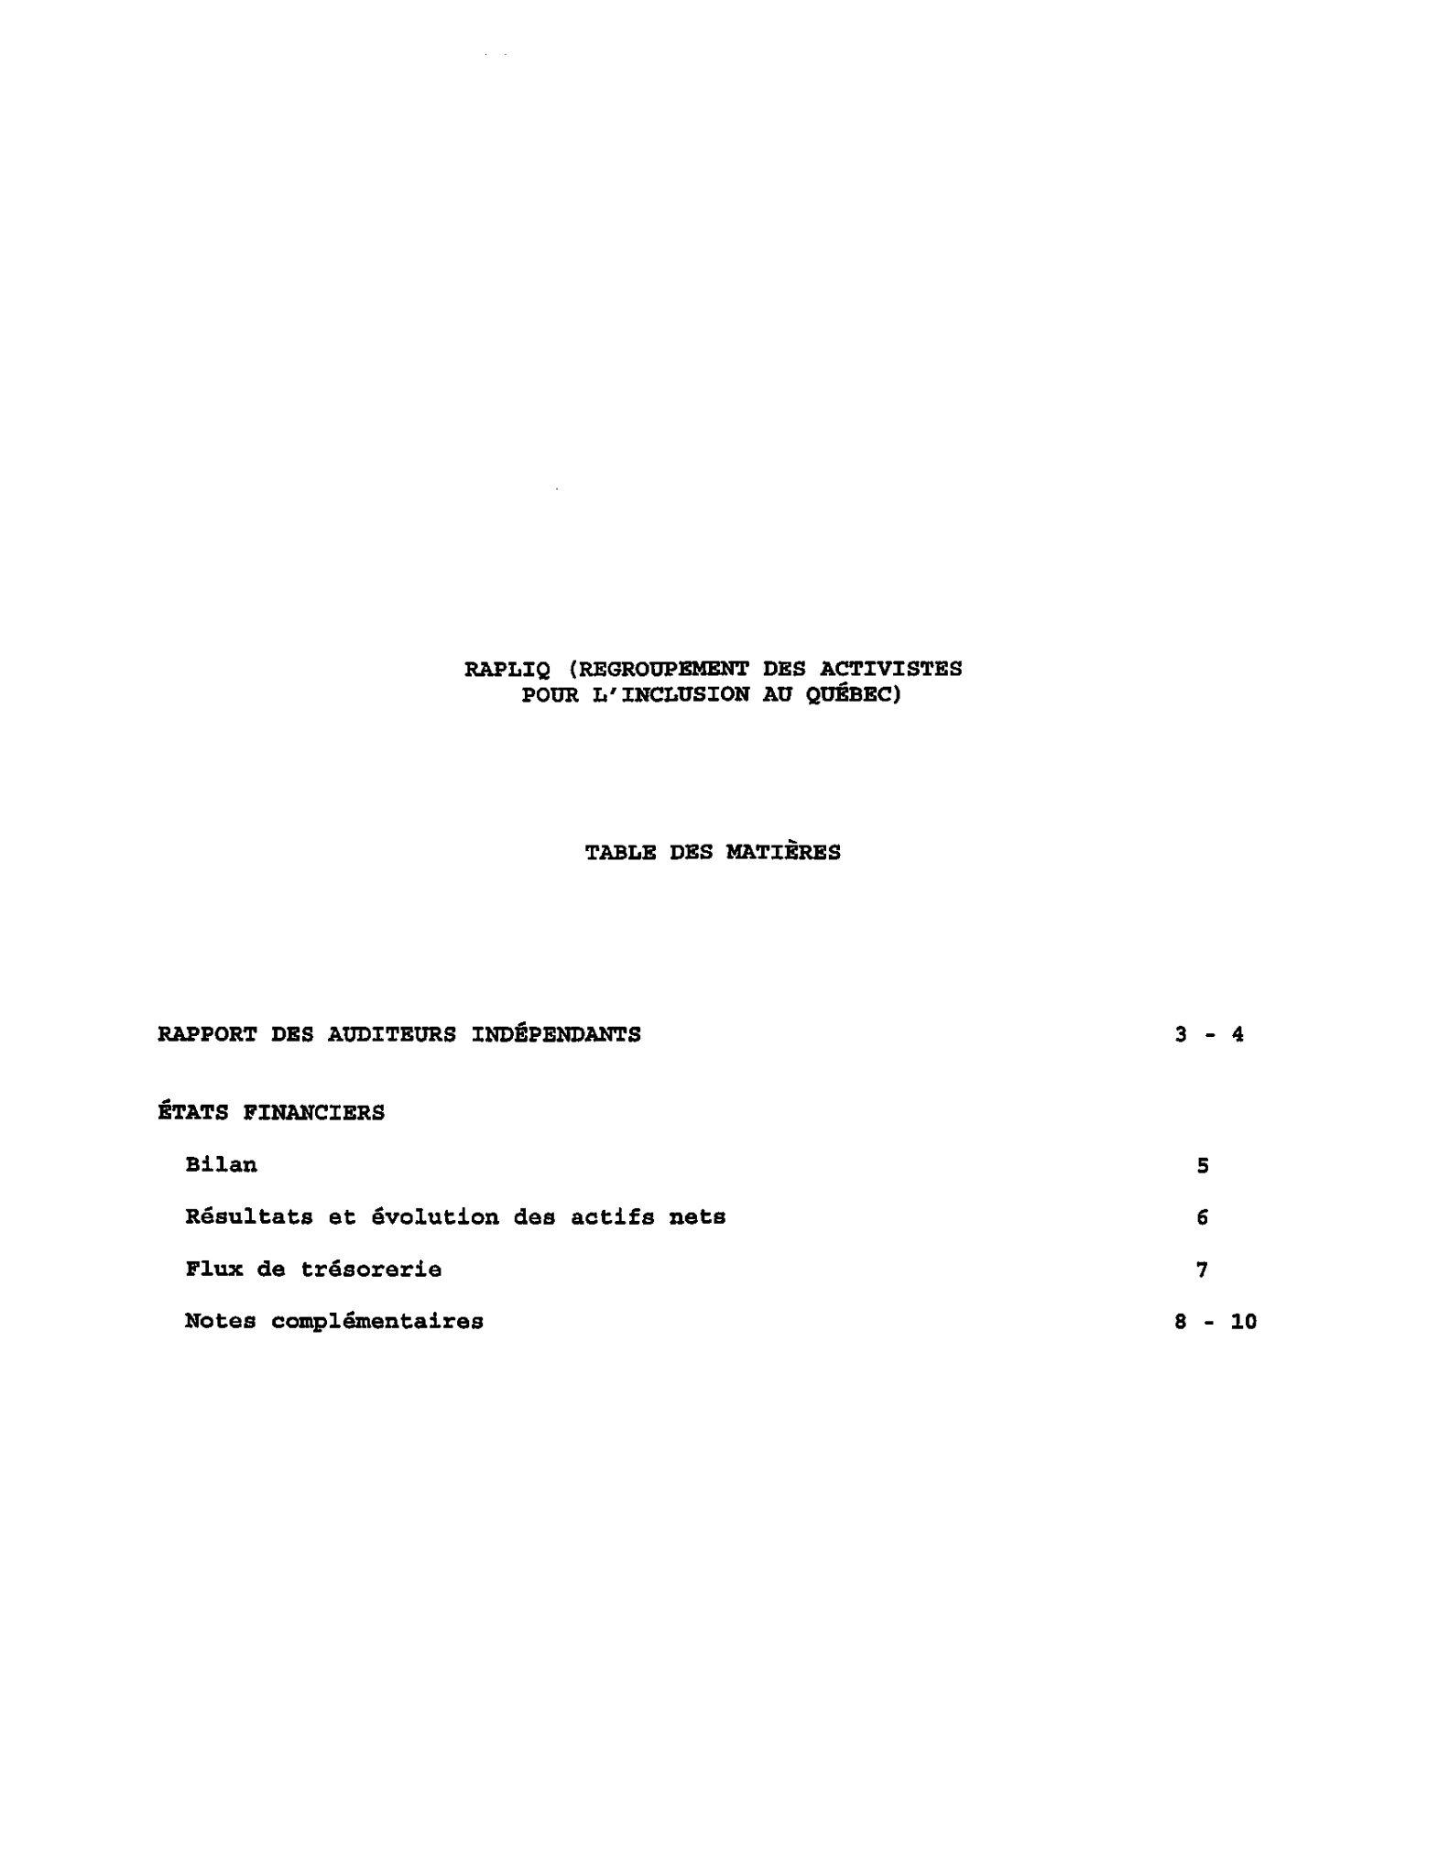

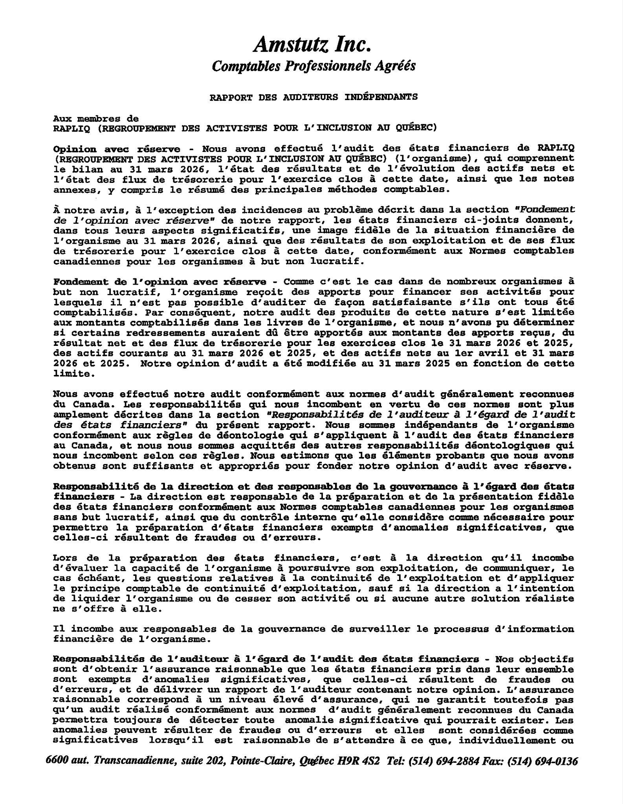
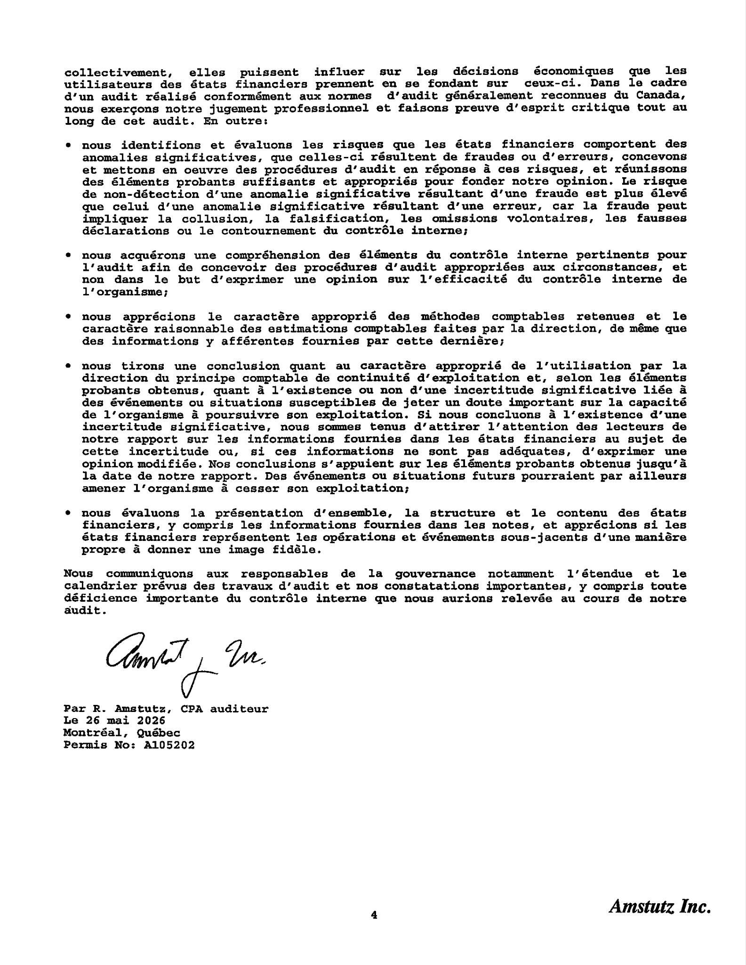

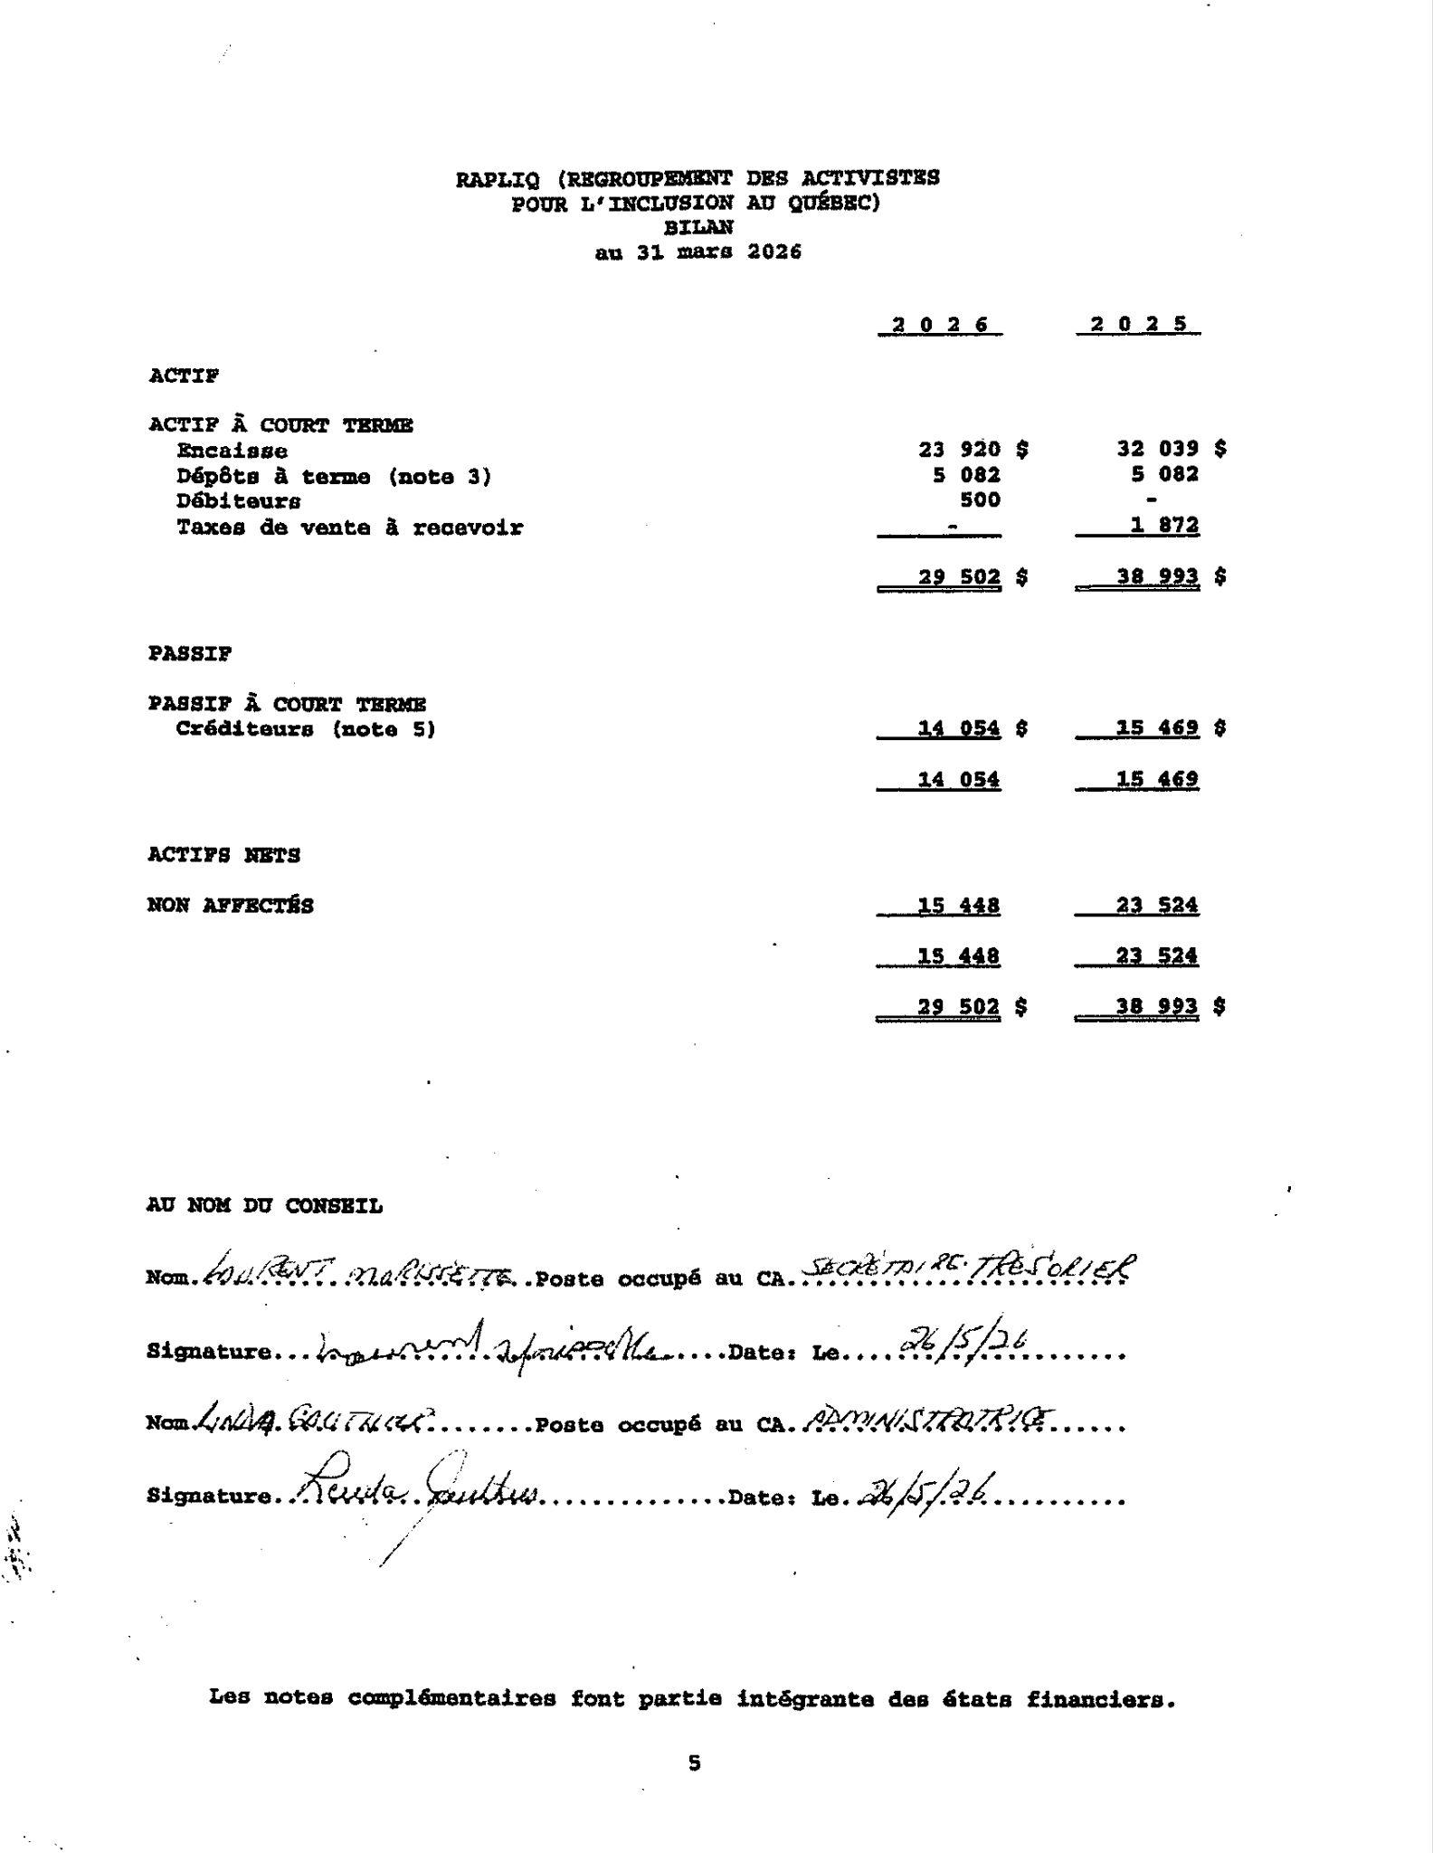
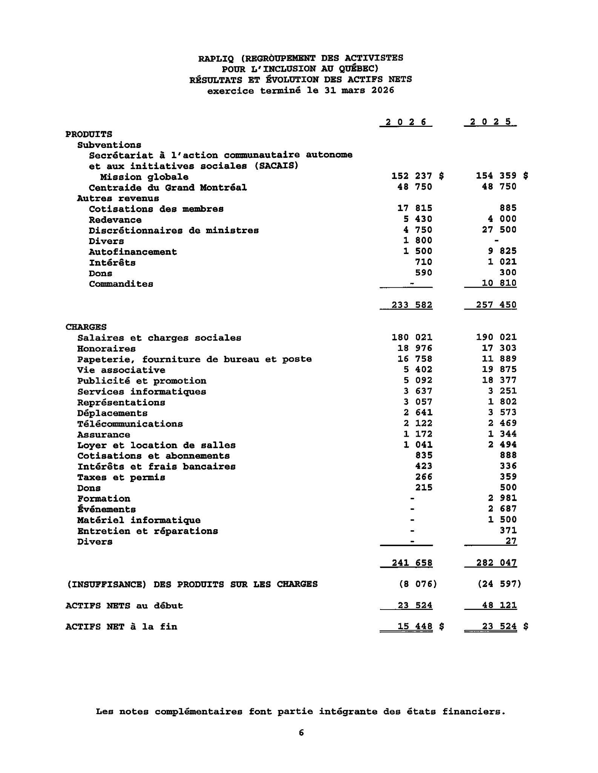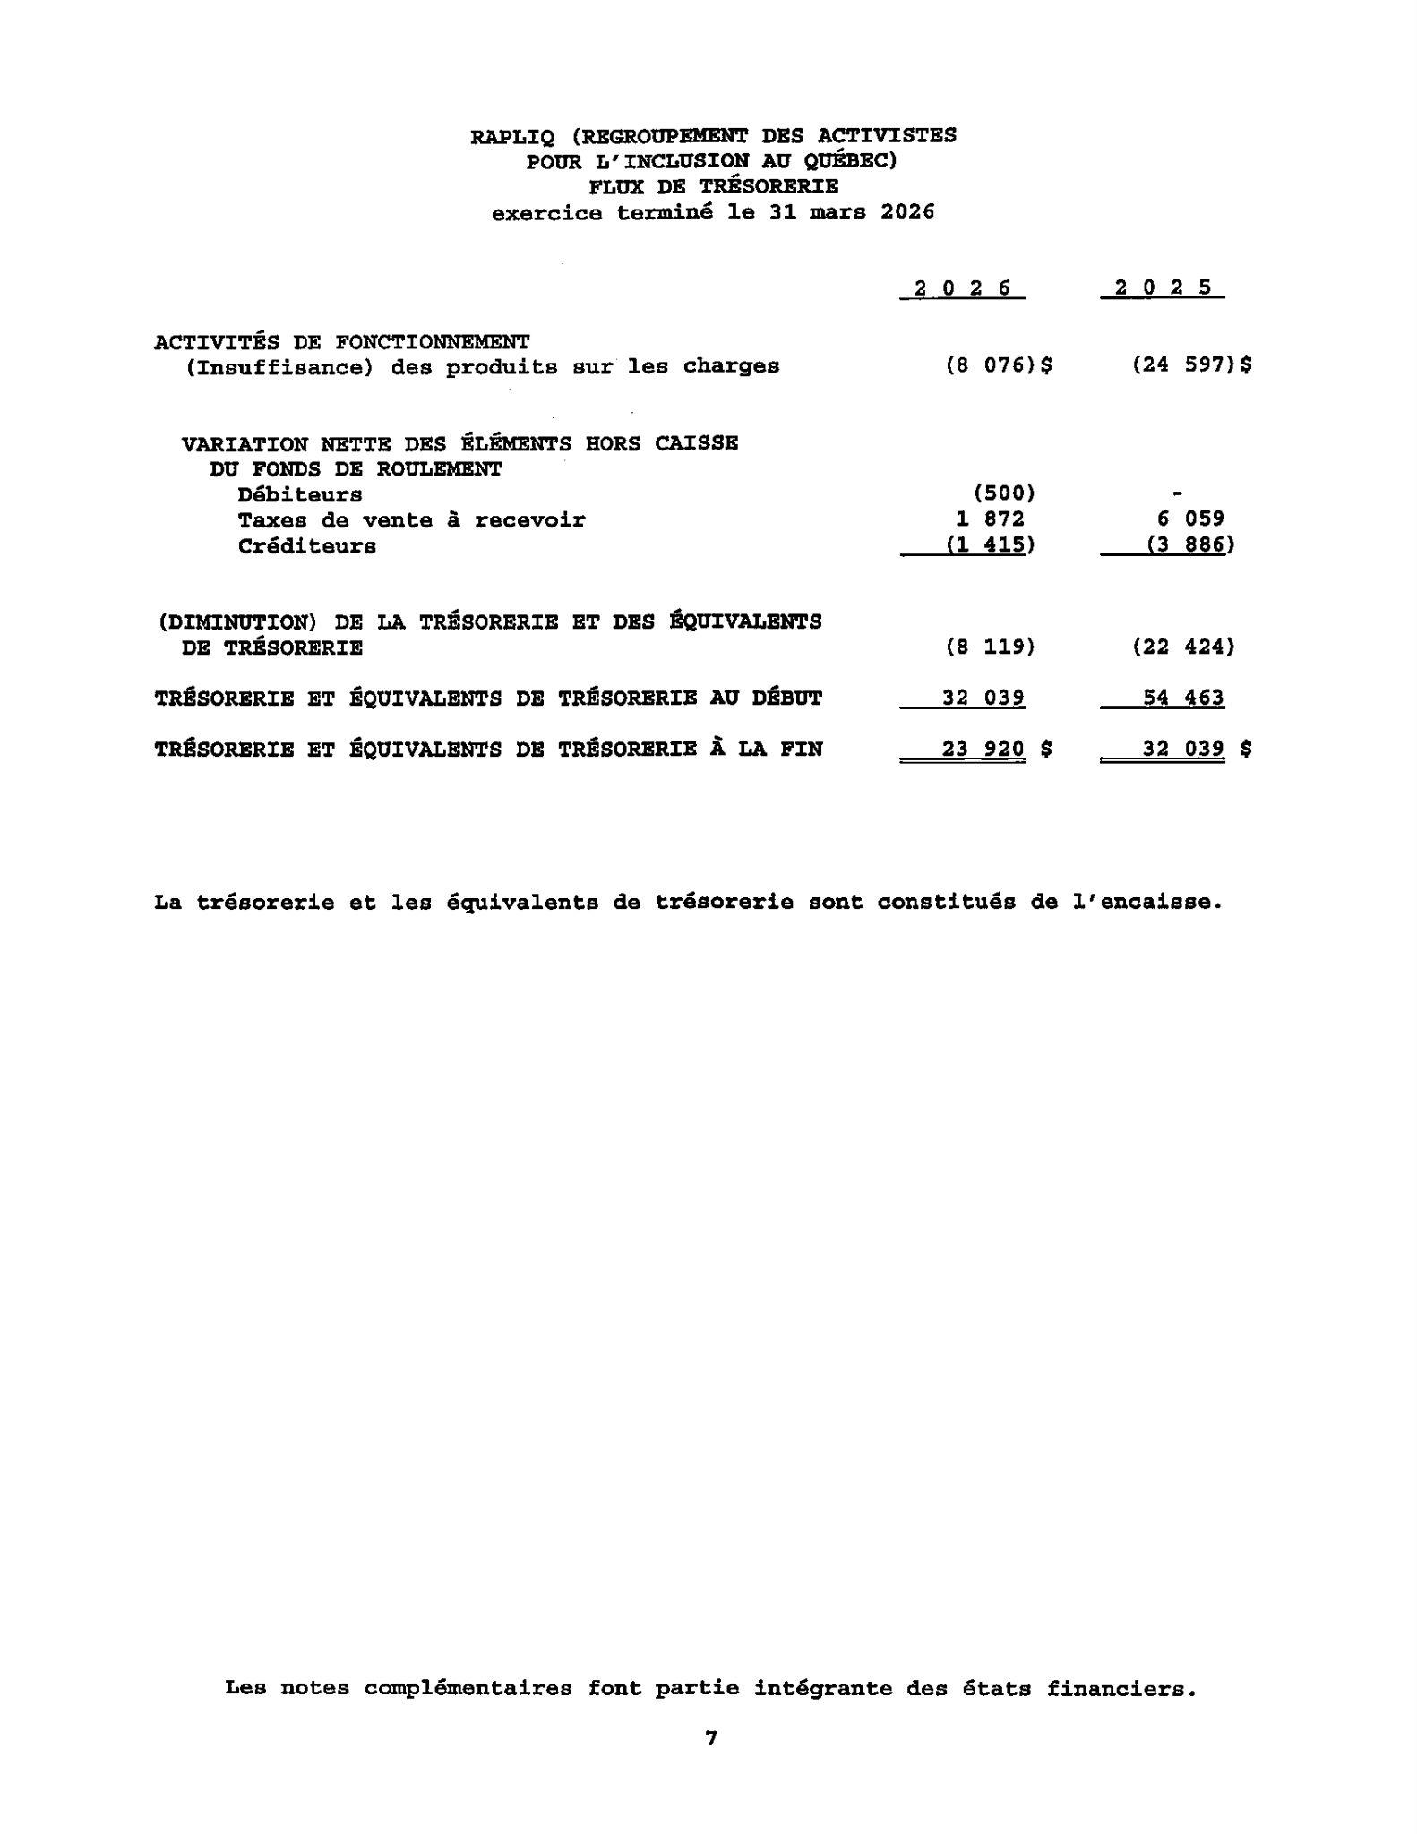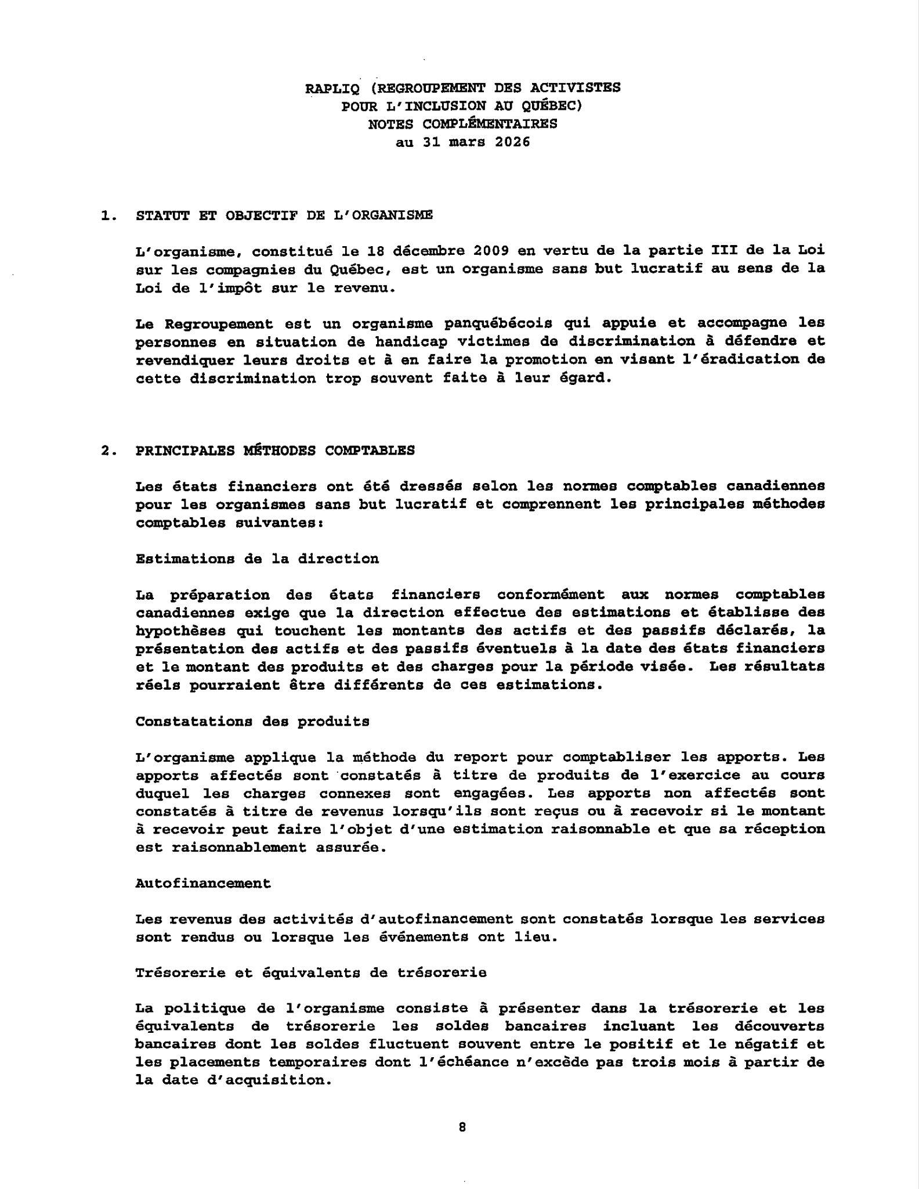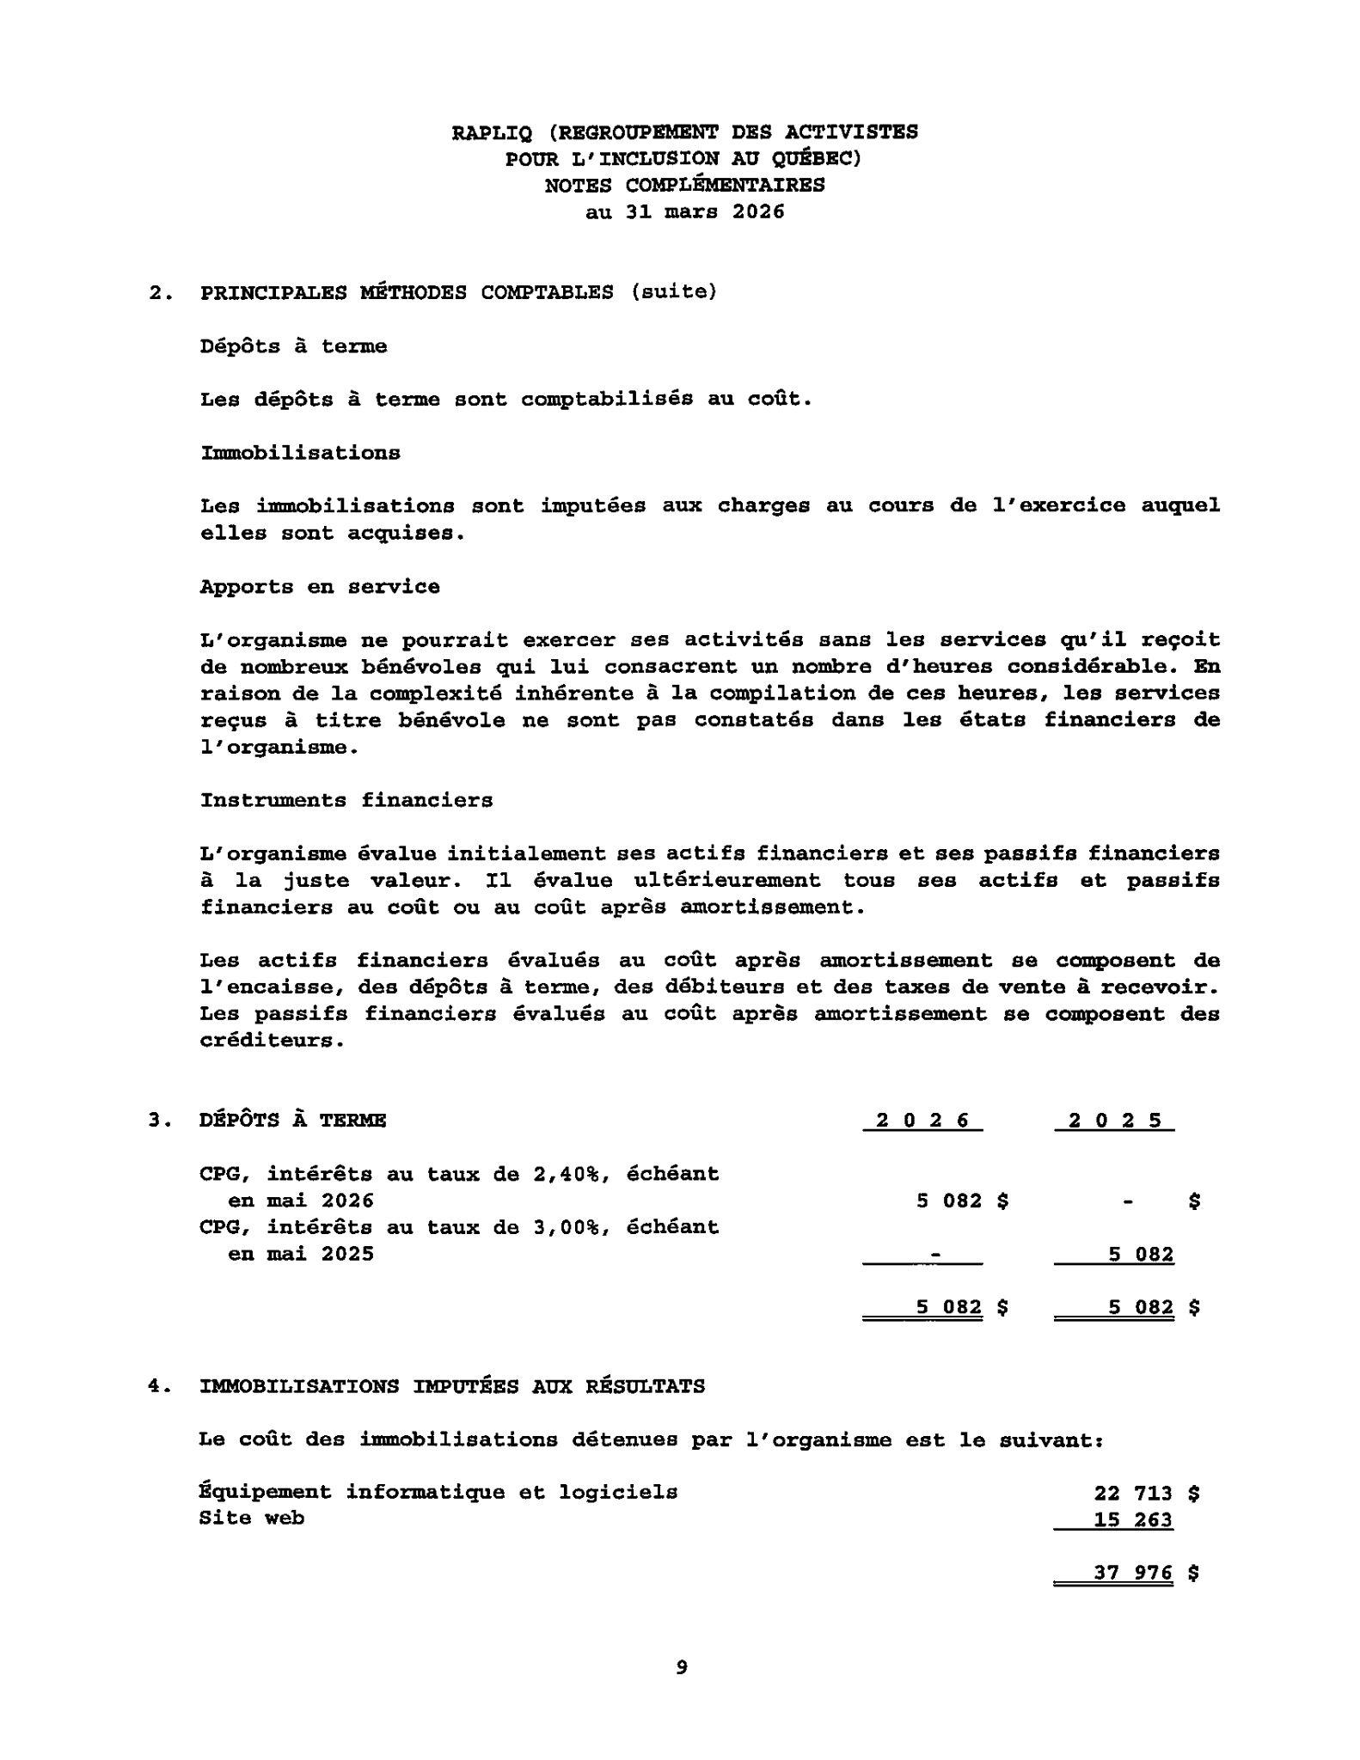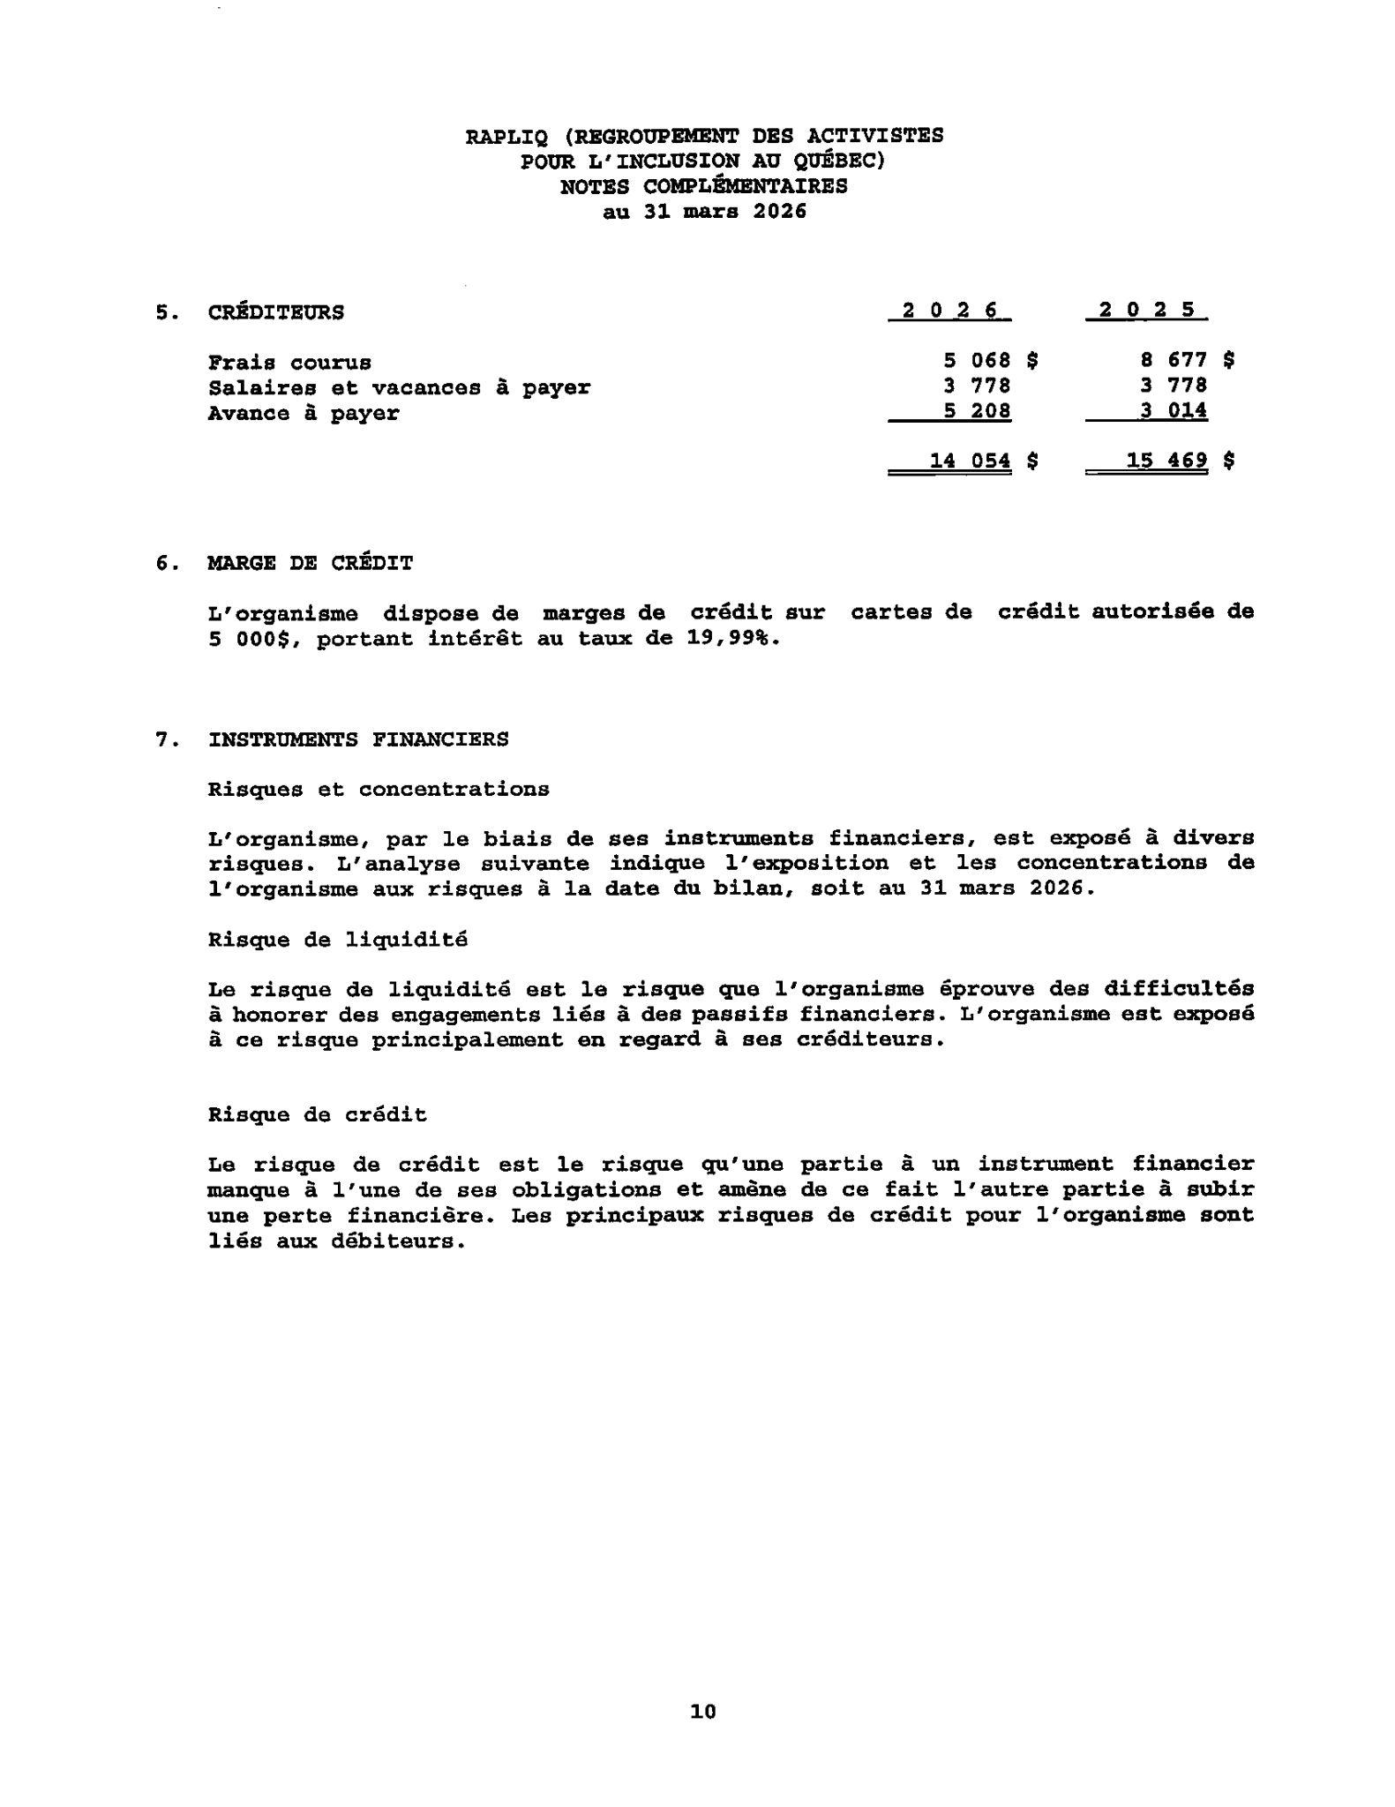

Prévisions budgétaires

Revenue sources | Forecast 2026-2207
Grants and Contributions | 218760,00
Royalties / Self-Financing Activities | 28250,00
Membership Fees | 1000,00
Ministerial and MP Discretionary Funds | 5000,00
Donations | 1000,00
Sponsorships | 1000,00
Training and Conferences | 2000,00
Interests | 1100,00
Total des revenus | 258110,00
Expenses | Forecast 2026-2027
Salaries and Benefits | 175 254,00
Payroll Service Fees | 1600,00
Courier and Postal Services | 3000,00
Office Supplies | 4000,00
Administration and Office Fees | 4500,00
Professional Services | 3700,00
Accounting fees | 1000,00
Lawyers fees | 20000,00
Technology and Software | 1600,00
Web Sites | 1100,00
Medias and Press releases | 0,00
Publicity / Promotions | 5000,00
Bank Fees and Interest | 500,00
Credit Card Fees | 200,00
Internet and telecommunications | 3200,00
Insurances | 1450,00
Business Taxes and Fees | 359,00
Permit and Taxes | 380,00
Memberships | 900,00
Member Engagement and Organizational Activities | 5000,00
Donations (In memoriam and others) | 500,00
Greetings and Courtesies | 500,00
Training, Symposiums and Activities | 3000,00
Travel Expenses | 10000,00
Représentation | 2000,00
Computer Equipment Purchases | 0,00
Maintenance and General Repairs | 400,00
Expenses | 249143,00
Excess of Revenue Over Expenses | 8967,00

