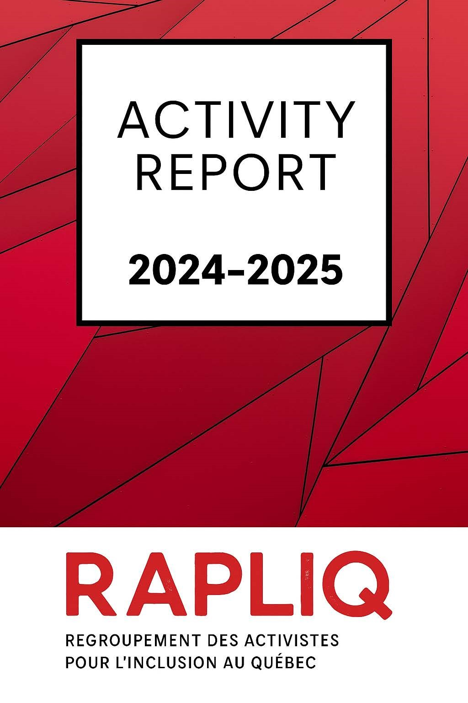
Table of Contents
Word from the President_______________________________________________4
Word from the Director General_____________________________________________ 4
Board of Directors____________________________________________________6
Volunteers__________________________________________________________6
Thanks____________________________________________________________ 6
Members___________________________________________________________7
Democratic functioning________________________________________________7
Board of Directors Meetings_______________________________________________ 7
Regular meetings of the board of directors______________________________ 7
Extraordinary meetings of the board of directors__________________________8
Current complaints___________________________________________________ 8
In Memory__________________________________________________________9
Honorary mentions___________________________________________________ 9
Main files___________________________________________________________9
Cuts in various services for people with disabilities_____________________________ 9
When the government cuts, it’s called a “reassessment”: RAPLIQ denounces the planned collapse of home support in Quebec_______________________________9 The PAD: an inhumane choice imposed on vulnerable people__________________9
A disguised attack on fundamental rights_________________________________ 10
RAPLIQ refuses deletion______________________________________________10
RAPLIQ says NO___________________________________________________ 10
We will not remain silent______________________________________________ 11
Women with disabilities victims of domestic violence (FHVVC)_____________ 11
RAPLIQ's fight against IVAC: For real justice and dignified reparation______________11
A reform with cruel consequences______________________________________ 12
Double punishment for people with disabilities_____________________________ 12
An intersectoral mobilization___________________________________________ 12
Quebec Pension Plan_____________________________________________________ 12
Terraces________________________________________________________________ 12
Follow-up on collective action______________________________________________13
Disabled people and discrimination in employment_________________________ 13
Mammography clinics________________________________________________14
Evaluation of the REM_______________________________________________ 14
Assessment of the accessibility of the REM_______________________________ 14
RISBOd (Intersectoral Research Network for Sustainable Oral and Bone Health)_ 14
Promotion of rights and debates___________________________________________ 15
Handicast_________________________________________________________ 15
Sexual assistance___________________________________________________15
Home support____________________________________________________________ 15
Mobilization against cuts in the health system: RAPLIQ in action_______________16
Closure of the Camilien-Houde road_________________________________________16
Announced end of minibuses in adapted transport: a worrying decision__________ 17 *La facture* shocking report: a shockwave on restaurant accessibility____________ 18
Continuing education and capacity building__________________________________ 19
Training and workshops for workplaces_____________________________________ 19
One-off files_______________________________________________________ 20
Medical assistance in dying (MAID)_____________________________________ 20
Worrying drifts and RAPLIQ's position___________________________________ 20
Collaborations___________________________________________________________21
Collaboration with the Network for Peace and Social Harmony________________ 21
RAPLIQ’s 15th Anniversary – A Powerful Moment of Unity______________________ 21
Two victories for inclusion: accessibility and social innovation__________________ 22
Democratic, associative and municipal, provincial and international life_________ 23
Institutional representation and external committees___________________________23
Engagement in coalitions defending the public health system___________________ 24
Speeches – Centraide Annual Fundraising Campaign__________________________ 24
Founding meeting of the DÉCLIQ Foundation – January 13, 2025________________ 25
Constitution of the board of directors and appointment of executive officers______ 26
Strategic planning: towards a stronger, more influential RAPLIQ_________________26
Vision____________________________________________________________26
Mission___________________________________________________________ 26
Strategic objectives and means of action____________________________________ 26
- Strengthen public influence andvisibility________________________________27
- Improve the organizational structure___________________________________27
- Develop strategic partnerships_______________________________________ 27
- Simplify and standardize internal processes_____________________________27
- Ensure the financial sustainability of RAPLIQ____________________________28
- Mobilize and engage the community___________________________________28
- Increase our influence at the federal level_______________________________28
Financial statements_________________________________________________29
Budget forecasts____________________________________________________41
RAPLIQ in the media________________________________________________ 43

Word from the President

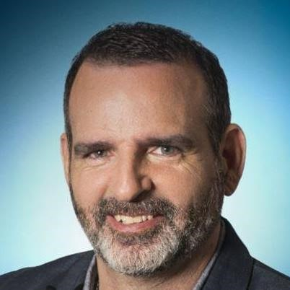
Dear members,
It is with deep gratitude that I address you as Interim Chair of the RAPLIQ Board of Directors. The year 2024–2025 was marked by significant progress, fruitful collaborations, and challenges that we have met together with determination.
Our unwavering commitment to inclusion and the rights of people with disabilities has translated into concrete actions. We strengthened our partnerships, notably with the Quebec
Oral and Bone Health Research Network (RISBOd), where our representative, Linda Gauthier, sits on the steering committee to promote inclusive practices. We also celebrated the 15th anniversary of RAPLIQ, an opportunity to reflect on our journey and renew our commitment to our mission.
Furthermore, we expressed our concerns regarding the announced end of minibuses for paratransit at the STM, emphasizing the importance of adequate driver training to ensure quality service for the most vulnerable users. We also commended the STM's efforts in the area of universal accessibility, while calling for an acceleration of work to meet the urgent needs of people with disabilities.
These actions demonstrate our ongoing commitment to defending the rights of people with disabilities and promoting a more inclusive society.
I would like to express my gratitude to Linda, Steven and Brigitte.
Their unwavering commitment is at the heart of our successes and our ability to meet the challenges that lie ahead.
Together, we will continue to work for a Quebec without obstacles or discrimination. In solidarity,
Sylvain Plourde

Word from the General manager

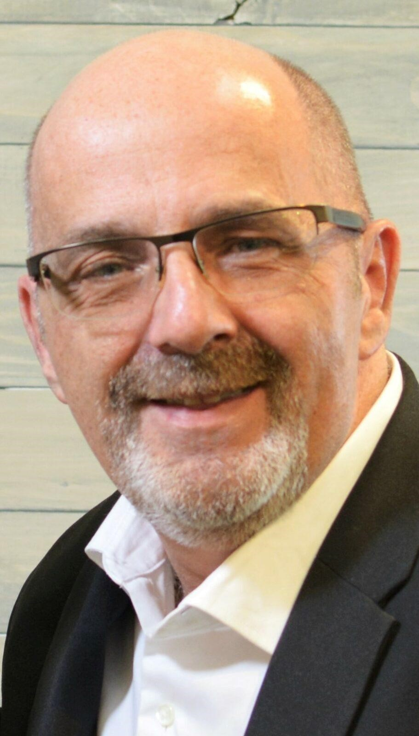
For RAPLIQ, 2024-2025 was a year of resistance, but also of strengthening. In a difficult political and economic context, marked by cuts to essential services and the suspension of programs such as home support, respite care, and home adaptation, we never gave up.
Despite these attacks on the most fundamental rights of people with disabilities, we have responded with strength and solidarity. We have stepped up our actions, filed complaints, organized protests, and, above all, forged new alliances that strengthen our ability to act.
These challenges have reminded us of one essential thing: unity is strength. It is together—members, allies, partners—that we have
been able to stand up to adversity and defend, once again, the fundamental principle of equality for all.
We celebrated RAPLIQ's 15th anniversary, a milestone that demonstrates our ongoing commitment to inclusion and the rights of people with disabilities. To mark the occasion, we strengthened our social media presence and launched new communications initiatives to better represent ourselves and serve our community.
Today, with our experience and these new forms of solidarity, we are looking resolutely toward the future. The challenges remain numerous, but our commitment remains unwavering: to make the voices of people with disabilities heard, without compromise and without respite, in order to accomplish our mission:support and assist disabled people who are victims of discrimination to defend and claim their rights and to promote them, aiming to eradicate this discrimination which is too often practiced against them.
I also thank all our members, partners, and collaborators for their support and commitment. Together, we will continue to work for a Quebec without barriers or discrimination.
Writing an activity report, listing our successes and reflecting on what stuck is a demanding exercise, but one which, year after year, fills me with joy as I see the achievements, efforts, relevance and importance of our actions in the quest for our mission.
Happy reading!

Steven Laperrière

Board of Directors

The board of directors as of March 31, 2025 was composed of:

- Sylvain Plourde, president;
- Christophe Bedos, vice-president;
- Laurent Morissette, secretary-treasurer;
- Linda Gauthier, administrator;
- Jacques Bisson, administrator;
- Amélie Allard, administrator;
- Emmanuelle Champagne, administrator.

Francine Leduc and Anne-Marie L’écuyer resigned during the year. RAPLIQ warmly thanks them for their contribution.

Volunteers

- Renée Caron;
- Christian Vaillant;
- Yves Plourde;
- Lise Gervais;

Thanks

- Louise Harel;
- Mr. Paul-Claude Bérubé;
- Andrea Morrison; ● Martine Lévesque; ● Michel Bédard:
- Miloud El Berrhama;
- Dr. Pierre Duquette;
- Line Bergeron;
- Martin Dion;
- Sarina Ferrara-Santone;
- Yannick De Grave;
- Brian Bronfman Family Foundation; ● Michelle Turenne:
- Simon Wong;
- Veronique Vézina;
- Lena Martinez Scala, Marika Giguère, Danielli Katherine Pascoal and Julie Fitzbay, social work trainees at UQAM.

Members

TheRAPLIQ countsandon the support of 207 individual members andthirteen (13)collective members:

- FRAME
- CNIB INCA Foundation
- ACTAQ
- Strong HandMontreal Inc.
- Amalgam
- Independent Living Montreal
- ROP-03
- Montreal Deaf Women's House
- L'AMASQ
- Network for Peace and Social Harmony

Thank you to each and every one of you.
Your commitment allows us to give the best of ourselves. Together, we bring about change and make a concrete contribution to building a more just and inclusive society.

Democratic functioning

The annual general meeting took place on June 1, 2024: 29 members attended.

Board of Directors Meetings
Regular meetings of the board of directors
In 2024:
- May 16
- July 11
- September 12
- November 7th

In 2025:
- January 9
- 6 mars

Extraordinary meetings of the board of directors
In 2024:
- July 30
- October 28

In 2025:
- January 30
- February 26
- 19 mars

Current complaints


When someone comes to us for assistance with their complaint, we draft it formally and file it on behalf of the victim with the body responsible for handling the dispute.

As of March 31, 2025, RAPLIQ was mandated in 112 complaints, distributed as follows:

- One hundred and seven to the Commission on Human and
Youth Rights;
- One in Small Claims Court;
- One to the Canadian Human Rights Commission;
- Three at the Canadian Transportation Agency

Ten complaints are awaiting assignment, either for mediation or for internal investigation. All have been deemed admissible.

Since its founding, your RAPLIQ has processed 946 complaints.

Currently, two RAPLIQ officers (Linda Gauthier and Steven Laperrière) provide assistance and support to complainants.

This total number of complaints does not reflect the total number of cases processed and resolved without official complaints, a number which far exceeds the number of complaints officially processed.

In Memory

“In loving memory of”:

Nicole Robillard
Clemence Guillemette

Honorary mentions

Louise Harel

Main files

Cuts in various services for people with disabilities
When the government cuts, it’s called a “reassessment”: RAPLIQ denounces the planned collapse of home support in Quebec
For several months, the Regroupement des activistes pour l’inclusion au Québec (RAPLIQ) has been sounding the alarm: essential services for people with disabilities are being dismantled before our eyes. Under the pretext of "reevaluation," the Quebec government is making brutal cuts to the Chèque emploi-service (CES) program, the Home Adaptation Program (PAD), the Work Integration Contract (CIT), respite services, and home care in general. To add insult to injury, there are even plans to charge people with disabilities for certain home services, thus breaking the social contract established in 1988, which stipulates that people with disabilities should not have to bear the costs of compensating for their disability.
These setbacks have dramatic consequences.
Today, more than20,000 peoplewaiting to receive home care in Quebec. Behind this stark figure are lives put on hold, exhausted families, and people left alone to face untenable situations. The most affected? People with disabilities who rely daily on basic services to eat, wash, get around, or simply live with dignity.

The PAD: an inhumane choice imposed on vulnerable people
The Home Adaptation Program, whose mission is to enable people with disabilities to remain in their homes, has been gutted. People are now being excluded without appeal, even though they depend on it to be able to live safely and with dignity in their own homes.
These people, now left to their own devices, find themselves facing a chilling dilemma: endure insecurity, have to resign themselves to being forcibly moved into a CHSLD or consider medical assistance in dying (MAID), not out of choice, but out of despair.

A disguised attack on fundamental rights
We hear talk of streamlining, good management, and "reassessing needs." The reality is a regression of rights. What's at stake isn't just financial or logistical support: it's the autonomy, security, and dignity of thousands of people.
- The THESEis transformed to the point of becoming inaccessible to many, forcing beneficiaries to cut their hours, to dismiss their assistants, or even to return to institutions.

- The PAD, once a tool for autonomy, becomes a breaking point.

- The CITis increasingly difficult to obtain, with opaque eligibility criteria and Kafkaesque administration.

- THE respite services are reduced, while they represent a vital breath of fresh air for caregivers.

- And meanwhile,home care stagnates, while demand explodes.

RAPLIQ refuses deletion
We do not accept that the State sends us back into the shadows, within the walls of a hospital-centric system or residual institutions. Home support is not a privilege: it is a fundamental right enshrined in the principles of the Law ensuring the exercise of the rights of persons with disabilities.
RAPLIQ therefore calls on the Legault government, the Minister responsible for Seniors and Home Care, and all parliamentarians: it is time to stop the bleeding. We must invest massively in home care, in CES, in respite and in all forms of direct assistance.

RAPLIQ says NO
No to the accounting logic that tramples on human dignity.
No to the erosion of the hard-won gains of generations of activists.
No to a system that pushes disabled people towards death rather than allowing them to live.
We request an emergency plan:
- Immediate reinvestment in all affected programs;

- A moratorium on the end of the PAD program;

- An inclusive reform of home support focused on self-determination;

- Official recognition of the fundamental nature of access to home services.

We will not remain silent
Actions are underway, and more will follow. Demonstrations, mobilizations, open letters, legal action: RAPLIQ will loudly and clearly raise the voices of the people this government is trying to silence. We also call for solidarity from the public, caregivers, professionals, and other community groups.
We will not let our autonomy die in indifference.

Women with disabilities victims of domestic violence (FHVVC)
RAPLIQ continued its commitment to raising awareness of the specific reality of women with disabilities experiencing domestic violence. This issue is being addressed in collaboration with community and institutional partners to ensure a response tailored to the needs of these doubly discriminated women. In 2024-2025, several presentations were made, including a training/workshop (see section: Training and workshops for workplaces) at the Nicolet National Police Academy (ENPQ) for future and current police officers, investigators and members of the direction.

RAPLIQ's fight against IVAC: For real justice and dignified reparation
For several years, RAPLIQ has been actively involved with people with disabilities who are victims of crime and whose rights are violated by the current IVAC regime. This regime, which is supposed to offer support, dignity, and reparation, has become a Kafkaesque, dehumanizing, and profoundly unjust system, particularly since the 2021 legislative reform.

A reform with cruel consequences
Under the guise of modernization, the reform introduced arbitrary restrictions that plunged many victims into distress. One of the most odious measures is the automatic termination of financial and psychological support after three years, as if the after-effects of rape, assault, or attack had an expiration date. This logic of "time-limited reparation" denies the reality of lasting and, very often, permanent trauma.

Double punishment for people with disabilities
Disabled people who are victims of crime are doubly penalized: on the one hand, they suffer the assault; on the other, they must fight against a rigid, opaque and insensitive administrative apparatus. The IVAC too often refuses to recognize certain disabilities, demands almost impossible proofs to provide and cuts the services without notice or sufficient justification.

An intersectoral mobilization
With allies such as Me Marc Bellemare, Me Sophie Mongeon, Senator Pierre-Hugues Boisvenu, the group “Les Invalides au front”, and many other partners from civil society, we will continue our work of collaboration and advocacy for the benefit of all these victims, particularly victims with disabilities.

Quebec Pension Plan
We would like to express our deep gratitude to Ms. Sophie Mongeon, Mr. Kevin McLean, his mother-in-law, Danièle Drolet (widow of Richard McLean) and the “Les Invalides au front” collective, as well as to all the community organizations that took part in this long fight. It was during our evening marking the 15th anniversary of RAPLIQ that Ms. Mongeon and Mr. McLean announced to us, with emotion and pride, that the bill had been ratified the day before. This moment will remain etched in our collective history as a symbol of struggle, solidarity and social justice.
Thanks to these joint efforts, disabled seniors can now breathe a little easier, with one less financial worry to bear. It is by joining our voices that we are pushing back against exclusion. And it is together that we will continue to move forward.

Terraces
As part of its monitoring of the accessibility of terraces in Montreal, your RAPLIQ is continuing its assessment and awareness-raising work. While dozens of restaurateurs have undertaken modifications to make their terraces accessible following our recommendations made in 2022, and despite the RAPLIQ having chosen a more “conciliatory” approach with merchants during the summers of 2022 and 2023 by attempting to inform and educate on the realities and needs of people with disabilities, too many have still not made the necessary adjustments. In addition, many establishments offer minimal accommodations which, while technically sufficient to avoid formal complaints, do not guarantee true accessibility for people with disabilities, placing them under the obligation to request an accommodation which may or may not be granted.
Faced with this persistent situation, on October 21, 2024, RAPLIQ filed 101 complaints with the Commission des droits de la personne et des droits de la jeunesse (CDPDJ) against owners of inaccessible terraces in Montreal. These complaints are currently awaiting processing.
It remains to be seen whether the Commission will address these issues before the publication of the next RAPLIQ activity report. We will closely monitor developments and continue to advocate for true, uncompromising universal accessibility.

Follow-up on collective action
As of this writing, as of May 24, 2025, the expected decision has still not been rendered. Initially, the dates of November 8 and the week of November 25, 2024, had been mentioned for the delivery of the judgment. However, more than six months later, a year and a half later, uncertainty remains.
It is inevitable for us to think that the press conference of the Minister of Transport
Geneviève Guilbault
(https://www.lapresse.ca/actualites/grand-montreal/2024-11-07/transport-collectif/red uire-les-depenses-de-350-millions-est-possible-conclut-une-firme.php) did not throw a new contextual economic reality on this issue.
Could the worrying state of public finances, combined with the general financial difficulties of transport companies, weigh in the balance?
Furthermore, the pressure exerted by the Minister of Transport on the management of transport companies, as well as the decision of the Société de transport de Montréal (STM) to suspend the accessibility of the metro network due to a lack of government funding, add to the concern.
Given these challenges, the postponement of the decision only heightens concerns about the prospects for accessibility and inclusion in the public transit network. The wait continues, but the urgency of a response remains.

Disabled people and discrimination in employment
RAPLIQ has supported several members who were victims of discrimination based on disability during the hiring process. We requested that this investigation be conducted.
submitted briefs, participated in consultations and provided legal support in some cases. Work continues to strengthen the measures of the Equal Access to Employment Program (EAEP) and ensure their effective implementation in both the public and private sectors.
We requested and collaborated with the Commission des droits de la personne et des droits de la jeunesse (CDPDJ) on a study on disability and employment, the results of which will be released in spring 2025.

Mammography clinics
Members have alerted us to the physical and logistical inaccessibility of several breast cancer screening clinics. Steps have been taken with the Ministry of Health to identify areas of non-compliance and require corrective action. A collaboration between us and the managers of the Quebec cancer program at the Ministry of Health and Social Services has been established, which will lead to results shortly.

Evaluation of the REM

Assessment of the accessibility of the REM
Field observations and participation in focus groups enabled RAPLIQ to document the accessibility of the REM. Recurring issues related to orientation, visual and audible signage, as well as connections with other networks were reported to the relevant authorities.

RISBOd (Intersectoral Research Network for Sustainable Oral and Bone Health)

The RiSBOd brings together more than 100 Quebec researchers dedicated to improving oral and bone health. Our mission is to generate and mobilize knowledge to improve the quality of life of Quebecers while reducing health inequalities.
Funded primarily by the Fonds de recherche du Québec (FRQ), RiSBOd is committed to an intersectoral and sustainable approach to meeting the health challenges of the 21st century.
Dr. Christophe Bedos, our colleague and vice-president of RAPLIQ,Associate Professor,
Researcher, Faculty of Dentistry, McGill University. Director of the Quebec Oral and Bone Health Research Network (A DRAWINGd), has done us the great honor of offering us a seat on the RISBOd steering committee.
RAPLIQ sits there as a partner (RAPLIQ), wishing to bring practices of social inclusion and universal accessibility, without any form of discrimination.
“We are honored to collaborate with RISBOd to promote inclusive and accessible research practices for all.”
— Linda Gauthier

Promotion of rights and debates
Throughout the year, RAPLIQ has been a leading public figure, advocating for the rights of people with disabilities, sparking critical debates, and influencing social policies. Our approach combines media presence, political advocacy, and collaboration with other civil society organizations.
During the 2024-2025 period, RAPLIQ significantly contributed to increasing the visibility of issues experienced by people with disabilities in the general and specialized media (see RAPLIQ and the Media section). Thanks to a sustained media presence and impactful positions, we were able to maintain constant pressure on political decision-makers, both at the provincial and federal levels, to ensure that the rights of people with disabilities are fully taken into account in public policies. This sustained mobilization has helped strengthen RAPLIQ's recognition as a key opinion leader and a true driver of social change in Quebec..

Handicast
With the help of UQAM's social work interns, we produced the first season of a podcast series, HandiCast. We cover healthcare, education, allies, and universal accessibility. We thank CHOQ-FM for the use of their magnificent studio, the training of interns, and the broadcast on their channel.

To listen to the podcasts, please follow this link:https://www.choq.ca/balados/handicast

Also available on YouTube, Spotify, Apple Music and other digital platforms.

Sexual assistance
In collaboration with Me Jérémie Moisan-De Serres, we continued our analysis of the Quebec and Canadian legislative framework on sex work and its impact on the sexual autonomy of people with disabilities. A political demand is currently being structured to protect users and third parties from any unjustified criminalization.
This file will be the subject of an episode of the second season of HandiCast.

Home support

Coalition Solidarité Santé and Coalition Services en Péril. Faced with the scale of cuts in the health system, whether in home services (Chèque Emploi Service), the indefinite suspension (at least until the next Quebec budget) of the PAD program (home adaptation program), respite services, the questioning of the decision made in 1988 promulgating that people with disabilities should not have to pay to compensate for their disability, to name just a few situations, your RAPLIQ has not remained inactive.

Mobilization against cuts in the health system: RAPLIQ in action
Faced with major cuts in the health system, particularly in home services (Chèque emploi-service), the indefinite suspension of the Home Adaptation Program (PAD) – at least until the next Quebec budget –, restrictions on respite services and the questioning of the principle established in 1988 according to which people with disabilities should not have to bear the costs related to their disability, the RAPLIQ has not remained inactive.
In addition to the actions already undertaken (see in particular the press conference of
February 19, 2025), we have joined the Coalition Solidarité Santé at the kind invitation of Amélie Duranceau, Executive Director of the SQDI. This approach allows us to join forces with other organizations and amplify the voice of people with disabilities in the fight to protect essential services.
In the same spirit, we also contributed to the creation of the Coalition Services en Risque, in collaboration with several partners, in order to coordinate efforts and maximize the impact of our demands.
The scale of the attacks on the rights of people with disabilities is such that the Commission des droits de la personne et des droits de la jeunesse (CDPDJ) deemed it necessary, last
December, to publish an official statement
(https://www.cdpdj.qc.ca/fr/actualites/declaration-soutien-domicile-handicap) reminding us that these rights must be protected and respected. However, this crisis has also had a mobilizing effect: it has strengthened solidarity within the community, where many organizations are now working together to reverse this trend. Inter-organizational collaborations are emerging, and many of them promise to be long-lasting.
Will we witness a new era of collaboration between organizations? This is certainly our hope for people with disabilities, because the more united we are, the farther and stronger our demands will be.

Closure of the Camilien-Houde road
Throughout 2024-2025, RAPLIQ actively opposed the City of Montreal's proposed permanent closure of Camillien-Houde Lane to automobile traffic. Although presented with a view to environmental protection and greening in mind, this project violates the fundamental right of people with disabilities to freely access public spaces, particularly Mount Royal Park, a true heritage gem and essential gathering place in the city.
RAPLIQ denounced the ableist vision underlying this project, which is based on the erroneous assumption that everyone can access the park on foot or by bicycle. However, for many people with disabilities, as well as for seniors, families with strollers, or people living with invisible limitations, motorized access remains essential. By prohibiting this route, we are effectively excluding a significant portion of the population, in violation of the principles of universal accessibility and the protections guaranteed by the Charter of Human Rights and Freedoms.
Furthermore, we are still trying to understand where the real environmental gain from such a project lies, when more than 82,000 vehicles per day will be redirected to adjacent streets, thus increasing congestion, stops at traffic lights, greenhouse gas emissions and risks to the safety of pedestrians and cyclists. Such a measure could, paradoxically, worsen the environmental and urban situation instead of improving it.
This issue has become emblematic of a broader challenge: the effective inclusion of people with disabilities in mobility, environmental, and land-use planning policies. For RAPLIQ, sustainable development cannot be conceived without social justice and universal accessibility. Reconciling ecology and inclusion is not only possible, but imperative—provided it is made a real priority.

Announced end of minibuses in adapted transport: a worrying decision
In February 2025, the Société de transport de Montréal (STM) announced that it would end its paratransit minibus service by 2026, transferring all trips to external partners, primarily taxi companies. This measure is part of a cost-saving plan aimed at reducing expenses by $145 million over several years.
Currently, 90% of paratransit trips are already provided by external partners. The STM expects this transition to standardize service and improve performance, while maintaining its commitment to a zero-refusal policy.
However, this decision has raised serious concerns among users, unions and disability rights organisations.
Everyone emphasizes that the most vulnerable users, who require special assistance, could be affected by this change. STM drivers receive five weeks of specialized training to meet the specific needs of this clientele, an expertise that is difficult to replace with private services.
RAPLIQ expresses its concern about this transition. We emphasize the importance of maintaining a quality, accessible, and equitable adapted transportation service for all people with disabilities.
We are reassured that planning, organization and responsibility remain under the control of the STM and we have expressed serious concerns about the training of paratransit drivers.
We call on the STM and the relevant authorities to ensure that this reorganization does not compromise the rights and dignity of paratransit users.
RAPLIQ will continue to closely monitor developments in this situation and work with stakeholders to ensure that the rights of persons with disabilities are fully respected.

*La facture* shocking report: a shockwave on restaurant accessibility
One of the highlights of the 2024-2025 year for RAPLIQ was the broadcast, on May 21, 2024, of a powerful report on Radio-Canada's *La facture*, focusing on the persistent inaccessibility of restaurants for people in wheelchairs. This segment highlighted the journey of Linda Gauthier, co-founder of RAPLIQ, who faced a series of refusals and obstacles simply to find an establishment where she could sit down with dignity.

The report and article (see the two links below), viewed by hundreds of thousands of people, sent shockwaves through Quebec. They exposed the glaring gap between the fundamental rights of people with disabilities and the reality on the ground: impassable entrances, inaccessible restrooms, and disconnected or condescending responses. The public was moved and outraged, and many media outlets followed suit to denounce this injustice.

But beyond the emotion, this report highlighted the persistent inconsistency between the different levels of government and their respective responsibilities. The Office des personnes handicapées du Québec (OPHQ), the Régie du bâtiment du Québec (RBQ), and the Minister responsible for Housing are passing the buck, unable to speak with one voice or propose a coherent plan to correct systemic shortcomings. Each claims that it is not within their jurisdiction, or that standards are "evolving," while thousands of people are literally left outside of facilities.

RAPLIQ denounced this institutional cacophony, calling for a clear harmonization of roles and genuine political will. We reiterated that the rights of persons with disabilities are not a matter of "good intentions" or "reasonable tolerance," but a legal and moral requirement.

This moment of truth, courageously carried by Linda Gauthier, will not only have shaken consciences, but strengthened our determination: as long as disabled people have to call ahead to "make sure they can eat with others", we will not be out of the woods.
"After 40 years of struggle, we still have to beg for the right to enter a restaurant like everyone else. It's not a privilege, it's a right."
— Linda Gauthier, co-founder of RAPLIQ
https://ici.radio-canada.ca/nouvelle/2139327/restaurant-fauteuil-roulant-acces-facture

https://ici.radio-canada.ca/tele/la-facture/site/segments/reportage/1990415/accessibilite-rest aurant-handicap-fauteuil-roulant

Continuing education and capacity building
RAPLIQ continued its continuing education efforts throughout 2024-2025, in order to consolidate its internal skills and better equip its teams to face the evolving challenges related to the rights of people with disabilities.
Lafortune Training – Law
Participation in a series of legal training sessions offered by Lafortune Formation, focusing on the rights of people with disabilities, possible remedies in cases of discrimination, and the legal obligations of public and private institutions. These training sessions helped RAPLIQ members deepen their knowledge of administrative law, fundamental rights, and collective defense strategies.
Training – Productivity and cutting-edge technological tools
In the interest of organizational efficiency, RAPLIQ has also undergone targeted training on next-generation technological tools: collaborative management, task automation, optimization of digital communications, and strategic monitoring. The goal is to maximize the impact of our interventions while ensuring the judicious use of our human resources.

Training and workshops for workplaces
Training – Data workshops, in collaboration with the
Côte-des-Neiges–Notre-Dame-de-Grâce (CDN–NDG) borough
RAPLIQ led a series of awareness workshops for blue-collar and white-collar workers in the CDN–NDG borough of Montreal. These sessions included:
- real-life testimonies of people with disabilities,

- interactive discussions on daily accessibility challenges,

- a presentation of the systemic issues linked to urban planning, institutional communication and the attitude of municipal services.
These workshops aimed to strengthen empathy, a concrete understanding of the realities experienced by citizens with disabilities, and to encourage lasting changes in public service practices.
During the year, RAPLIQ was invited to collaborate with the École nationale de police du Québec (ENPQ) to offer training and awareness workshops on the specific realities of women with disabilities, particularly in the context of domestic violence.
These training courses covered several essential themes:
- Specific obstacles to accommodation for women with disabilities who are victims of violence, often excluded from traditional, unsuitable resources;

- Issues related to accessible transport, particularly critical in emergency or isolation situations;

- The need for professional interpretation services for deaf women, to ensure their safety, autonomy and full participation in legal proceedings and social reintegration.
This initiative has helped to better equip future and current police officers to recognize, understand and intervene appropriately in situations affecting women with disabilities, who are too often invisible in public policies to combat violence.

One-off files

During the year, we have the privilege of being consulted on various projectsorstudiesledvarious municipal and government bodies.

Medical assistance in dying (MAID)
Worrying drifts and RAPLIQ's position
The year 2024-2025 has been marked by a worrying trivialization of medical assistance in dying (MAiD) in the public sphere, particularly when it comes to people with disabilities living in conditions of great precariousness, solitude, or despair. We are witnessing a worrying deviation from the very spirit of the law: what was intended to be an exceptional measure framed by palliative care becomes, too often, an alternative to a lack of care, support, or reasonable accommodations allowing people to live with dignity.
RAPLIQ has protested against this shift in discourse and against several high-profile cases where MAiD is presented, implicitly or explicitly, as a "solution" to poverty, social isolation, or the deficiency of public services. This trend raises major ethical questions: In what kind of society do we accept that people ask to die because living has become unbearable for them—not because of their health, but because of systemic abandonment?
The case of Mr. Meunier, who requested and received medical assistance in dying after receiving poor hospital care and developing bed sores that caused unbearable pain. We described this situation as dehumanizing and unacceptable.
Faced with these excesses, RAPLIQ strongly reaffirms its position:
- MAiD should never be a response to lack of support, income or services.

- People with disabilities must be able to live with dignity before they are offered the opportunity to die with dignity.

- No policy on MAiD should be adopted without direct consultation with organisations led by and for people with disabilities, in accordance with the fundamental principle of 'Nothing about us without us'.

Through our media appearances, open letters, and appearances on several public and other panels, we have conveyed this message loud and clear: the lives of people with disabilities are worth living, provided that society truly provides them with the means to do so. The right to die must never supersede the right to live with dignity.

Collaborations

Collaboration with the Network for Peace and Social Harmony
As part of its representation and consultation activities, RAPLIQ has actively collaborated with the Network for Peace and Social Harmony, an intersectoral group that aims to promote living together based on inclusion, social justice and diversity.
Two members of RAPLIQ took part in the work of the strategic committees of this network:
- Linda Gauthier served on the Arts and Culture Committee, bringing an essential perspective on cultural accessibility and the participation of people with disabilities in artistic life.

- Steven Laperrière participated in the Funders Committee, contributing to discussions on equitable and accessible funding mechanisms for community organizations run by and for marginalized people.
These collaborations have made it possible to make the voices of people with disabilities heard in planning spaces that are often inaccessible. Final reports from these committees are expected in 2025. RAPLIQ will analyze the resulting recommendations and return to them in detail in its next activity report.

RAPLIQ’s 15th Anniversary – A Powerful Moment of Unity
On November 29, 2024, RAPLIQ celebrated its 15th anniversary with a unifying event held at Resto Plateau in Montreal. This landmark evening was an opportunity to highlight fifteen years of struggles, concrete progress, and solidarity around the rights of people with disabilities.
More than a hundred people—members, partners, allies, activists, and friends of RAPLIQ—gathered to celebrate our organization's commitment and resilience. The atmosphere was both festive and emotional, punctuated by inspiring speeches, powerful testimonies, and a sense of profound collective gratitude.
One of the highlights of the evening was the public reading of the RAPLIQ Manifesto by its author, Ms. Laurence Parent, researcher, activist, and municipal councilor for the City of Montreal. This seminal text, which embodies a bold vision for a truly inclusive Quebec, resonated powerfully in the room.
A complete photo file of the event is available in the Google Drive link below, testifying to the human and symbolic richness of this memorable evening.
This anniversary was not just a look back at the past; it also allowed us to vigorously reaffirm our desire to go even further, together, in defending rights, denouncing injustices and building a Quebec accessible to all.
https://drive.google.com/drive/folders/1Syyh5vX2f_VJEzyvP6AOe04AV_Vau-4Z?usp=drive_l ink

Two victories for inclusion: accessibility and social innovation
In 2024-2025, RAPLIQ recorded two significant victories that demonstrate that collaboration and boldness can produce concrete and transformative results in terms of inclusion.
1.Taxi Coop Québec – More accessible mobility in Quebec
Thanks to an innovative partnership between RAPLIQ and Taxi Coop Québec, a major step forward has been made to improve the accessibility of taxi services in the Capitale-Nationale region. This pilot project has enabled:
- an increase in the number of adapted vehicles in service,

- the establishment of a dedicated telephone line for wheelchair users,

- better training of drivers in relation to the needs of people with disabilities.

This model of collaboration was hailed as a concrete example of a response to a need that has been ignored for too long and could inspire other similar initiatives across Quebec.
👉 See the full press release: rapliq.org/amelioration-de-laccessibilite-des-services-de-taxi
2. Bread in the Sails – Inclusion in bakery
In another bold move, the artisanal bakery “Le Pain dans les Voiles” has partnered with RAPLIQ to rethink accessibility in its branches. This partnership has led to concrete actions:
- modification of the interior layout to facilitate access for people with reduced mobility,

- review of service counters and payment methods to suit all customers,

- formal commitment to continue inclusion efforts in ongoing consultation with our organization.

This collaboration demonstrates that it is possible to combine commercial excellence and social responsibility, and opens the way to other partnerships with the SME sector.
👉 See the full press release: rapliq.org/collaboration-audacieuse-avec-le-pain-dans-les-voiles
Democratic, associative and municipal, provincial and international life

Institutional representation and external committees
Throughout the year 2024-2025, RAPLIQ was heavily involved in several round tables and advisory committees, in order to make the voices of people with disabilities heard directly within decision-making bodies.
Linda Gauthier, co-founder of RAPLIQ, represented our organization on three major committees:
- The OPHQ / SHQ consultation table within the framework of the PEA (Small Accessible Establishments) program, to promote real and sustainable commercial accessibility in local businesses of less than 300 square meters.

- The Taxi Coop Québec consultation committee, where she contributed to the development of an innovative model of accessible taxi services in the Quebec region.

- The consultation committee of the Régie du bâtiment du Québec (RBQ), where she raised concrete issues related to the application and interpretation of construction and development standards in terms of universal accessibility.

- Dr. Christophe Bedos, Associate Professor at the Faculty of Dentistry at McGill
University and Director of the Quebec Oral and Bone Health Research Network
(RISBOd) and Vice-President of RAPLIQ. Dr. Bedos invited RAPLIQ to sit on the
RISBOd Steering Committee as a community partner. Linda Gauthier, Co-founder
and Senior Advisor of RAPLIQ, represents the organization on the RISBOd Steering Committee.

Steven Laperrière, Executive Director of RAPLIQ, represented our organization on three major committees:
- The Advisory Committee on Services for Students with Disabilities or Difficulties in Adjustment or Learning (CCSEDHAA), in order to contribute to a truly inclusive and equitable education.

- The Associative Sector Partner Subcommittee (SCPMA) of the Réseau de transport de la Capitale (RTC), to defend the interests of users with reduced mobility in the development of accessible policies and facilities.

- The RTC PDAU Committee, responsible for developing the 2025–2029 Universal Accessibility Plan, a major strategic document that builds on the previous plan adopted by the RTC. This committee helped co-construct, with community partners, an ambitious and inclusive vision for public transit in Quebec City.
👉 View the map: PLAN PDAU 2025–2029 – RTC

Furthermore, Linda Gauthier and Steven Laperrière alternate their presence within the consultation table of the Commission des droits de la personne et des droits de la jeunesse (CDPDJ), where the RAPLIQ actively contributes to the analysis of systemic discrimination issues, the formulation of recommendations and the evaluation of public policies from the perspective of the rights of people with disabilities.
Through its continued presence at these various bodies, RAPLIQ pursues its mission of structuring and strategic representation, in order to influence policies, practices and standards from a perspective of social justice and real equality.

Engagement in coalitions defending the public health system
RAPLIQ is an active member of two major Quebec civil society organizations: the Coalition Solidarité Santé and the Coalition Santé en Risque. These two coalitions bring together community, union, citizen, and professional organizations committed to defending a public, accessible, universal, and equitable health care system.
Our participation is part of a firm desire to bring the voice of people with disabilities to the heart of broader social struggles, and to ensure that their specific realities are fully taken into account in collective demands.
By taking part in mobilization actions, political consultations, public positions and monitoring work, RAPLIQ contributes to building meaningful alliances and strengthening the impact of its action in favor of a truly inclusive Quebec.

Speeches – Centraide Annual Fundraising Campaign
As every year, RAPLIQ responded to Centraide of Greater Montreal's call for its annual fundraising campaign. We had the honor of speaking several times before committed partner institutions to highlight the importance of their contribution.
Linda Gauthier delivered a vibrant testimony in French during the event held at Laurentian Bank, highlighting how Centraide's support represents much more than just funding. It is structuring support, a lever for action, but also a network of solidarity and essential resources for organizations like ours.
Steven Laperrière, Executive Director of RAPLIQ, represented the organization in speeches in English at events organized by Laurentian Bank and in French for TD Bank and the Department of National Defence – Montreal Garrison (see photo). He reiterated that:
“Centraide isn’t just a funder for us—it’s a partner, a catalyst for connections, and an amplifier of impact. Thanks to their support, we can go further and reach people who are too often left behind.”
These interventions made it possible to put a human face on the concrete impact of donations, to recall the persistence of inequalities experienced by people with disabilities, and to warmly thank those who choose to make a difference.
We will continue to actively support these mobilization campaigns which strengthen our social fabric and make our work possible, day after day.

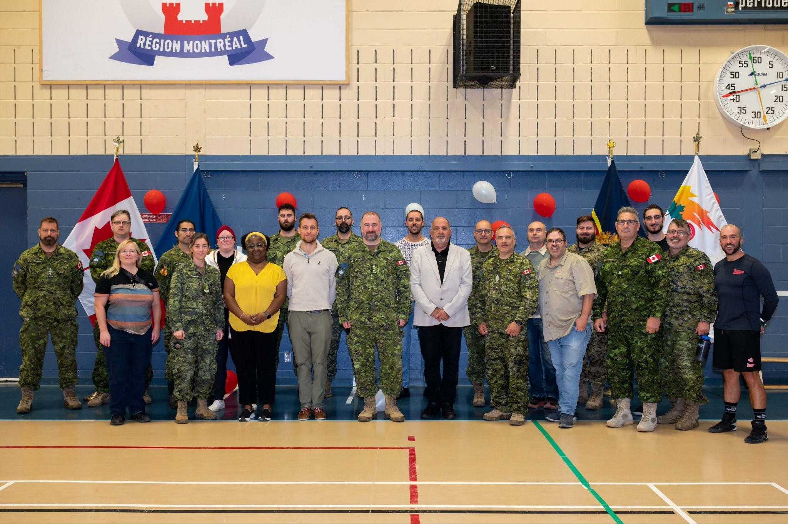

Founding meeting of the DÉCLIQ Foundation – January 13, 2025
The Décliq Foundation held its founding meeting on January 13, 2025, officially marking the start of its activities. This founding meeting brought together the following members:
- Paul-Claude Bérubé

- Linda Gauthier

- Louise Harel

- Steven Laperrière

- Martine Lévesque

- Michèle Turenne

Brigitte Nadon was responsible for taking notes during this meeting.
Dr. Pierre Duquette subsequently joined the Board of Directors.
This first meeting made it possible to lay the administrative and strategic foundations of the Foundation, to adopt the provisional general regulations, to appoint the provisional officers and to confirm the main guidelines aimed at financially supporting individuals and organizations working in the defense of rights, social inclusion and the promotion of studies in human rights.

Constitution of the board of directors and appointment of executive officers
Following the founding meeting on January 13, 2025, the members present officially formed the first board of directors of the Décliq Foundation. The unanimously adopted resolutions made it possible to appoint the following executive officers:
- President :
Paul-Claude Bérubé
(Resolution AF-250113-05 – Proposed by Michèle Turenne, seconded by Linda
Gauthier)

- Vice-President:
Linda Gauthier
(Resolution AF-250113-06 – Proposed by Louise Harel, seconded by Michèle Turenne)

- Secretary-Treasurer:
Steven Laperrière
(Resolution AF-250113-07 – Proposed by Louise Harel, seconded by Michèle Turenne)

These appointments, adopted unanimously, mark a structuring step for the governance of the Décliq Foundation. This board is called upon to guide the implementation of the Foundation's objectives, ensuring the rigor of its administrative and financial management, and embodying its fundamental values of inclusion, integrity and social impact.

Strategic planning: towards a stronger, more influential RAPLIQ
We are proud to present the foundations of our new strategic plan, the result of collaborative work with our members and support from the Centre St-Pierre. Developed progressively, this plan is in line with our mission and aims to strengthen our impact, effectiveness, and ability to build a truly inclusive Quebec.
Vision
Continue to promote inclusion and the defense of the rights of people with disabilities, by strengthening our influence and increasing our organizational effectiveness.
Mission
Support and assist people with disabilities who are victims of discrimination,

Strategic objectives and means of action
1. Strengthen public influence and visibility
Means :
- Develop awareness campaigns on social networks;

- Participate in national and international events to promote best practices;

- Collaborate with media and influencers to amplify our message.

2. Improve the organizational structure
Means :
- Recruit an additional person to ease the current workload;

- Implement training programs in digital and organizational skills;

- Create internal committees to improve the management of projects and initiatives.

3. Develop strategic partnerships
Means :
- Collaborate with developers, builders and architects to promote accessibility of infrastructure;

- Establish partnerships with international groups and professional orders;

- Strengthen collective actions by joining forces with other rights defense organizations.

4. Simplify and standardize internal processes
Means :
- Develop a framework for handling complaints;

- Standardize procedures for filing and supporting complaints;

- Use digital tools to improve internal efficiency.

5. Ensure the financial sustainability of RAPLIQ
Means :
- Create a foundation dedicated to the diversification of financing;

- Organize regular fundraising campaigns;

- Identify specific grants and projects that can provide funding.

6. Mobilize and engage the community
Means :
- Encourage the participation of non-disabled people in political and awareness-raising actions;

- Organize educational workshops and seminars on inclusion;

- Encourage active engagement of members in RAPLIQ activities.

7. Increase our influence at the federal level
Means :
- Build lasting professional relationships with members of the new federal government, including ministers, parliamentary secretaries and political attachés;

- Position RAPLIQ as a key contact in matters of disability, accessibility and human rights;

- Participate in consultations, forums and strategic meetings to promote the priorities of people with disabilities at the national level.

Financial statements


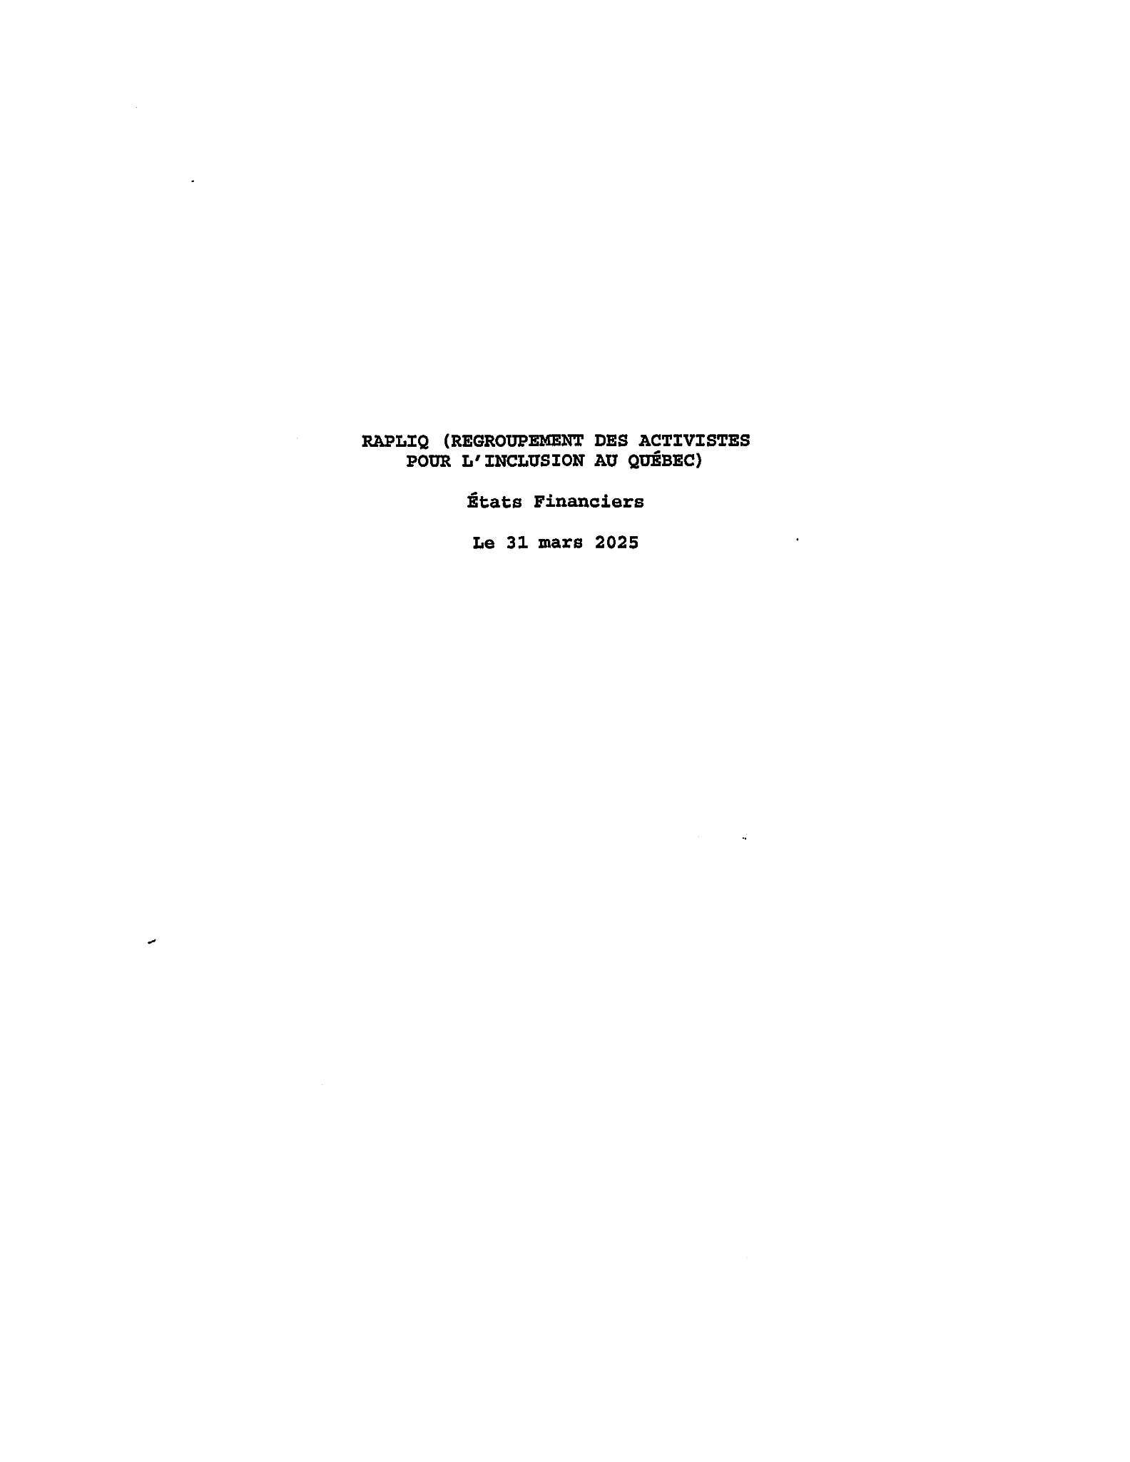
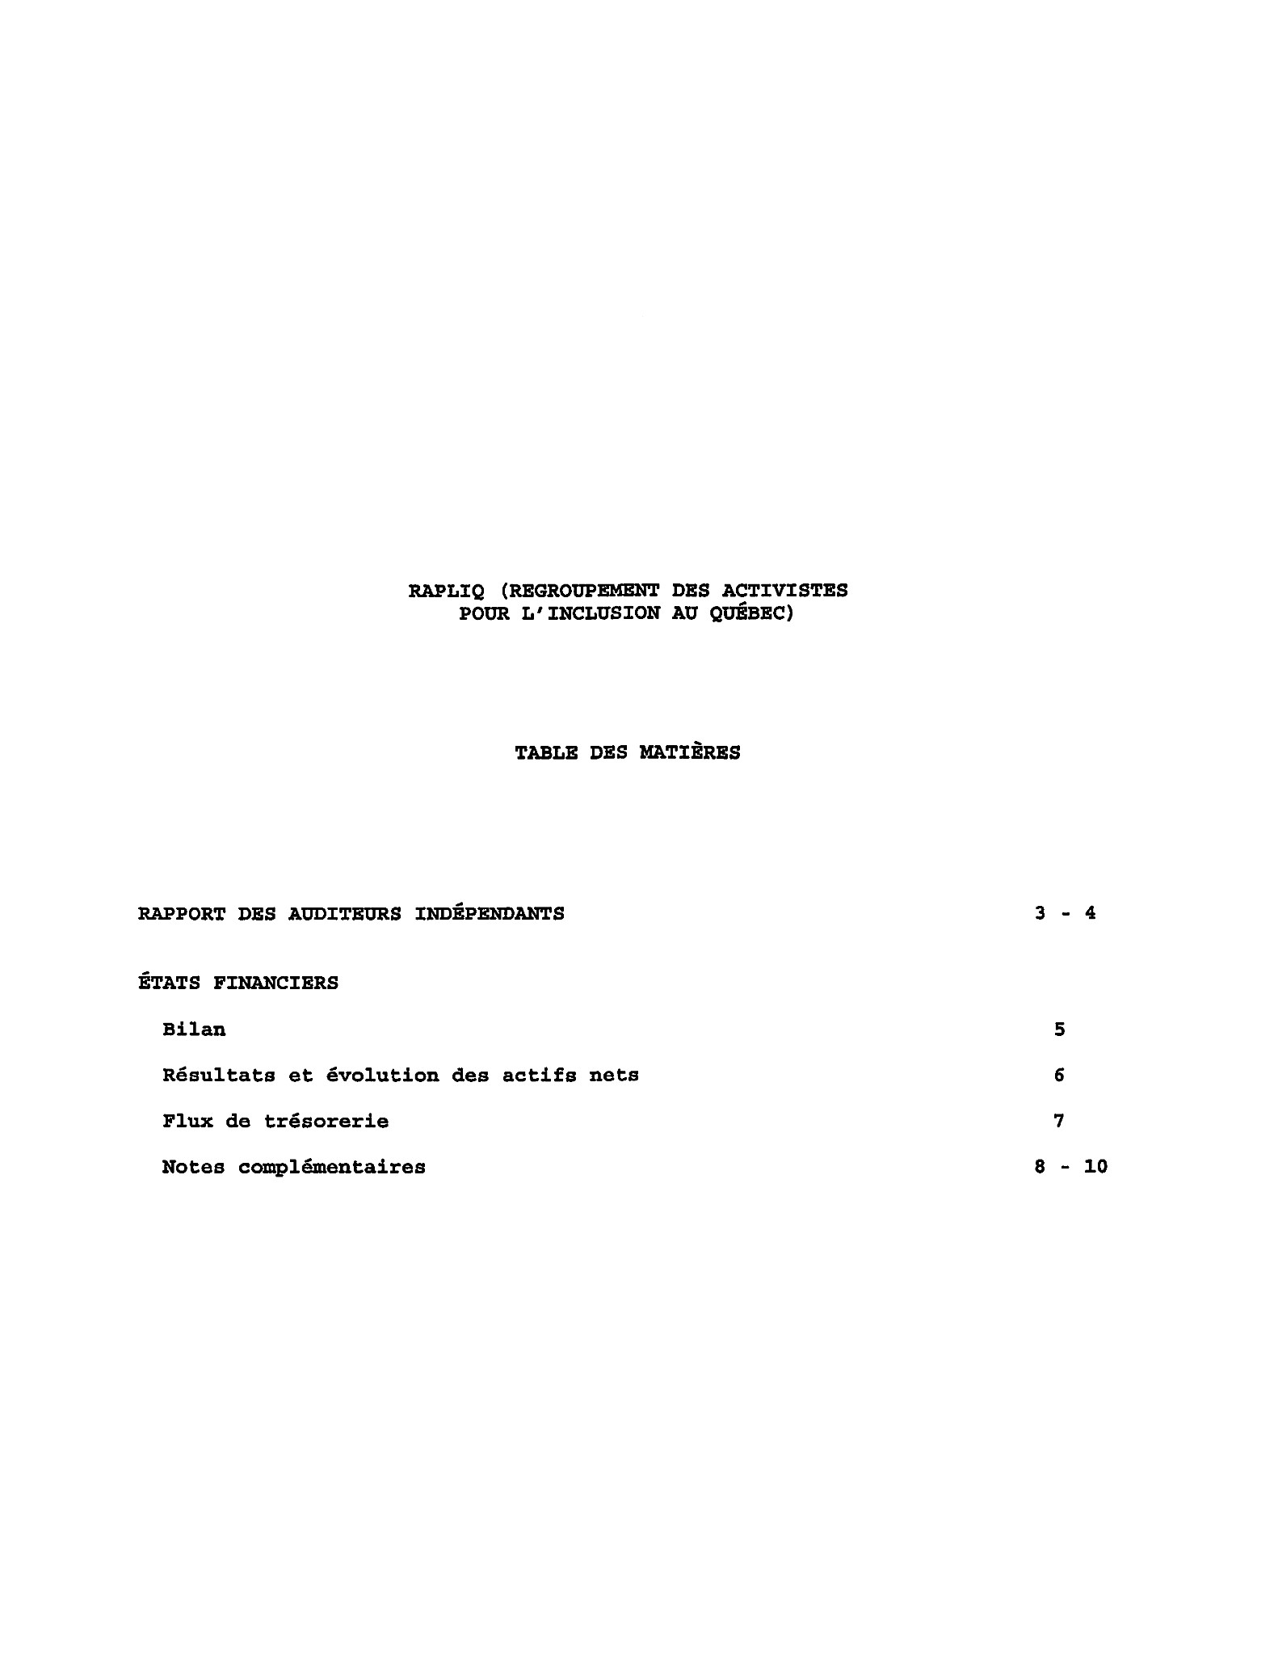
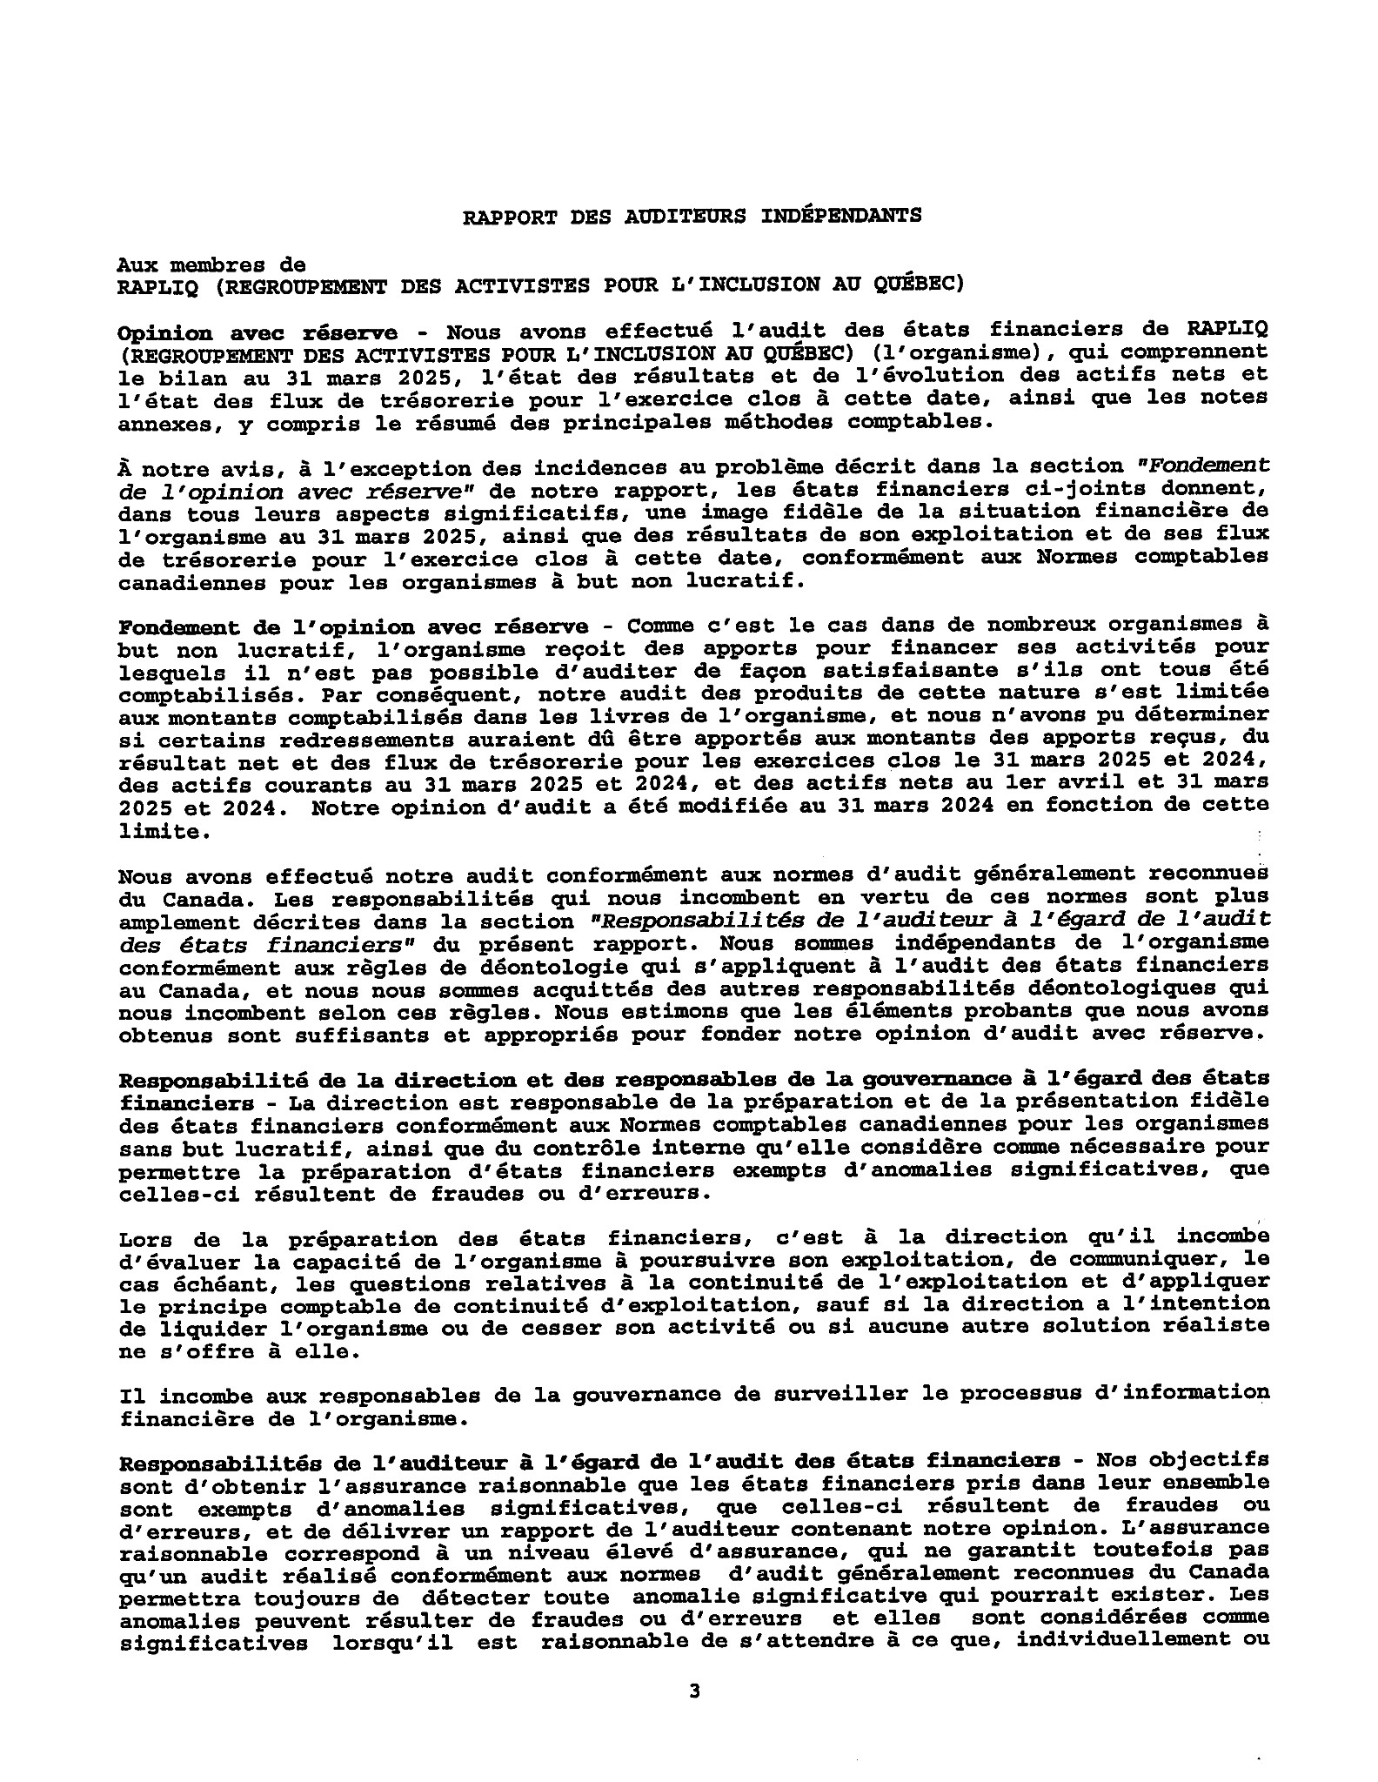

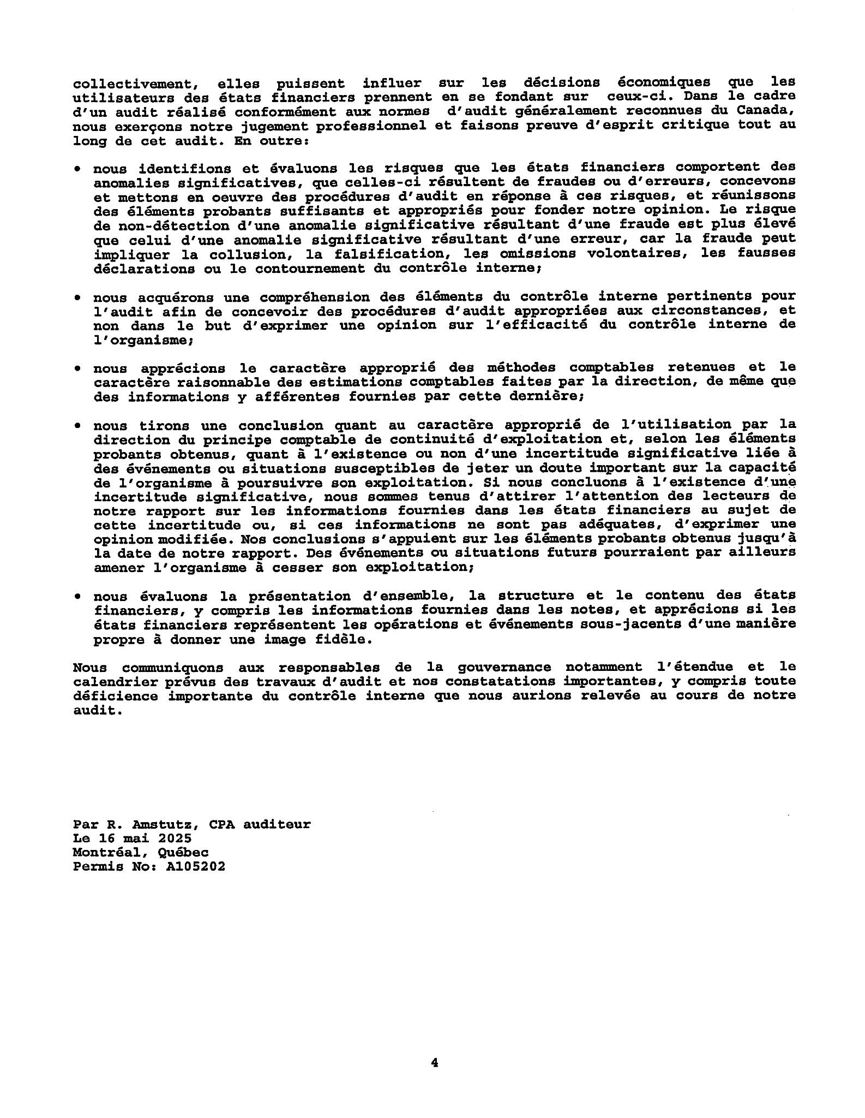

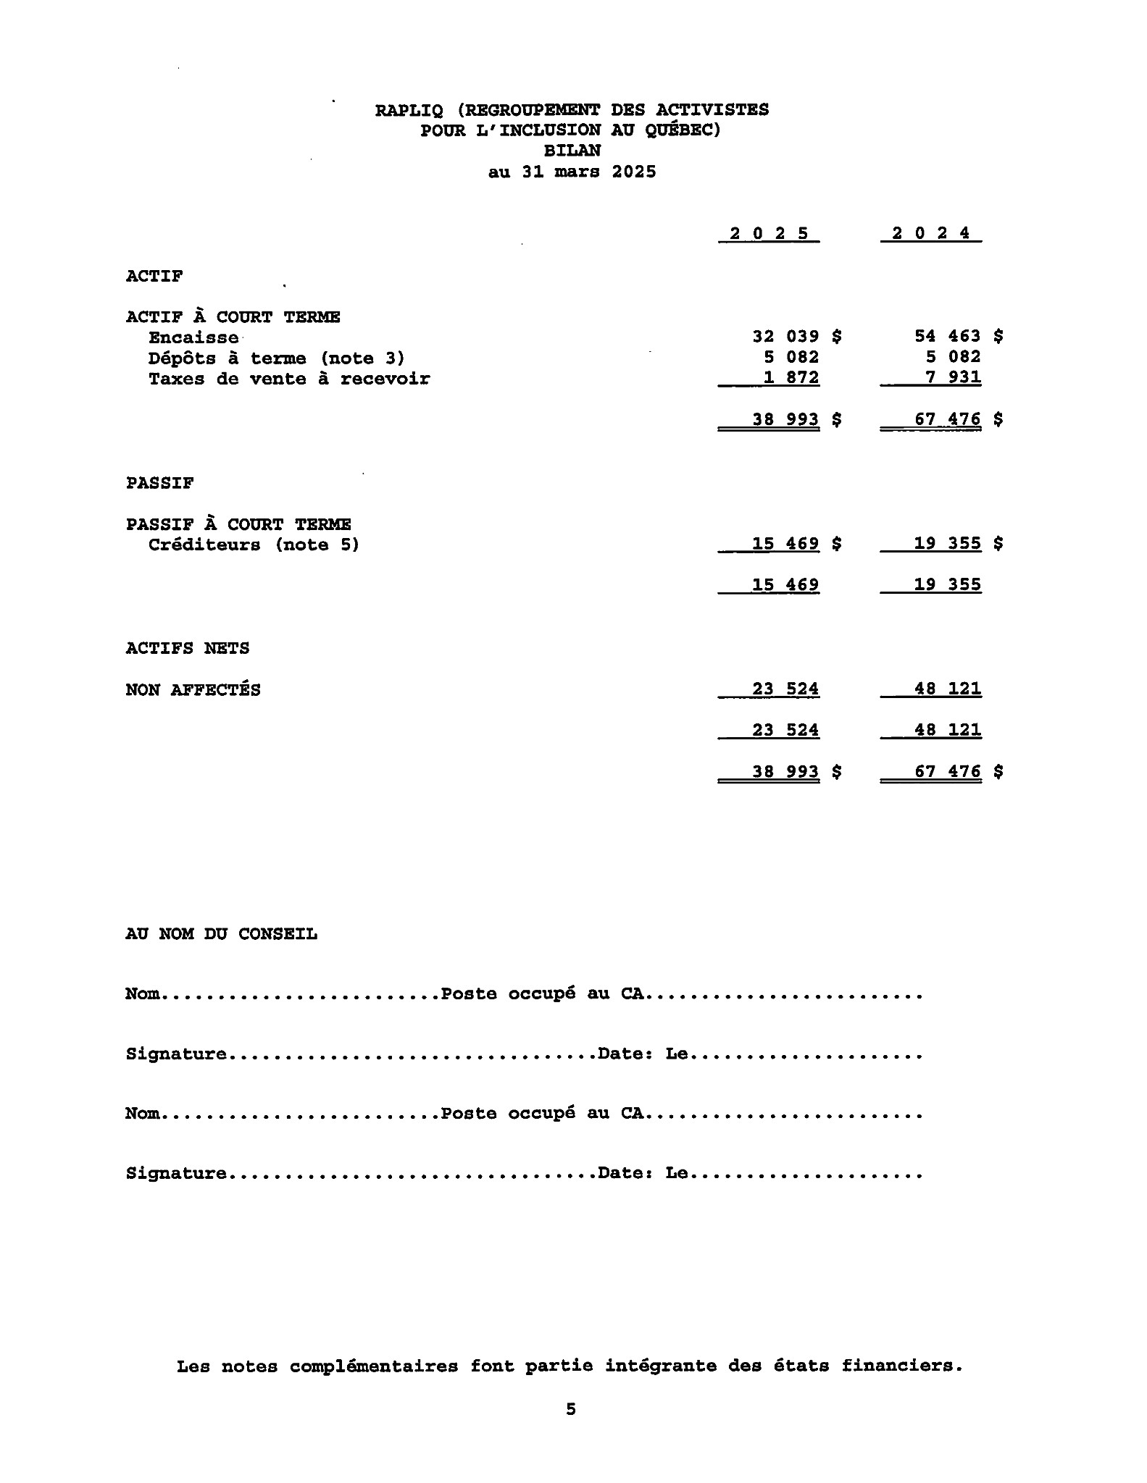
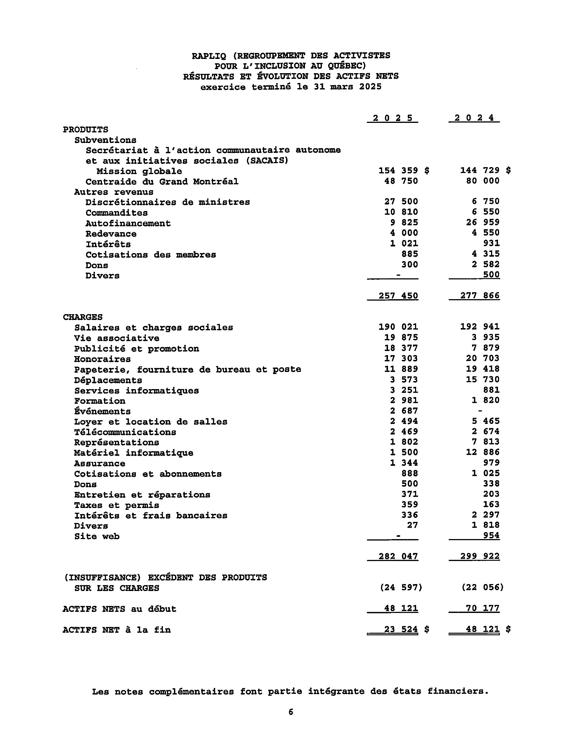

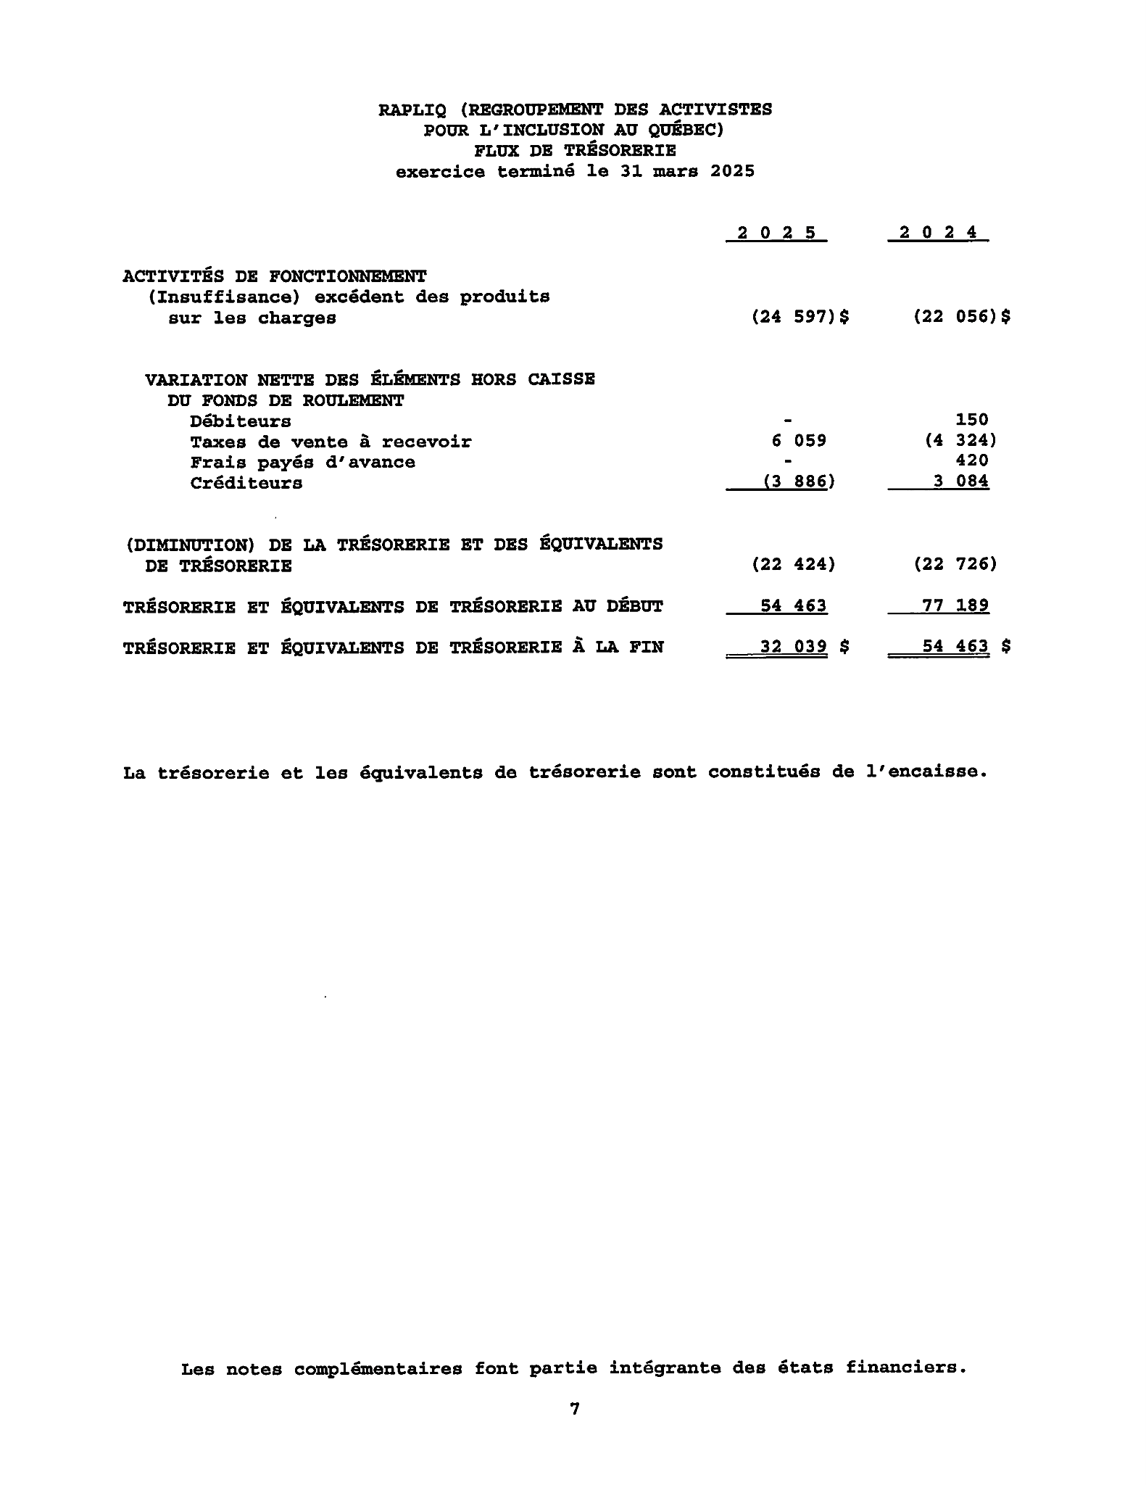

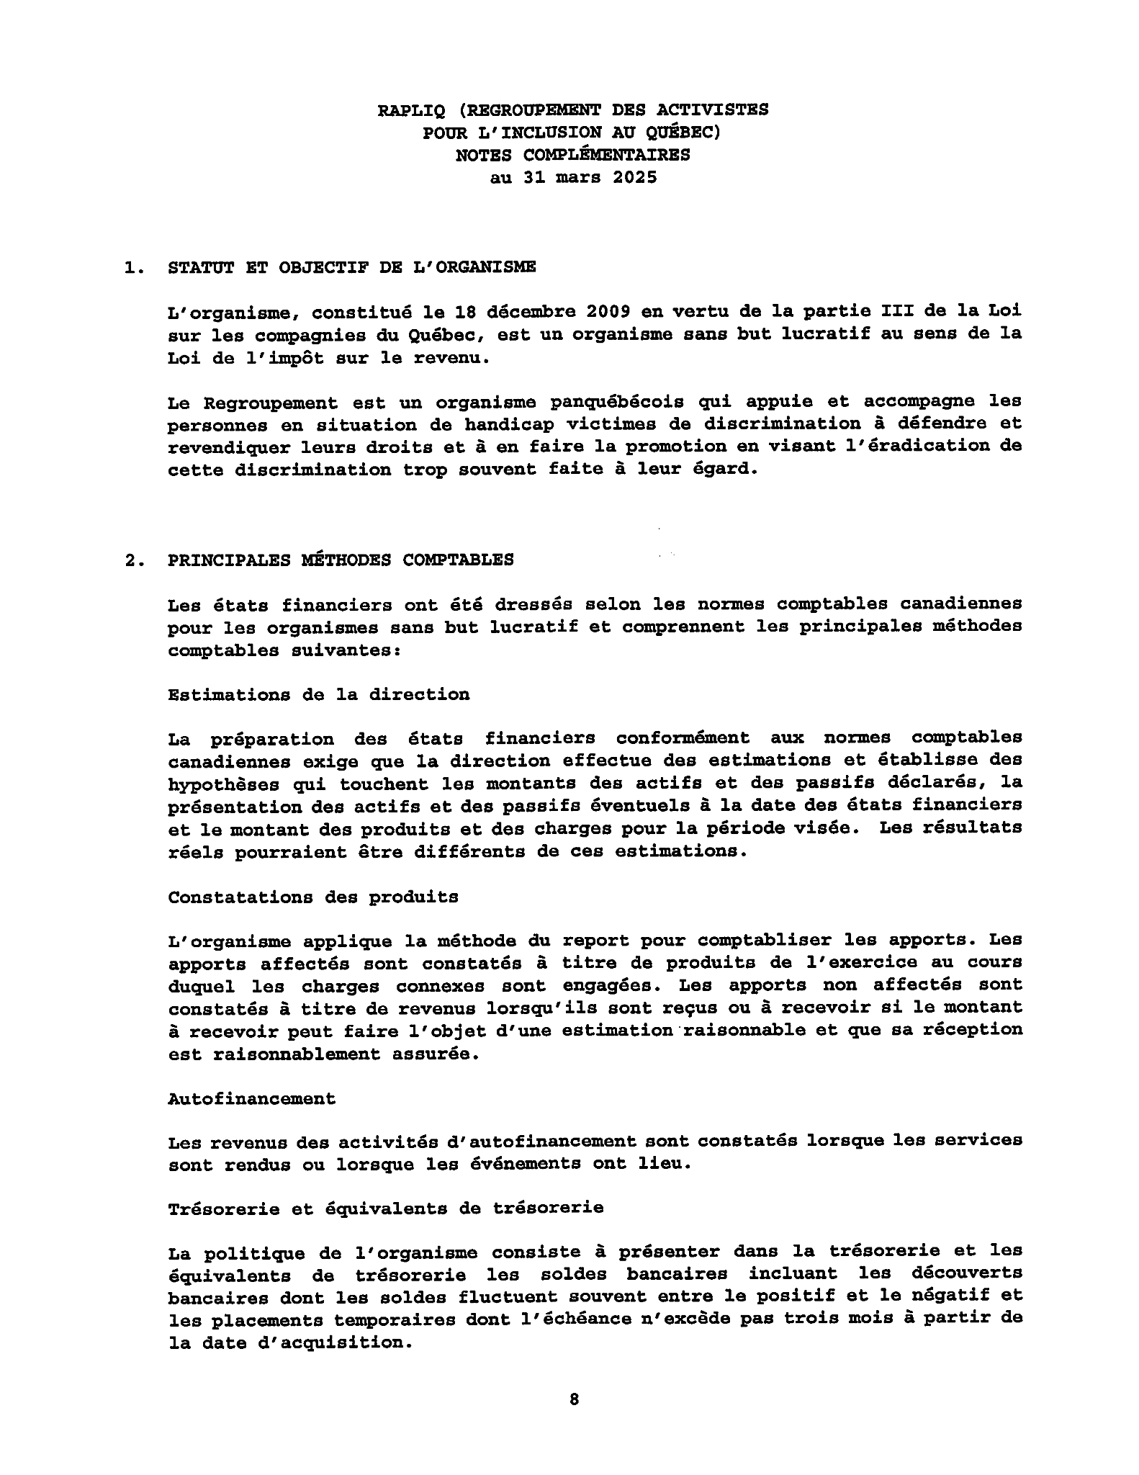
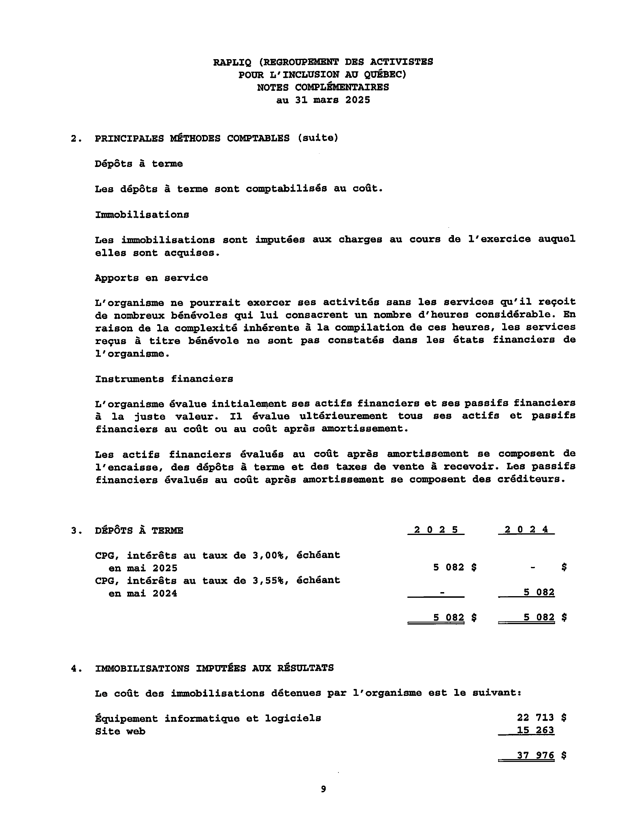
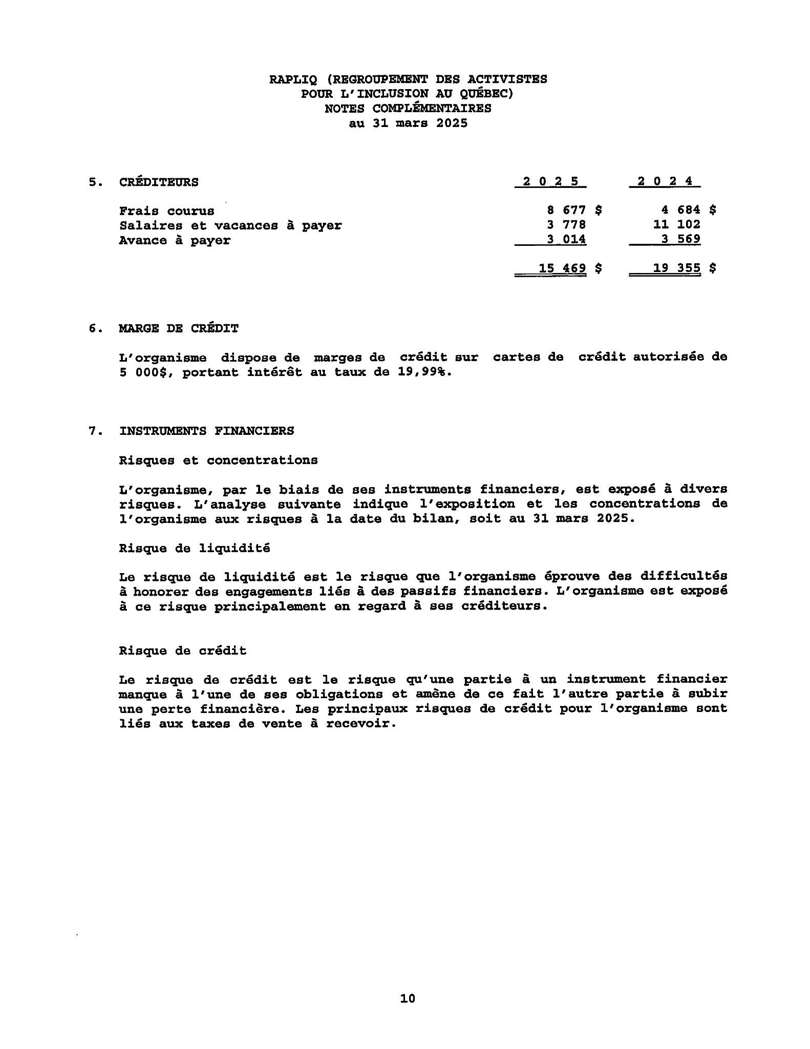

Budget forecasts

Expense items | Forecasts 2025-2026
Grants |  | 223 000,00 $
Royalties |  | 4 000,00 $
Membership fees |  | 1 000,00 $
Discretionary ministers and deputies |  | 8 000,00 $
Dons |  | 500,00 $
Sponsorships |  | 2 000,00 $
Self-financing |  | 10 000,00 $
Interest + other bank returns + Miscellaneous |  | 1 000,00 $
Training, conferences |  | 2 000,00 $
Total revenue |  | $251 500,00
Expenses | Forecasts 2025-2026
Salaries and social security contributions |  | 161 649,50 $
Payroll service fees |  | 1 600,00 $
Courier and Postal Service |  | 3 000,00 $
Office supplies |  | 4 000,00 $
Office and administration expenses |  | 4 000,00 $
Professional fees |  | 12 000,00 $
accounting fees |  | 2 500,00 $
IT costs |  | 1 500,00 $
Site web |  | 1 000,00 $
Media and press releases |  | 0,00 $
Advertising and promotion |  | 5 000,00 $
Interest, bank charges and miscellaneous |  | 450,00 $
Credit card fees |  | 180,00 $
Telecommunications and Internet |  | 3 000,00 $
Assurances |  | 1 350,00 $
Fees and business license |  | 359,00 $
Contributions and subscriptions |  | 900,00 $
Community life and activities |  | 4 000,00 $
Donations (In memoriam and others) |  | 500,00 $
Courtoisies |  | 500,00 $
Training, conferences and activities |  | 3 000,00 $
Travel expenses |  | 10 000,00 $
Representations | 2 000,00 $
Accessibility fees | 0,00 $
Meeting expenses | 0,00 $
IT equipment purchases | 0,00 $
General maintenance and repair | 400,00 $
Advances / employees | 0,00 $
Documentation | 0,00 $
Virtual assistance / Consultant | 15 000,00 $
Total expenses | 237 888,50 $
Excess of income over expenses | 13 611,50 $

RAPLIQ in the media

April 2024
CBC News - Quadriplegic Quebec man chooses assisted dying after 4-day ER stay leaves horrific bedsore
CBC News - STM announces operation to 'reassure' Metro users as safety concerns grow
La Presse - Refusals for women in wheelchairs
CityNews Montreal - Quebec woman in wheelchair battles barriers for access to mammograms
CBC Daybreak Montreal - April 18, 2024: Many clinics in Quebec are refusing to offer mammograms to people who use wheelchairs
CBC News - Wheelchair users turned away from mammogram clinics
QUB - Woman with multiple sclerosis unable to get mammogram
Gènéthique - Canada: euthanized following a bedsore caused during a stay in the emergency room
CBC News - Mammograms are routine. For people who use wheelchairs, they're anything but
June 2024
La Presse - In the REM, an “aberrant” emergency protocol
CBC - Wheelchair user stranded without a ride home after Montreal's REM shuts down
CTV - Laval woman with health condition faces eviction over dog trained to help her function
August 2024
Ici Radio-Canada (15-18) - In search of an efficient adapted taxi service
CBC News - Private adapted taxis pilot project
La Presse - The Rosemont metro terminus remains closed
September 2024
CBC News - At 11, he suffered in palliative care for weeks. His mom says MAID should have been an option
October 2024
La Presse - The bus terminal finally opens
CityNews - Some Montreal terraces face disability discrimination claims
CJAD - Disability rights advocacy group laments lack of acessibility of some Montreal terrasses
CBC - Advocates say inaccessible Montreal terrasses send message that 'nobody wants you there'
November 2024
CBC News - Some seniors outraged over being left out of federal plan to dole out $250 cheques
QUB Radio - The government has underestimated the needs of people with disabilities, deplores the director general of RAPLIQ
December 2024
The Gazette - Disability advocates say Montreal accessibility plan doesn't go far enough
CBC News - Cuts to the Direct Payment Program
CBC News - Health ministry reprimands Santé Québec for going too far in cuts to home-care services
CBC Radio Noon - GST Holiday Tax Break
Journal de Montréal - The Société d'habitation du Québec has exhausted its home adaptation budget "for an indefinite period"
Le Soleil - When the most vulnerable pay the price of political choices
CIEU-FM - Disability rights groups are concerned about the Legault government's recent decisions
January 2025
CBC News - Quebec mom who needs adapted vehicle for son inspires community to raise money to buy one
CBC - Ontario teen works to raise money for new wheelchair van with community cookbook
Radio-Canada 15-18 - Development of accessible toilets in public places
CBC - Why are Montreal’s metro station doors so hard to open?
Journal de Montréal - Snow removal in Montreal: travel more difficult than ever for vulnerable people
February 2025
https://www.lapresse.ca/actualites/grand-montreal/2025-02-06/economies-de-145-mi llions/bientot-la-fin-des-minibus-en-transport-adapte-a-la-stm.php
https://ici.radio-canada.ca/tele/la-facture/site/segments/reportage/1990415/accessibil ite-restaurant-handicap-fauteuil-roulant
https://ici.radio-canada.ca/tele/la-facture/site/segments/reportage/1990415/accessibil ite-restaurant-handicap-fauteuil-roulant
https://www.985fm.ca/audio/678207/neglige-t-on-la-realite-des-personnes-qui-viventen-fauteuil-roulant
https://www.ctvnews.ca/montreal/article/stms-plan-to-turn-paratransit-over-to-privatecompanies-raising-concerns/?fbclid=IwY2xjawIa8ltleHRuA2FlbQIxMAABHfry9xjF51a kfKkZSkPl80tN-4S9CJgxsptDavHcchjM0qDQSQZppaQkVA_aem_tqfNY5Wv9j0WLr pWFyPtfw
https://www.assnat.qc.ca/fr/video-audio/archives-parlementaires/activites-presse/Aud ioVideo-107495.html?support=video
https://montreal.citynews.ca/2025/02/18/montreal-snow-disabled-mobility-challenges
/
https://www.journaldemontreal.com/2025/02/24/je-trouve-ca-difficile-des-montrealaisa-mobilite-reduite-coinces-chez-eux-depuis-neuf-jours-en-raison-de-la-neige Mars 2025
https://www.thesuburban.com/townnews/politics/more-than-5-300-sign-disabilities-petit ion-sponsored-by-prass/article_73e2bbbe-f534-11ef-a131-ebddb72b3494.html
https://www.lapresse.ca/actualites/grand-montreal/2025-03-12/voie-camillien-houde/onest-du-bon-cote-de-l-histoire-affirme-valerie-plante.php

***If you would like to stay up to date with your RAPLIQ's media appearances and articles, you can consult this link at any time: https://linktr.ee/RAPLIQ

