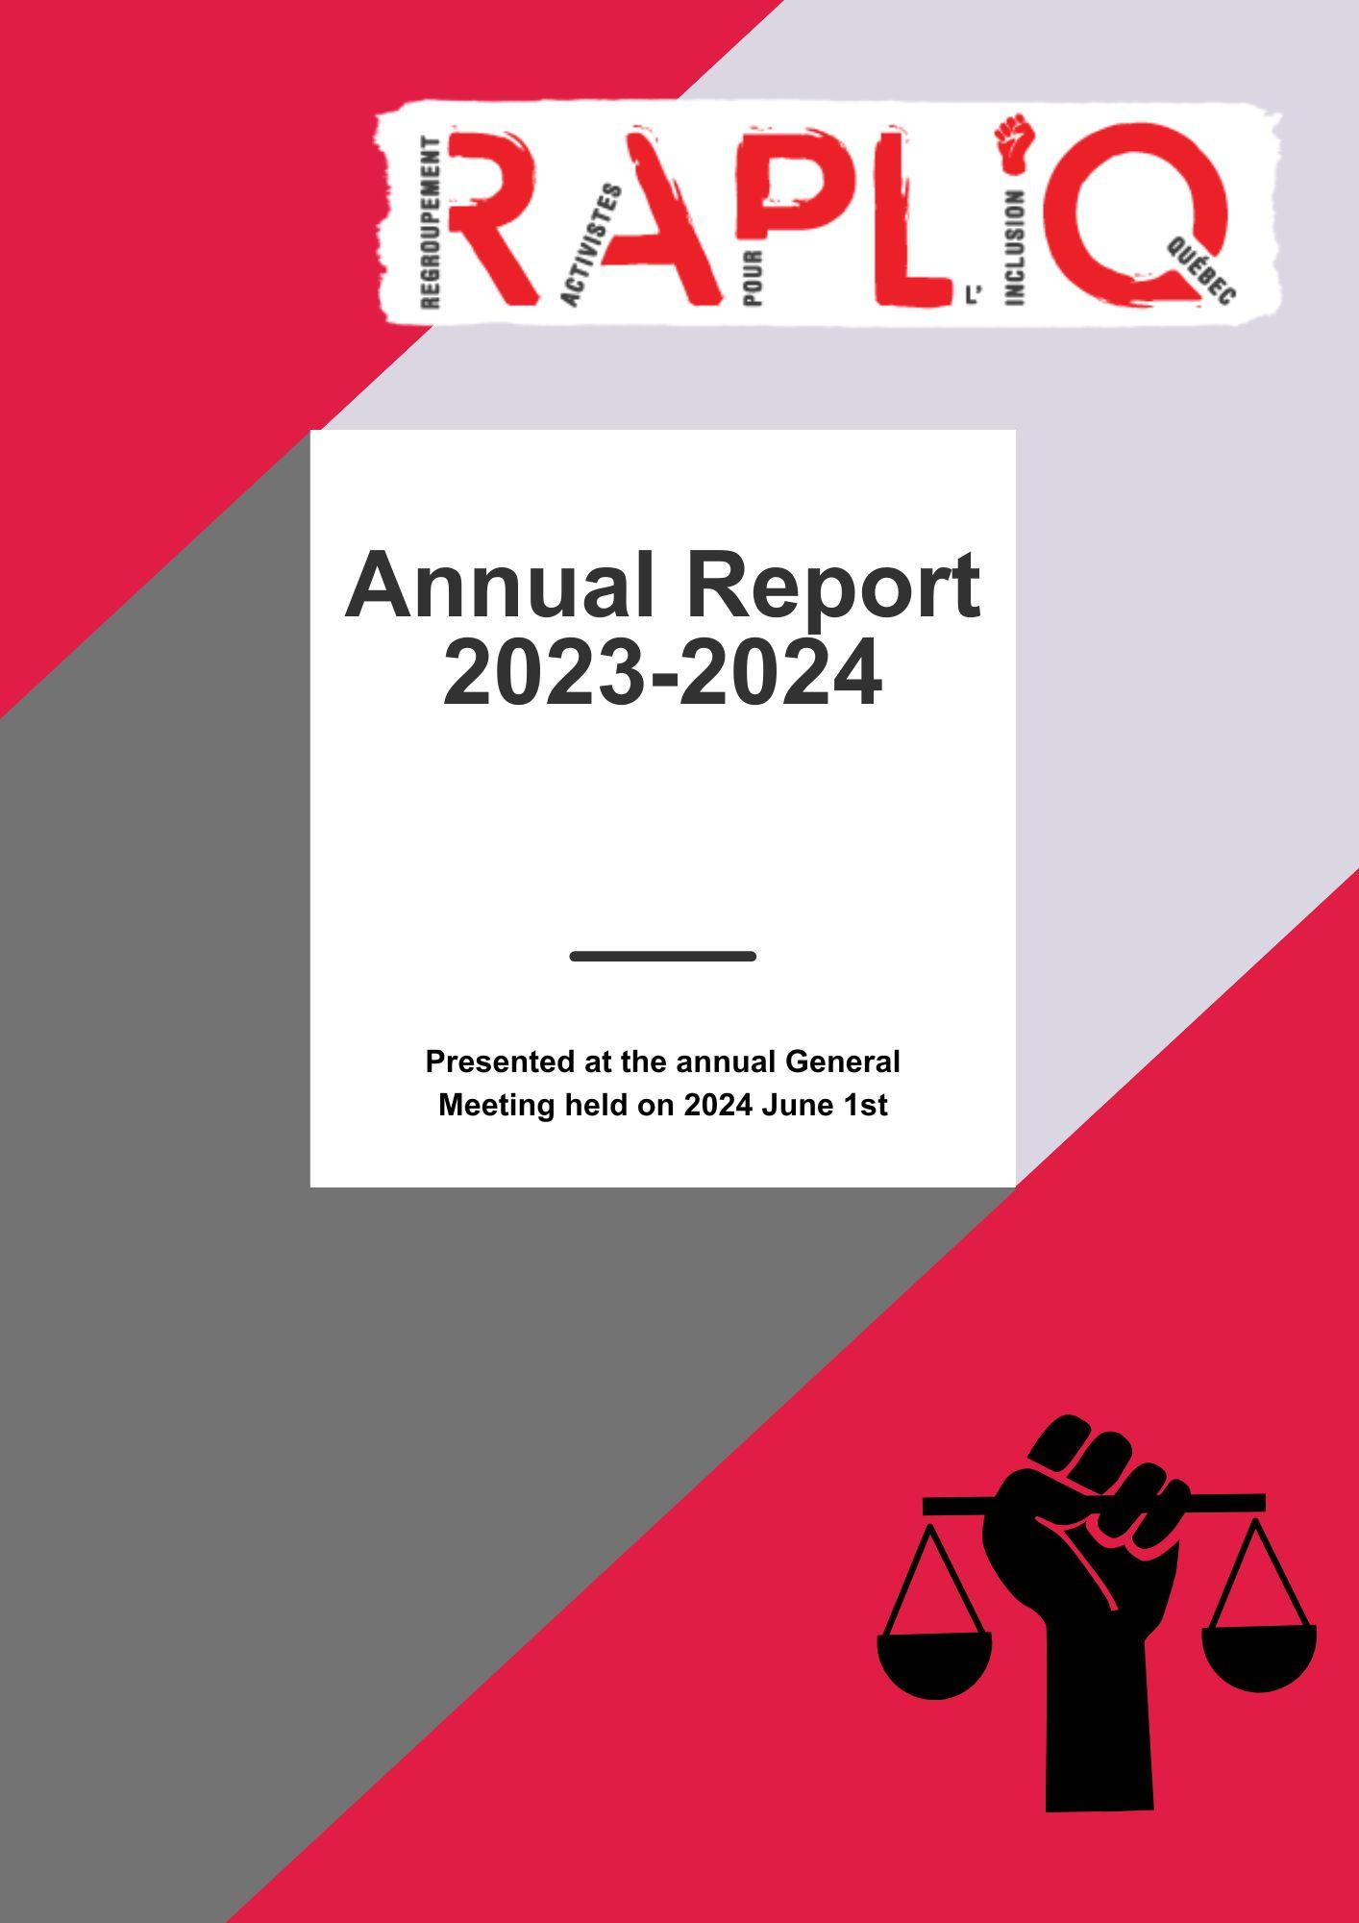

Table des matières
Word from the chairperson 3
Word from General Manager 4
Board of Directors 5
Volunteers 5
Special Thanks 5
Members 6
Democratic operation 7
Ongoing complaints 7
In Memoriam 8
Honorific Mentions 8
Main files 8
Disabled Women Victims of Domestic Violence (DWVDV) 8
Terraces 10
Follow-up on the class action 10
Disabled People and Employment Discrimination 11
Mammography Clinics 11
REM Evaluation 12
RISBOD ((Intersectoral Network for Sustainable Oral and Bone Health Research) 12
RBQ 13
Promotion of Rights and Debates 13
Handicast 14
Sexual Assistance 14
Accessibility Dictation 14
Continuous Formation 14
Diverse Matters 15
Acknowledgment 15
Specific files 16
Medical Aid in Dying (MAID) 16
Quebec Pension Plan 17
Municipal, Provincial, and International Democratic Life 17
Human Rights and Youth Rights Commission (CDPDJ) 17
Employment Equity Program (PAÉE) 17
Concertation Table 18
TGFM 18
High-Level Political Forum — New York — Sustainable Development Goals 2030 18
Centraide 19
Strategic Planning 20
Financial Statements 23
Budget Projections 33
Our Meetings 35
RAPLIQ in the medias 43

Word from the chairperson


As the Chairperson, I would like to express to you with immense pride that RAPLIQ presents to you its achievements, ongoing projects, and future endeavours.

Your RAPLIQ, celebrating its fifteenth year of existence on December 18th, has seen remarkable accomplishments under the guidance of its co-founder Linda Gauthier, the principal consultant, and the General Manager Steven Laperrière.

I must not overlook our Deputy Director, Brigitte Nadon, who works tirelessly behind the scenes, always there to organize numerous meetings, along with the dedicated administrators of the Board of Directors who contribute professionally and passionately.

RAPLIQ would not have become the resilient and steadfast adolescent it is without the dedication of our volunteers, who have always been of great assistance. Our heartfelt gratitude also goes to caregivers, caregivers' families, and of course, immediate family members.

Without you, members and friends of RAPLIQ, who support and assist us in our mission, we would not have come this far or achieved such progress.

For all individuals living with disabilities, it has been hours of work, exploration, consultations, discussions, and nurturing to find solutions, provide support, better care, attentive and productive listening regarding the daily challenges, which bring immense satisfaction but unfortunately often come with their share of frustrations.

I now leave you to enjoy discovering this activity report and wish us all a fantastic
FIFTEENTH ANNIVERSARY !

Francine Leduc, chairperson

Word from General Manager

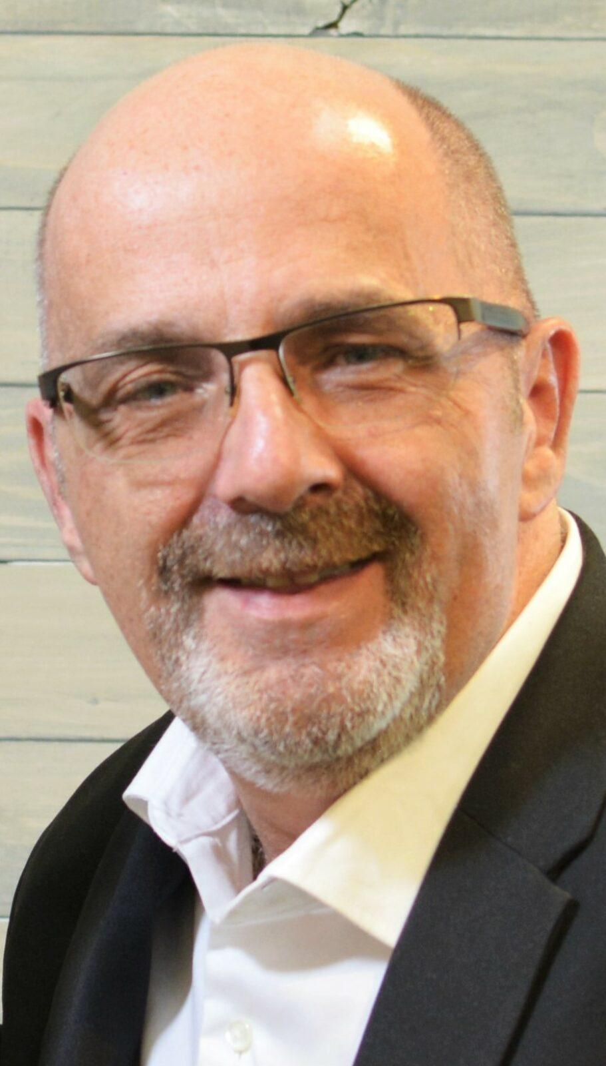
Another fulfilling year for RAPLIQ.

The hearings regarding the class action lawsuit were a highlight of our past year. As public transit, in general, faces a financial crisis already impacting accessible transportation services, we eagerly await the judgment that, hopefully, will not only bring advancements in accessible transportation but also open doors in other areas of the daily lives of people with disabilities.

We are extremely pleased with the government's decision to end the unfair penalty that was reducing retired individuals with disabilities' incomes by 24%. We take pride in contributing to changing and improving their situation.

We've noticed an increase in discussions about universal accessibility on social media. While this is positive, it's crucial to translate these discussions into concrete actions to achieve tangible results. Challenges remain abundant, particularly for disabled women who are victims of domestic violence seeking accessible shelter to escape their toxic environments, the fight against climate change, and your place in discussions and decisions.

I am deeply concerned about the evolution of medical assistance in dying. Initially designed to offer a dignified end of life, it seems increasingly to become an alternative due to the lack of home care and services. How many individuals, who chose this option by default due to inadequate care, would still be with us if they had access to services allowing them to live with dignity and lead a happy, productive life? The alarming increase in requests warrants thoughtful reflection and concerns me on a daily basis.

Throughout this report, you will discover the various topics, meetings, and media coverage that marked our year. I am particularly proud of our strategic plan for the next four years, developed with the active collaboration of several members during two planning sessions.

I want to express my sincerest thanks to our team — Francine, Linda, and Brigitte — as well as every member of our Board of Directors. Your support, especially during this sometimes challenging year for me personally, has been invaluable. Solidarity at RAPLIQ is not just an empty phrase tossed around; you have vividly demonstrated it to me. Thank you all!

Onwards to 2024!

Board of Directors

As of March 31, 2024, the Board of Directors consisted of:

- Francine Leduc, Chairperson;
- Christophe Bedos, Vice-Chairperson;
- Laurent Morissette, Treasurer;
- Sylvain Plourde, Secretary;
- Linda Gauthier, Administrator ;
- Anne-Marie L’écuyer, Administrator;
- Jacques Bisson, Administrator;
- Serge Bélisle, Administrator;
- Michel Pigeon, Administrator;
- Amélie Allard, Administrator;
- Emmanuelle Champagne, Administrator.

Volunteers

- Martine Lévesque and her entire team ;
- Renée Caron ;
- Marie-Hélène Tanguay ;
- Christian Vaillant ;
- Yves Plourde ;
- Lise Gervais ;
- Michel Bédard.

Special Thanks

- Louise Harel ;
- Miloud El Berrhama;
- Line Bergeron ;
- Martin Dion ;
- Yvonne Nelson;
- Jackie Morissette;
- Yannick De Grave ;
- Séverine De Sensi ;
- Fondation famille Brian Bronfman ;
- Michelle Turenne ;
- ACTAQ (Association des chauffeurs de taxi accessibles du Québec);
- RAAMM (Regroupement des aveugles et amblyopes du Montréal métropolitain);
- Simon Wong ;
- Olivier Collomb-D’Eyrames ;
- Véronique Vézina
- Raymonde Filion-Girard
- Josée-Anne Couture, Stephanie Toussaint, Maude Gauthier, Lilou Oléane Babin-Turcotte and Kim Berthiaume, social work interns at UQAM.

Members

RAPLIQ relies on the support of 200 individual members and twelve (12) collective members:

- RAAMM
- Fondation CNIB INCA
- Chez Stella
- ACTAQ
- RUTAC-MRC-RDN
- Main Forte Montréal Inc.
- Amalgame
- Vie Autonome Montréal
- Mouvement Citoyen Handicap Québec
- PIMO
- ROP-03
- Maison des femmes sourdes de Montréal

Thank you all.
You allow us to be at our best, and together, we truly are agents of change.

Democratic operation

The annual general meeting took place on June 3, 2023. 27 members participated.

The Board of Directors held six regular meetings in the past year, on May 11, July 13, September 14, and November 9, 2023, and on January 11 and March 14, 2024.

The Board of Directors held five extraordinary meetings on June 17 and October 30, 2023, and January 11, February 16, and March 19, 2024.

Ongoing complaints


When an individual approaches us for assistance with their complaint, we draft it formally and submit it on behalf of the victim to the authorized body responsible for handling the dispute.

As of March 31, 2024, RAPLIQ was mandated in 23 complaints, with 13 distributed as follows:

- Two to the Small Claims Court;
- Three to the Human Rights Tribunal;
- Eight to the Human Rights and Youth Rights Commission.

Ten complaints are awaiting assignment, either for mediation or for internal investigation. All have been deemed admissible.

Unfortunately, as of this date, we were facing a backlog of 47 complaints of all kinds of discrimination based on disability, as well as 83 complaints strictly related to the accessibility of terraces and/or their furniture.

Since its founding, your RAPLIQ has handled 936 complaints, not counting the 138 pending complaints.

Currently, two of RAPLIQ's officers (Linda Gauthier and Steven Laperrière) provide assistance and support to complainants.

In Memoriam

« In sweet memory of » :

Aube Savard
Luc Forget
Normand Meunier
Daniel Pilote
Mme Louise Bourque-Laperrière

Honorific Mentions

The names of the individuals will be announced during the annual general assembly on June 1, 2024.

Main files

Disabled Women Victims of Domestic Violence (DWVDV)


As incredible as it may seem, in a matter as crucial as significantly increasing access to first and second-stage shelters for disabled women victims of domestic violence, obstacles abound.

Converting an unsuitable house into an adapted one can sometimes be impossible and extremely costly. We understand this and are grateful to all those houses that have dedicated efforts and resources to improve the accessibility of their premises.

However, it is outrageous to observe that, on a regular basis, new constructions of inaccessible first or second-stage houses emerge all over Quebec. Under the pretext that having one or two larger rooms to accommodate a woman (or child) in a wheelchair takes up too much space and makes a "regular" room have to be subtracted, because it costs more to implement the necessary adaptations, the construction cost "per door" increases, and the choice is made to sacrifice accessibility.

This effectively means that in our society, everything has a cost, a value, and thus disabled women are deemed to have less value than "non-disabled" women. This is the shocking realization we have faced and against which we do not falter.

Some merely manage the situation through surveys, through singular questionnaires sent by email to their member houses. This is futile because to assess accessibility fairly, unless there is a person with the most limiting disability in their immediate circle, if it is a motor disability, you need to know how they navigate such spaces and environments if they are blind. If the person is visually impaired, it's another matter, because at that point, and this is also very important, you need to assess the lighting (lux) and if stroboscopic lighting is available in case of an alarm for deaf or hard-of-hearing people. We have observed during our visits that several houses defining themselves as accessible are not really or, at best, partially accessible. It's not because the managers of these houses don't care about universal accessibility, but because it's not explained. It's not through surveys that this is learned.

On November 4, 2023, an important article entitled "Intimate Partner Violence and Disability: Addressing Systemic Barriers" was published in the prestigious publication "Georgetown Journal of International Affairs," authored by Yolanda Muñoz, Martine Lévesque, Laurence Roy, Lisandre Labrecque-Lebeau, and Linda Gauthier. (Read the article here)

A second article, published in the CREMIS journal, in which the work of the research group, including RAPLIQ, is highlighted, addresses the trajectories of leaving domestic violence for disabled women by analyzing structural barriers and occupational needs. (Read the article here)

An awareness-raising capsule was developed in collaboration with Lévesque MC, Bergeron L, Tremblay A, Meng J, Gauthier L, Théberge É., "Police Officers' Use of a Quebec Sign Language (LSQ) Interpreter When Responding to a Deaf Woman Victim of Domestic Violence, a Matter of Access Equity to Services". This 15-minute capsule was co-developed as part of a partnership research project (SSHRC, 2022-2023), conducted with the Maison des femmes sourdes de Montréal, the Montreal Police Service (SPVM), and the Regroupement des activistes pour l’inclusion au Québec (RAPLIQ) and was produced with the help of Étienne Théberge, a film student at the University of Montreal. It is intended for the initial and ongoing training of police forces in Quebec. (See the video here)

These publications and initiatives demonstrate the effectiveness of collaborative efforts and RAPLIQ's leadership, supported by recognized experts in their field. These efforts have generated new literature and evidence, hitherto insufficient, to support our claims. Thanks to this information, it is now possible to underline the crucial importance of systematically taking into account the needs of disabled women victims of domestic violence. This includes integrating these women into universally adapted refuge houses and providing them with adequate equipment to ensure a continuum of care, a service basket from CLSC that follows disabled women, thus ensuring their safety and well-being, regardless of their refuge location to escape violence.

The main objective of our initiative is to ensure that disabled women facing emergency situations receive accommodation and support tailored to their particular needs. Through our awareness-raising and evaluation campaigns, we aim to continuously strengthen housing services and promote an inclusive environment for all women victims of domestic violence. However, we have encountered challenges, particularly with the CLSC "service basket" system, which does not always guarantee the necessary follow-up in emergency housing situations, especially when the women involved move between regions. It is imperative to find solutions to these problems. If this challenge remains unresolved, our commitment to improving the conditions of disabled women persists, and your ongoing support is crucial for the success of these efforts and for generating a lasting positive impact.

Terraces
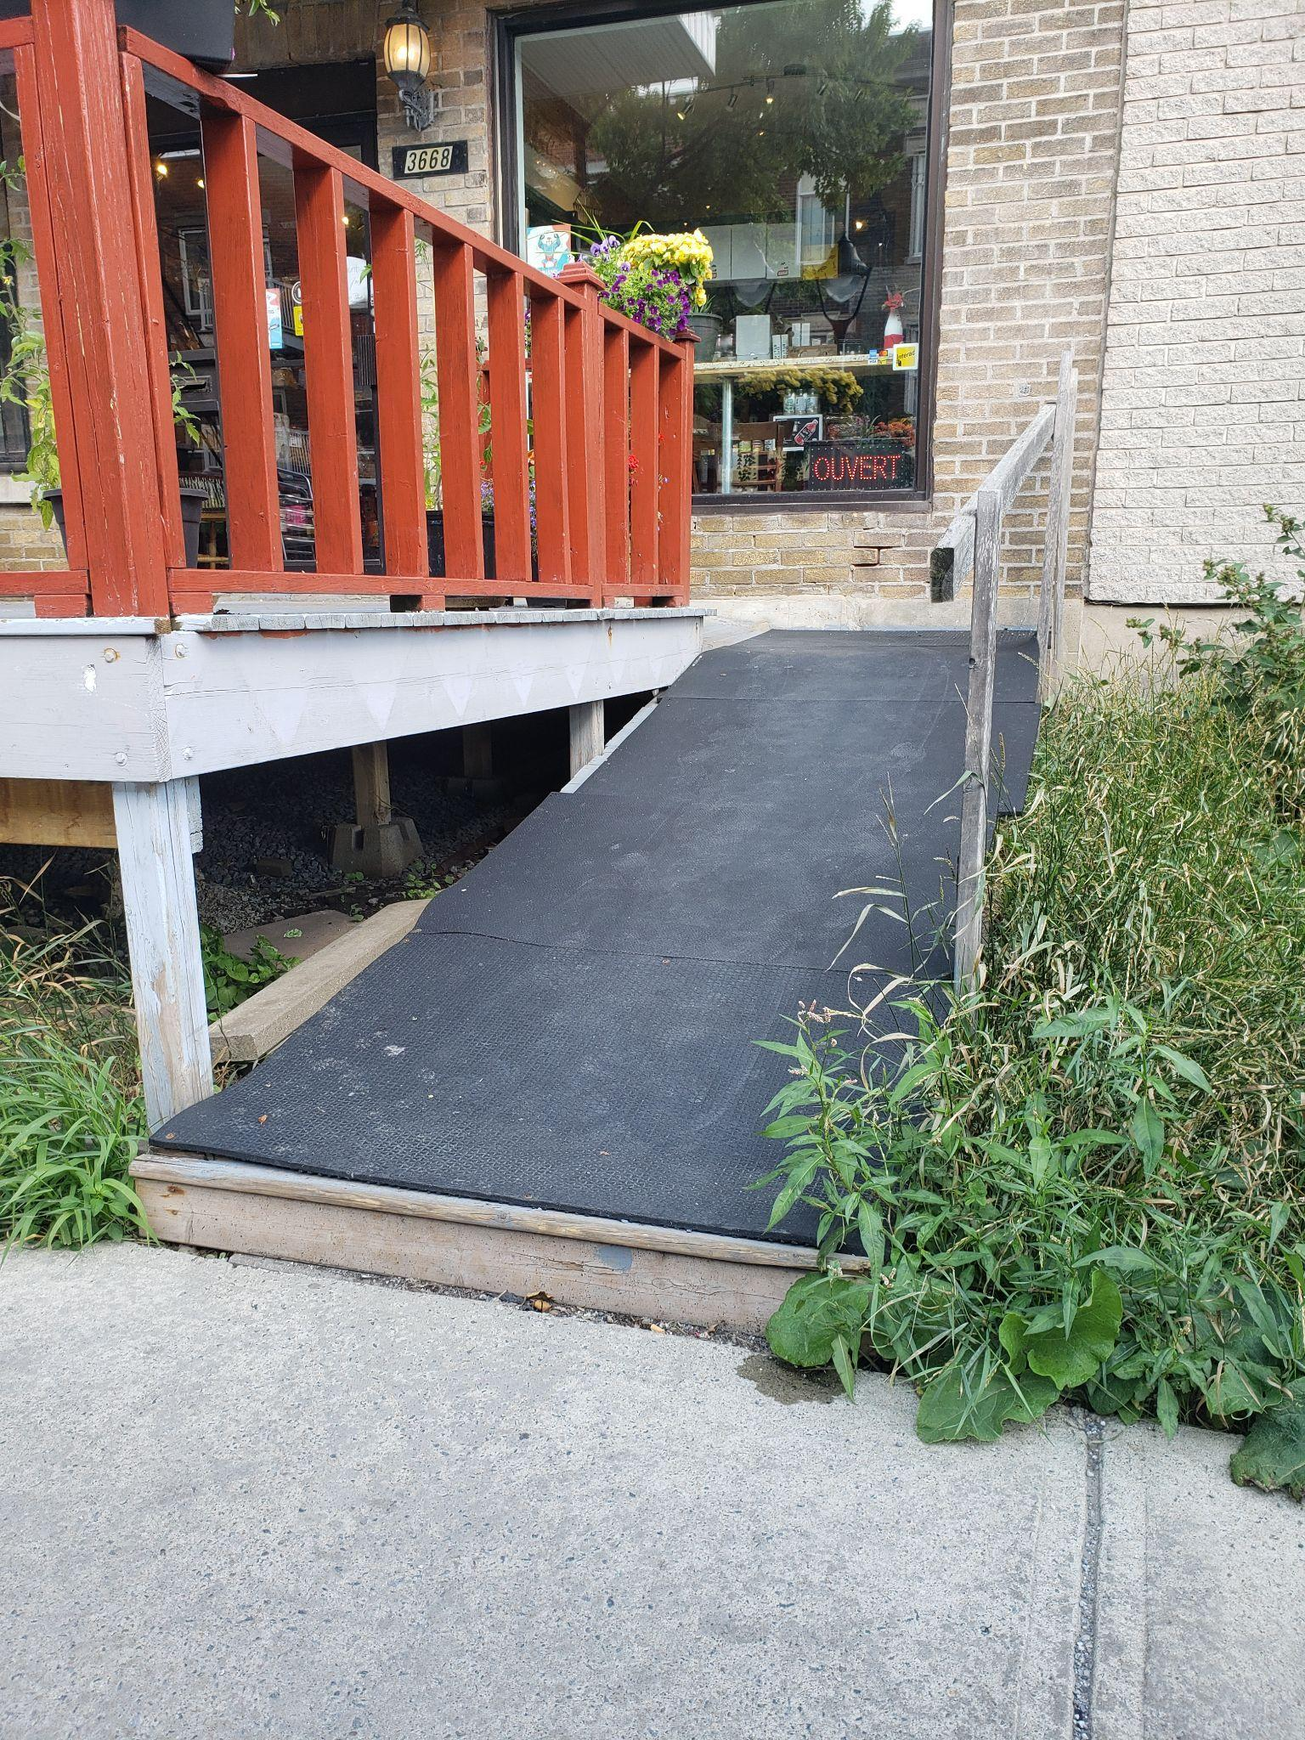
One of our top priorities is the accessibility of commercial and public establishments, as well as terraces. We advocate for urban architecture that promotes smooth and secure circulation for all individuals with disabilities.

As in the past two years, Martin Dion conducted a tour of summer terraces located in the following boroughs: Ville-Marie, Plateau Mont-Royal, Rosemont-La Petite Patrie, Mercier–Hochelaga-Maisonneuve, Verdun, and Sud-Ouest. Once again this year, over 200 terraces were either inaccessible or their furniture was not accessible.

As a reminder, in December 2022, a memorandum on the accessibility of terraces in Montreal was presented to the Montreal Ombudsman. This memorandum was also sent to the management of all boroughs. You can download it here: RAPLIQ Memorandum on the Accessibility of Summer Terraces in Montreal.

Follow-up on the class action

Between October 10 and December 20, 2023, the Quebec Superior Court held thirty-three days of hearings regarding the class action filed on April 14, 2015.

These hearings, held before the Honourable Judge Céline Legendre, were an emotional rollercoaster for all of us, including our members who came out in large numbers to support our claims.

We warmly thank each of the witnesses for generously sharing their often emotional stories of discrimination they have faced.

The individuals who testified: Linda Gauthier, Laurent Morissette, Martin Dion, Steven Laperrière, Didier Chelin, Serge Bélisle, Manon Brière, Francine Leduc, Nathalie Tellier, David Demers, Nabila Nouara, Yves-Marie Lefebvre.

We also wish to express our profound gratitude to our team of lawyers who went above and beyond the call of duty with all the respect and sensitivity required. Me Aymar Missakila, Me Justin Wee, Me Gilles Gareau, Me Audrey Labrecque, and Me Alain Arsenault, thank you for your tenacity, determination, and dedication to ending the discrimination of inaccessibility to public transportation.

Indeed, you have already contributed to this cause. As evidence, the increasing number of accessible stations and ongoing works to increase this number. It is worth remembering that before the class action was filed, the Société de transport de Montréal (STM) was planning something like 1.2 metro stations per year, resulting in the entire metro system being made accessible only by 2085, if at all. The growing number of accessible stations, 27 to date, is in itself a victory.

RAPLIQ asserts itself as a leader in the field of accessible and public transportation, achieving unprecedented progress. Through the class action, significant pressure was exerted on the STM, resulting in a notable increase in the number of accessible stations. You can be proud of your RAPLIQ.

Disabled People and Employment Discrimination

On multiple occasions over the past several months, we have made a request to the Commission des droits de la personne et des droits de la jeunesse (CDPDJ) to undertake an in-depth study on the issue of employment discrimination, integration, and retention. Our request was similar to the one they had previously conducted on race-based discrimination in hiring, integration, and retention in employment. The CDPDJ has thus made the decision to address this crucial social issue for people with disabilities.

We have actively contributed to this study by recommending individuals with various strong limitations and different experiences (positive or negative) in the job market or job search to be part of this investigation. We are now awaiting the results of this extensive survey, which are expected to be published by the end of 2024.

Mammography Clinics

In December, we began our fourth study on the accessibility of mammography exams for disabled women. As the study concluded in April, we will provide more in-depth information in the 2024-2025 activity report. However, we can tell you that while the results have slightly improved, the proportion of government-designated clinics refusing these exams to disabled women is still unacceptably high, at around 45%. The media has picked up on this story, leading to high-level political meetings to improve access and put an end, once and for all, to this discrimination against disabled women. Stay tuned.

REM Evaluation
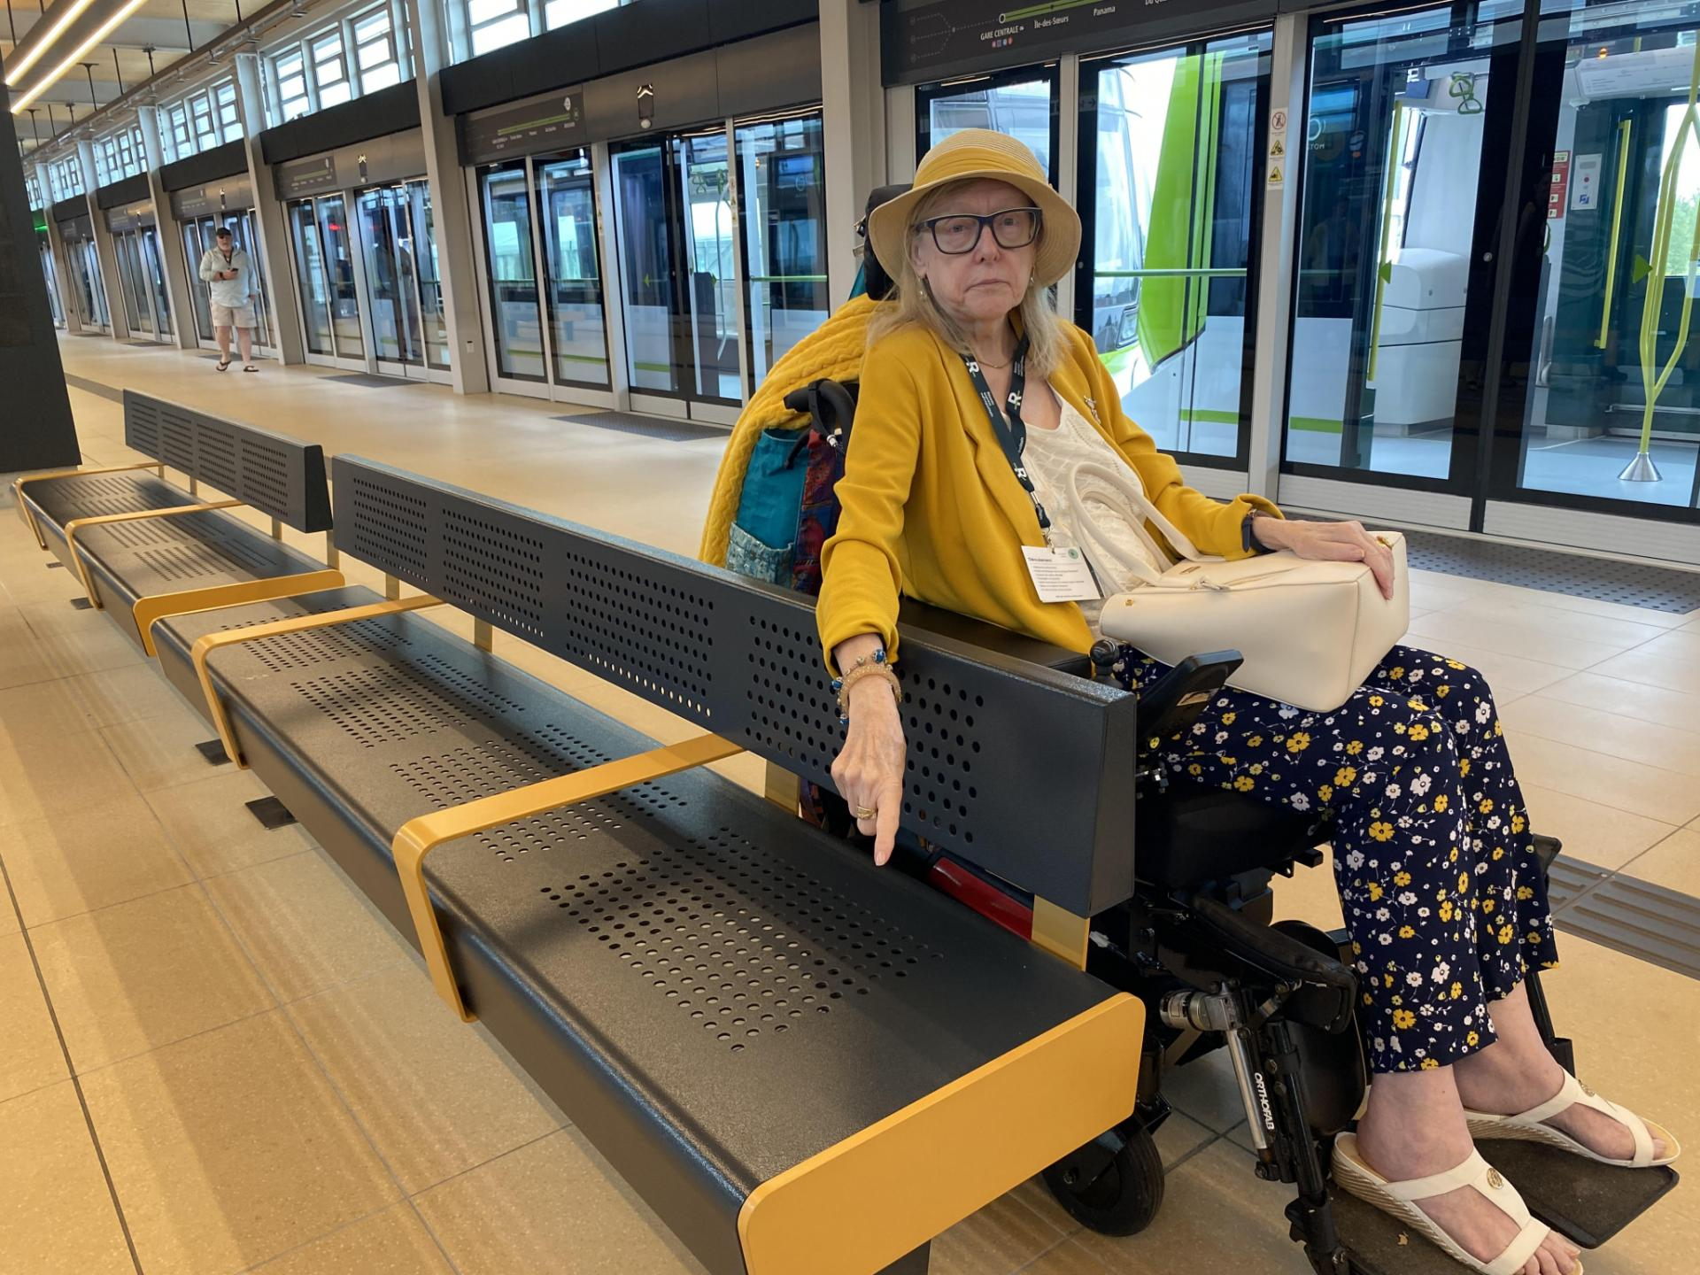
The REM has been a constant concern for your RAPLIQ and also among you, members and users, of what was heralded as the eighth wonder of the world in terms of universal accessibility.

We all remember the long-term elevator outages from the official public opening, the random breakdowns that often left no choice but to turn back, go home, or find an alternative way to travel when possible.

In last year's report, we included the list of recommendations we had made following the visit to the terminus and the Panama station in Brossard (see the report here). Unfortunately, most of our recommendations, as well as those of our colleagues from other organizations, were not taken into account.

It is fair to set the record straight. When asked by a journalist about the lack of accessibility at the terminus, a REM representative claimed that the advocacy community had been consulted and agreed with the current situation, without mentioning, of course, that REM managers had not taken into account the significant observations and suggestions from your RAPLIQ and colleagues from other organizations.

RAPLIQ has never given its approval without recommendations being respected and implemented. Let's be very clear about that. In fact, some organizations may withdraw from the working group.

We have chosen to show leadership and remain present and active at the REM advisory table for the time being, but our patience is not infinite.

RISBOD ((Intersectoral Network for Sustainable Oral and Bone Health Research)

Under the leadership of Dr. Christophe Bedos, a trained dentist, professor in dentistry, oral and bone medicine, and dedicated researcher at McGill University, the RISBOD program addresses the concerns of thousands of disabled individuals excluded from the dental healthcare system, who are calling for an inclusive Quebec.

Denying disabled individuals access to care is unjust and contrary to the fundamental principles of the Charter of Rights and Freedoms. This situation also constitutes a public health problem: deprived of the care we need, our overall health is compromised.

RAPLIQ wishes to contribute to the governance of RISBOD by getting involved in the bodies that RISBOD has established. We also share RISBOD's vision, which emphasizes the importance of citizen voices. Science, in our view, should be open to all and benefit everyone.

Thus, Linda Gauthier, co-founder of RAPLIQ, proposes to play an active role within RISBOD. RAPLIQ will be an active partner of RISBOD to ensure that science contributes to making care accessible and inclusive, allowing all citizens of Quebec to live healthy lives throughout their lives, without discrimination of any kind.

RBQ

Minister of Labor, Jean Boulet, who oversees the Régie du bâtiment du Québec (RBQ) which oversees the Quebec Building Code, has decided to propose a reform of the Code. It was submitted on February 1, 2024.

As expected, his reform addresses sensitive issues such as the interregional mobility of workers and the sharing of tasks among certain trades.

The reform also aims to promote access to the industry for categories of people who are not sufficiently represented, such as racialized, Indigenous, immigrant, and disabled individuals, Minister Boulet emphasized.

Subtle, isn't it? When we skim through and see "disabled individuals," we stop reading and think, "I can't believe my eyes... universal accessibility at last! It's about time...

Then, we quickly return to the article because, in the end, we're not sure of what we read, and it plunges us back into the same disbelief. The reform seems to focus more on access to and retention of employment than on a thorough and necessary revision of the Quebec Building Code,

RAPLIQ attempted to contact the minister, but to no avail. We will try again.

Promotion of Rights and Debates

- RAPLIQ supported the position of La Débrouille Shelter (Rimouski) to accommodate trans individuals who are victims of domestic violence.

- RAPLIQ continues to advocate for the need for universal accessibility, without compromise with Vidéotron Inc.

- On May 1, 2023, RAPLIQ participated in the Invalides demonstration demanding the abolition of the penalty imposed on disabled individuals when they reach 60 years old.

- RAPLIQ sits on two committees of the Network for Peace and Harmony: Steven: Fundraisers and Linda: Arts and Culture.

Handicast

With the enthusiastic assistance of five social work interns from UQAM, four podcasts on the themes of health, education, universal accessibility, and allies of disabled individuals have been created and will be broadcast on CHOC FM during the month of May. In the next activity report, we will provide an update on a possible broader distribution as well as the possibility of a second season.

Sexual Assistance

Following our themed evenings on the topic of sexuality in people with disabilities, a committee was formed. This committee, tasked with researching best practices, is working to strengthen our advocacy efforts to help prevent legal action against disabled individuals (and/or their families) who seek the services of sex workers (protected by law from potential prosecution) and to promote the importance and benefits of healthy sexuality on physical and psychological health. We also aim to contribute to breaking persistent taboos and prejudices that suggest disabled individuals lack intimate, romantic, and parental lives.

Accessibility Dictation

To celebrate the International Day of Persons with Disabilities, RAPLIQ launched its third edition of the "Accessibility Dictation," still sponsored by Ms. Louise Harel, chair of the Montreal French language committee. The Dictation was read by Ms. Harel and corrected by provincial political attaches.

The event was followed by a festive holiday dinner and a comedy show featuring the incredible Angelo Schiraldi. This was followed by a draw for numerous door prizes.

Continuous Formation

In our daily work, the needs are so pressing and the causes of discrimination so numerous that sometimes we feel like we're in continuous training every day. However, we are always looking for productivity gains and ways to improve, and with that in mind, we attended a few training sessions over the past year.

Human Journey: Financing and Improving Working Conditions in Nonprofits, by Espace OBNL.

Promoting and Showcasing Your Project or Organization: Communication Plan 101, by the Centre Saint-Pierre.

Essentials of Communications in Nonprofits, by Espace OBNL.

Diverse Matters

Acknowledgment

Order of Montréal

On May 17, 2023, Ms. Linda Gauthier was awarded the title of Officer of the Order of Montreal by the Mayor of Montreal, Valérie Plante, during a ceremony held at Le Windsor ballroom.
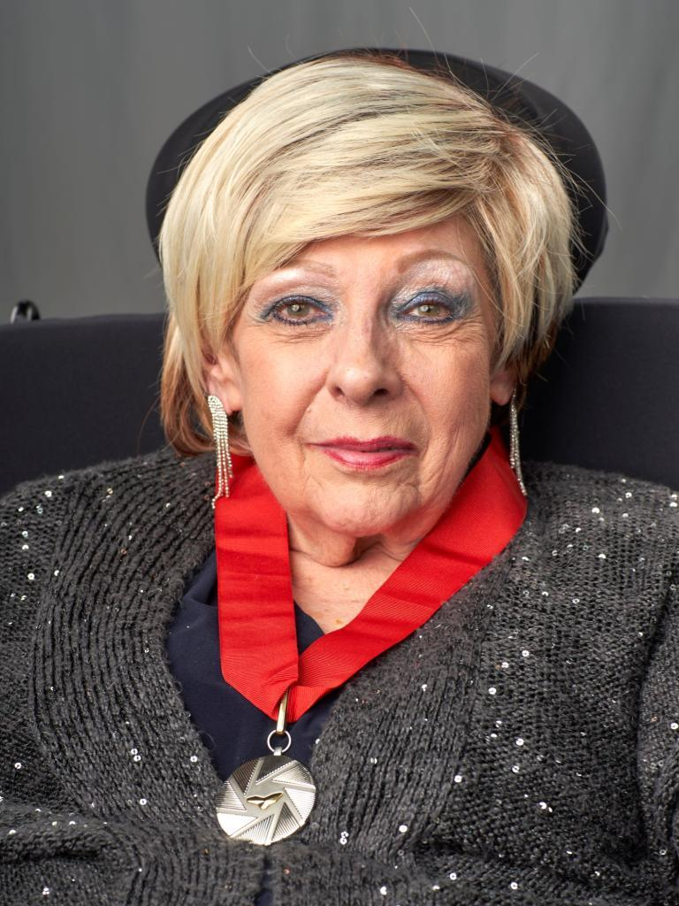

Acknowledgment at the National Assembly

On June 9, 2023, Chantale Rouleau, Minister responsible for Social Solidarity and Community Action as well as Member of the National Assembly for Pointe-Aux-Trembles, paid tribute to Ms. Linda Gauthier for her contribution to various struggles against discrimination faced by people with disabilities through a statement delivered in the blue room. (watch video here)

Papillon Award

On June 16, 2023, the first Papillon Awards gala of COPHAN was held at the Palais des congrès de Montréal. COPHAN awarded RAPLIQ the Accessibility Initiative award for its work on the accessibility of Montreal's summer terraces. The award was presented through a video presentation by the then Minister of Employment, Workforce Development, and Disability Inclusion, the Honourable Carla Qualthrough.

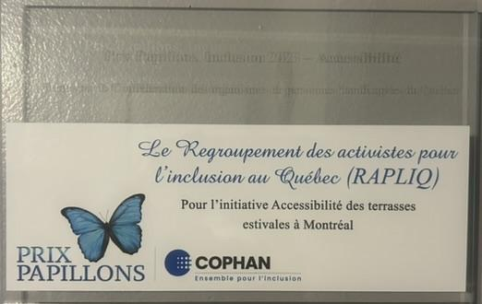

Specific files

Throughout the year, RAPLIQ had the privilege of being consulted on various projects or studies conducted by various municipal and governmental bodies. Here are two cases that particularly occupied our time due to their importance.

Medical Aid in Dying (MAID)

In Quebec, between January 1 and December 31, 2023, 5,686 individuals received medical aid in dying. This represents 7.3% of the deaths recorded in the province during this period.

2022 marked six and a half years of access to medical aid in dying in Canada. In 2022, 13,241 cases of medical aid in dying were recorded in Canada, bringing the total number of deaths attributable to medical aid in dying in Canada since 2016 to 44,958. In 2022, the total number of cases of medical aid in dying increased by 31.2% (2022 compared to 2021), compared to 32.6% (2021 compared to 2020). The annual growth rate of cases of medical aid in dying has been stable over the past six years, with an average growth rate of 31.1% between 2019 and 2022.

Don't you find these numbers alarming? The spirit of medical aid in dying (MAID) was initially intended to relieve individuals at the end of a predictable life, offering them a dignified end. Over time, MAID has been extended to individuals suffering from intense and incurable pain, still with the aim of offering a dignified end of life. RAPLIQ supports both of these objectives.

However, it is evident that MAID is sometimes requested or offered because home care services are insufficient, or because people want to avoid spending their final days in an institution. When MAID becomes an alternative to quality care or placement in long-term care, when it becomes the "easier" option instead of living with dignity, the spirit of this law is completely distorted.

There are testimonies where doctors subtly suggest MAID to sick and vulnerable individuals, often without adequate family or social support, thus influencing their final decision.

We pose this crucial question: among the people who chose MAID, how many would still be alive and enjoying a pleasant and productive life if we had effective, consistent, and warm home support services? In 2024, is it really too much to ask for? Is living with dignity less important than dying with dignity?

RAPLIQ advocates for support for a dignified life before MAID, while respecting the choice of each individual. We are convinced of two things: in 2024, we can do better, and if we fail to do so, the numbers for MAID will skyrocket in the years to come.

Quebec Pension Plan


Shortly before the parliamentary session resumed, the CAQ decided to appeal the decision of the Administrative Tribunal of Québec regarding financial discrimination against disabled individuals aged 65 and over.

On May 1st, during the hearings, a coalition of organizations, including RAPLIQ, went to make themselves heard before the Administrative Tribunal of Québec. We had the support of the CSN, which agreed to lend us speakers. Despite the inclement weather, solidarity was present.

On September 18, the official opposition spokesperson for seniors and family caregivers and in-home care, Lynda Caron, held a press conference to appeal to the government's empathy and urge it to reverse its decision. She was accompanied by Me Sophie Mongeon, representatives of COPHAN, Invalides au Front, and RAPLIQ. To watch the press conference video, click here.

During the budget presentation in March 2024, the government announced that the reduction in retirement benefits would finally be eliminated as of January 2025. An increase in benefits of up to $3,930 per year for approximately 77,000 people.

Your RAPLIQ is proud to have contributed to this fight alongside all those who supported this cause. Special thanks to Ms. Louise Harel for her unwavering support.

Congratulations, congratulations, congratulations!

Municipal, Provincial, and International Democratic Life

Your RAPLIQ and its officers actively participate in democratic life, particularly when it comes to representing you in various important forums.

Human Rights and Youth Rights Commission (CDPDJ)

Employment Equity Program (PAÉE)

Francine Leduc is a member of the Employment Equity Program (PAÉE) committee of the Human Rights and Youth Commission.

Concertation Table

Linda Gauthier is the representative of RAPLIQ at this table, but occasionally, Francine and Steven have also represented RAPLIQ.

TGFM

Once again this year, RAPLIQ remains a member of the Table des groupes de femmes de Montréal as an allied group, and our worthy representative is none other than our Director's Assistant, Brigitte Nadon, within the Feminist Committee for the Right to the City. The mission of this regional group is to promote and defend women's interests from a feminist perspective of gender equality. It intervenes in spheres of social, political, economic, and cultural life that can influence the living conditions of women in Montreal.

High-Level Political Forum — New York — Sustainable Development Goals 2030

In July 2023, our Director General had the pleasure of representing you within the Canadian delegation during a visit to the United Nations as part of the High-Level Political Forum on Sustainable Development. (see the program here).

The outcome of this stay in New York is interesting, promising, and full of potential changes. However, in his return luggage, our Director General brings back a huge sense of urgency and increased motivation.
During the conferences he attended, as well as through numerous parallel discussions with delegates from around the world, one alarming thing stands out. Everyone talks about fighting discrimination, exclusion, the importance of leaving no one behind, gender equality, equality for transgender individuals, and plans to help youth, seniors, etc.
However, not a single word about people with disabilities. Not only does no one talk about it, but during his stay, he didn't see any visibly disabled people, except for one person with visual impairment.
Our Director made it a point to discuss this with everyone he had the opportunity to engage with, and he believes he succeeded in sparking some reflection.



Speaking of discussions, he had an excellent opportunity to have one with the Canadian Ambassador to the United Nations, the Honourable Bob Rae. He was able to explain why RAPLIQ was there, our findings, and the urgent need to include people with disabilities and their allies in discussions. He made some recommendations to us that we will follow religiously.

The same goes for Minister Gould. Intelligent, charming, engaged, interested, she also made some suggestions to us that we will follow up on.

Links have been forged with other Canadian organizations and beyond. These connections need to be strengthened and deepened, but I believe we have gained some allies in our cause.

In short, the success of this mission will be measured in the months to come, but clearly, the sense of urgency to act is more present than ever for our disabled friends to be included not only in decisions but also in discussions that will lead to the achievement of the 2030 goals in terms of combating climate change.

We feel that we have contributed to something positive.

Rest assured that we, at RAPLIQ, will not let up.

Thank you to these organizations and friends for your support, whether it was financial, informational, and/or encouraging. Each and every one of you has provided us with an additional source of motivation and moral support that accompanied us at every moment during this mission. Together, we are all stronger.

Centraide

After two years of experience, this business relationship between Centraide and your RAPLIQ has proven to be more than satisfactory on several levels.

Centraide's contribution has allowed us to dedicate the time and resources necessary for the rigorous and, all in all, rapid advancement, notably of the FHVVC project, as previously described. Centraide's support also enables us to pursue our ambitions and our commitment to FHVVC, to work towards and promote their rights in order to finally offer them more housing and services.

Centraide represents much more than just financial assistance. Although this financial support is particularly allocated to the FHHVC project, it also contributes to many other actions and achievements carried out as part of our mission.

In addition to funding, Centraide offers consultations and resources in management and governance. It provides access to a vast network of contacts, as well as various training opportunities, including the "Human Path: Financing and Improving Working Conditions in NGOs" training by Espace OBNL.

These different initiatives allow us to deepen our knowledge and understanding of the issues in order to assist disabled people who turn to us when they are victims of discrimination.

In summary, Centraide is not limited to simple financial support. It also offers consultations, management and governance resources, an important network of contacts, training opportunities, and various actions to deepen our understanding of the issues. These initiatives play an essential role in our work for disabled people, providing comprehensive support and strengthening our impact in political and other spheres.

Regarding the latest fundraising campaign, our CEO was very proud to talk, in a company, about all that Centraide represents for an organization like ours, to talk about what more we can accomplish thanks to Centraide's support.

We are delighted to announce that the partnership between Centraide and your RAPLIQ will continue for the 2024-2025 year.

We thank the Centraide team who believes in our mission and in the importance of promoting and advocating to eliminate the discrimination and prejudices that disabled people face all too often.

Strategic Planning

The end of the pandemic has allowed us to achieve one of our objectives: holding two strategic planning sessions with our members and partners.

These two sessions were crucial for identifying our strengths, weaknesses, opportunities, and threats that are part of our daily lives.

One important point we have addressed since then is the hiring of an external consultant in communication and government relations to better communicate our achievements, our demands, etc. Soon, you will see improvements in our social media presence, as well as in our newsletter, in short, everything related to communications. We are certain that this improvement will be visible and appreciated. That said, we are always eager for your feedback and ideas. Don't wait for the next strategic planning meetings to share your ideas with us.

We are proud to present the beginning of this strategic plan:

Vision
To continue promoting the inclusion and advocacy of the rights of people with disabilities, strengthening our influence, and increasing our organizational effectiveness.

Mission
To support and assist people with disabilities who are victims of discrimination, while raising public awareness and influencing public policies for a more inclusive society.
Strategic Objectives
- Strengthen Influence and Visibility by increasing presence in French and English media.
• Strategies
– Develop awareness campaigns on social media; – Participate in international events to share best practices and promote inclusion; – Collaborate with media outlets and influencers to amplify our message.
- Improve Organizational Structure
• Strategies
– Recruit an additional person to lighten the workload; – Implement training programs to improve the digital and organizational skills of the team; – Create committees for more efficient project and initiative management.
- Develop Strategic Partnerships
• Strategies
– Collaborate with developers, builders, and architects to improve infrastructure accessibility; – Establish partnerships with international groups and professional orders; – Work with other advocacy organizations to strengthen collective actions.
- Simplify and Standardize Processes
• Strategies
– Develop a reference framework for complaints; – Simplify and standardize complaint filing and support procedures; – Use digital tools to improve internal process efficiency.
- Ensure Financial Sustainability
• Strategies
– Establish a foundation to diversify funding sources; – Implement regular fundraising campaigns; – Explore funding opportunities through specific projects and grants.
- Mobilize and Engage the Community
• Strategies
– Mobilize non-disabled individuals for political actions and awareness; – Organize educational workshops and seminars to raise public awareness about inclusion issues; – Promote active member participation in RAPLIQ activities.
- Success Indicators
– Increase in the number of active members; – Increase in media coverage and public visibility; – Reduction in complaint processing time; – Number of strategic partnerships established; – Diversification and increase in funding sources.
Conclusion
This strategic plan aims to strengthen RAPLIQ's capacity to advocate for the rights of people with disabilities, improve internal efficiency, and develop partnerships for a more inclusive society.
A plan defined with objectives, result indicators, and a timeline, in line with the feedback gathered during the two reflection meetings, will be communicated to you later. We will seek your feedback, ideas, etc.

Financial Statements
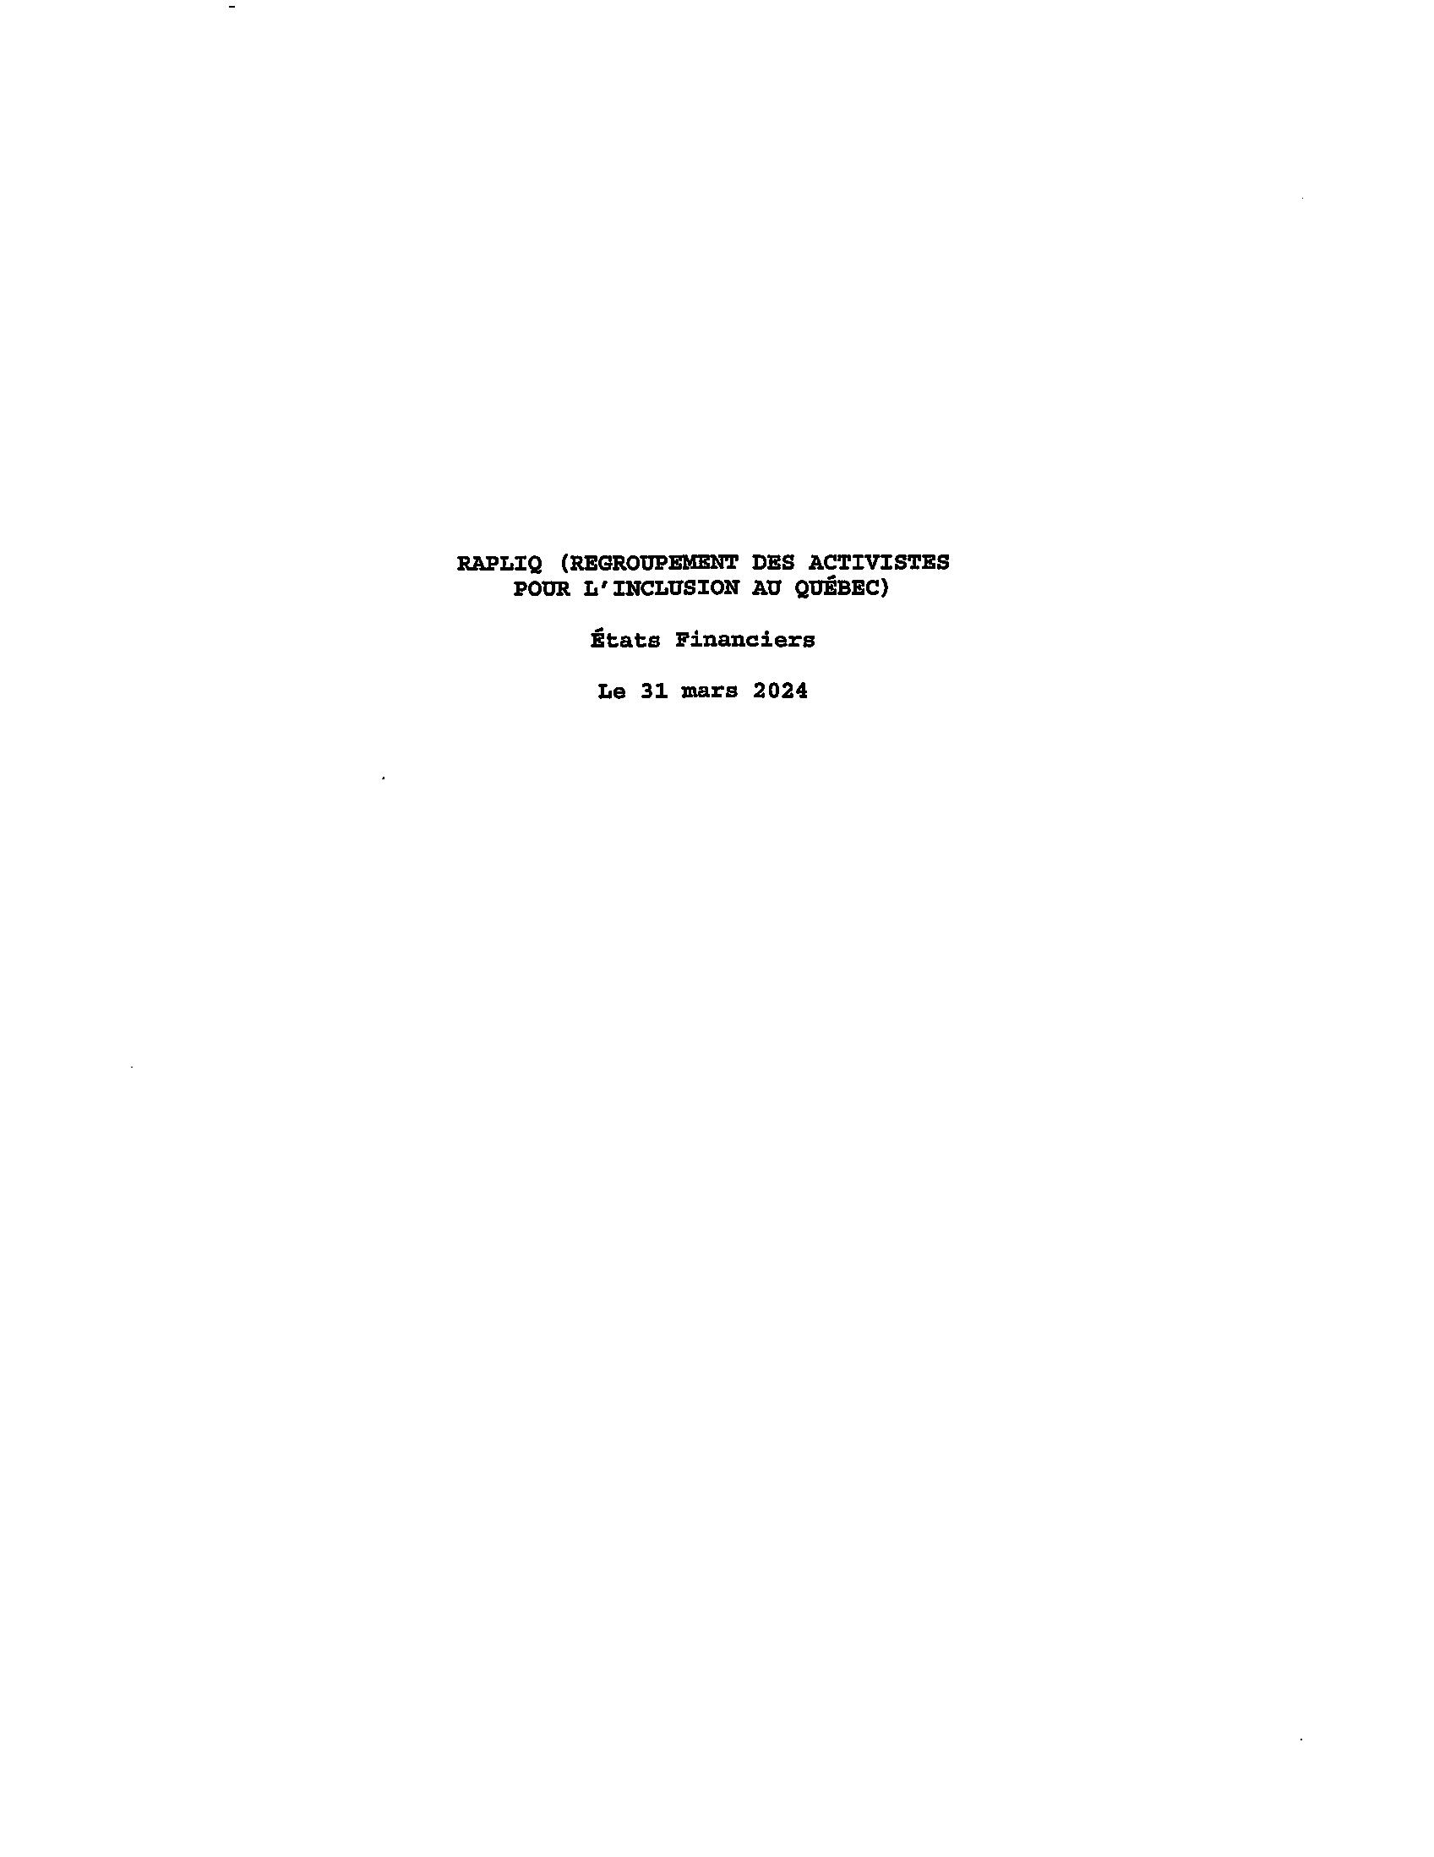
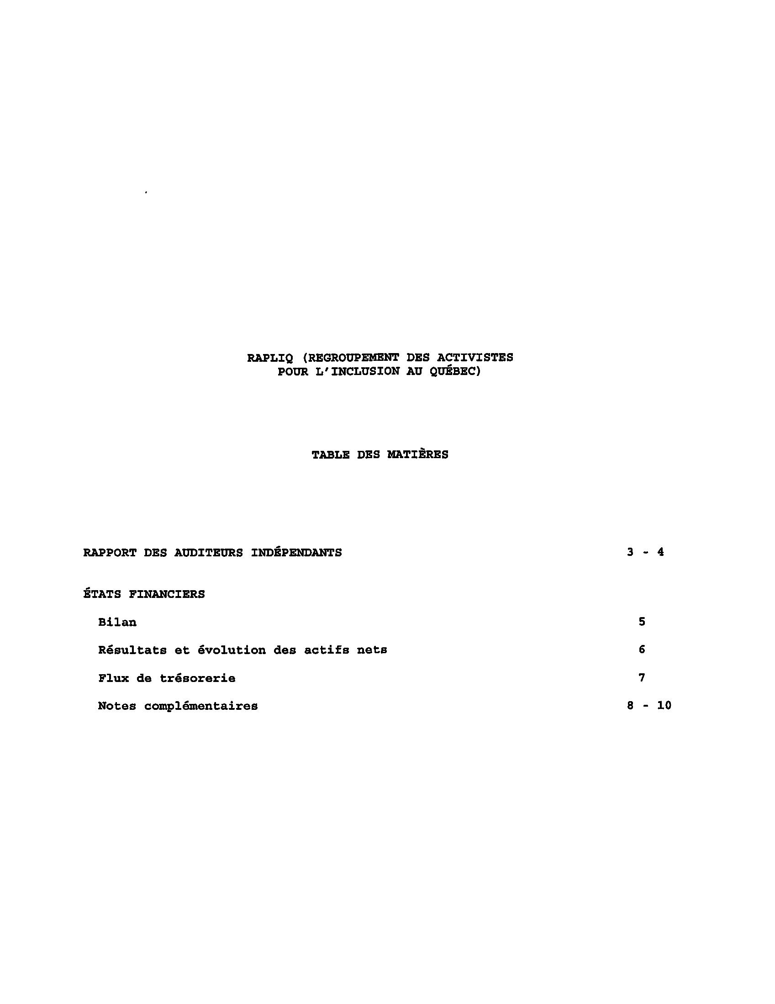
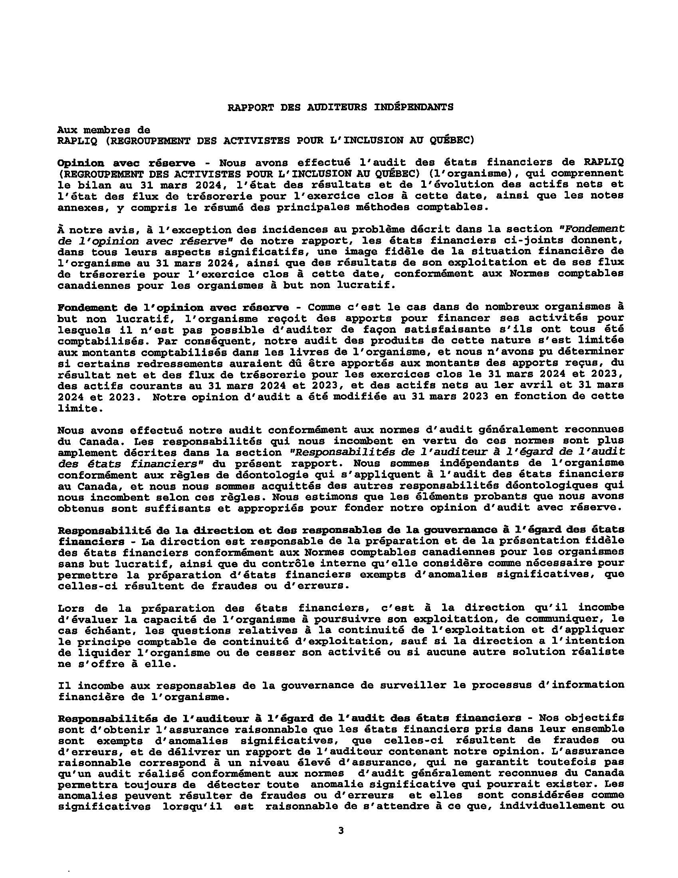
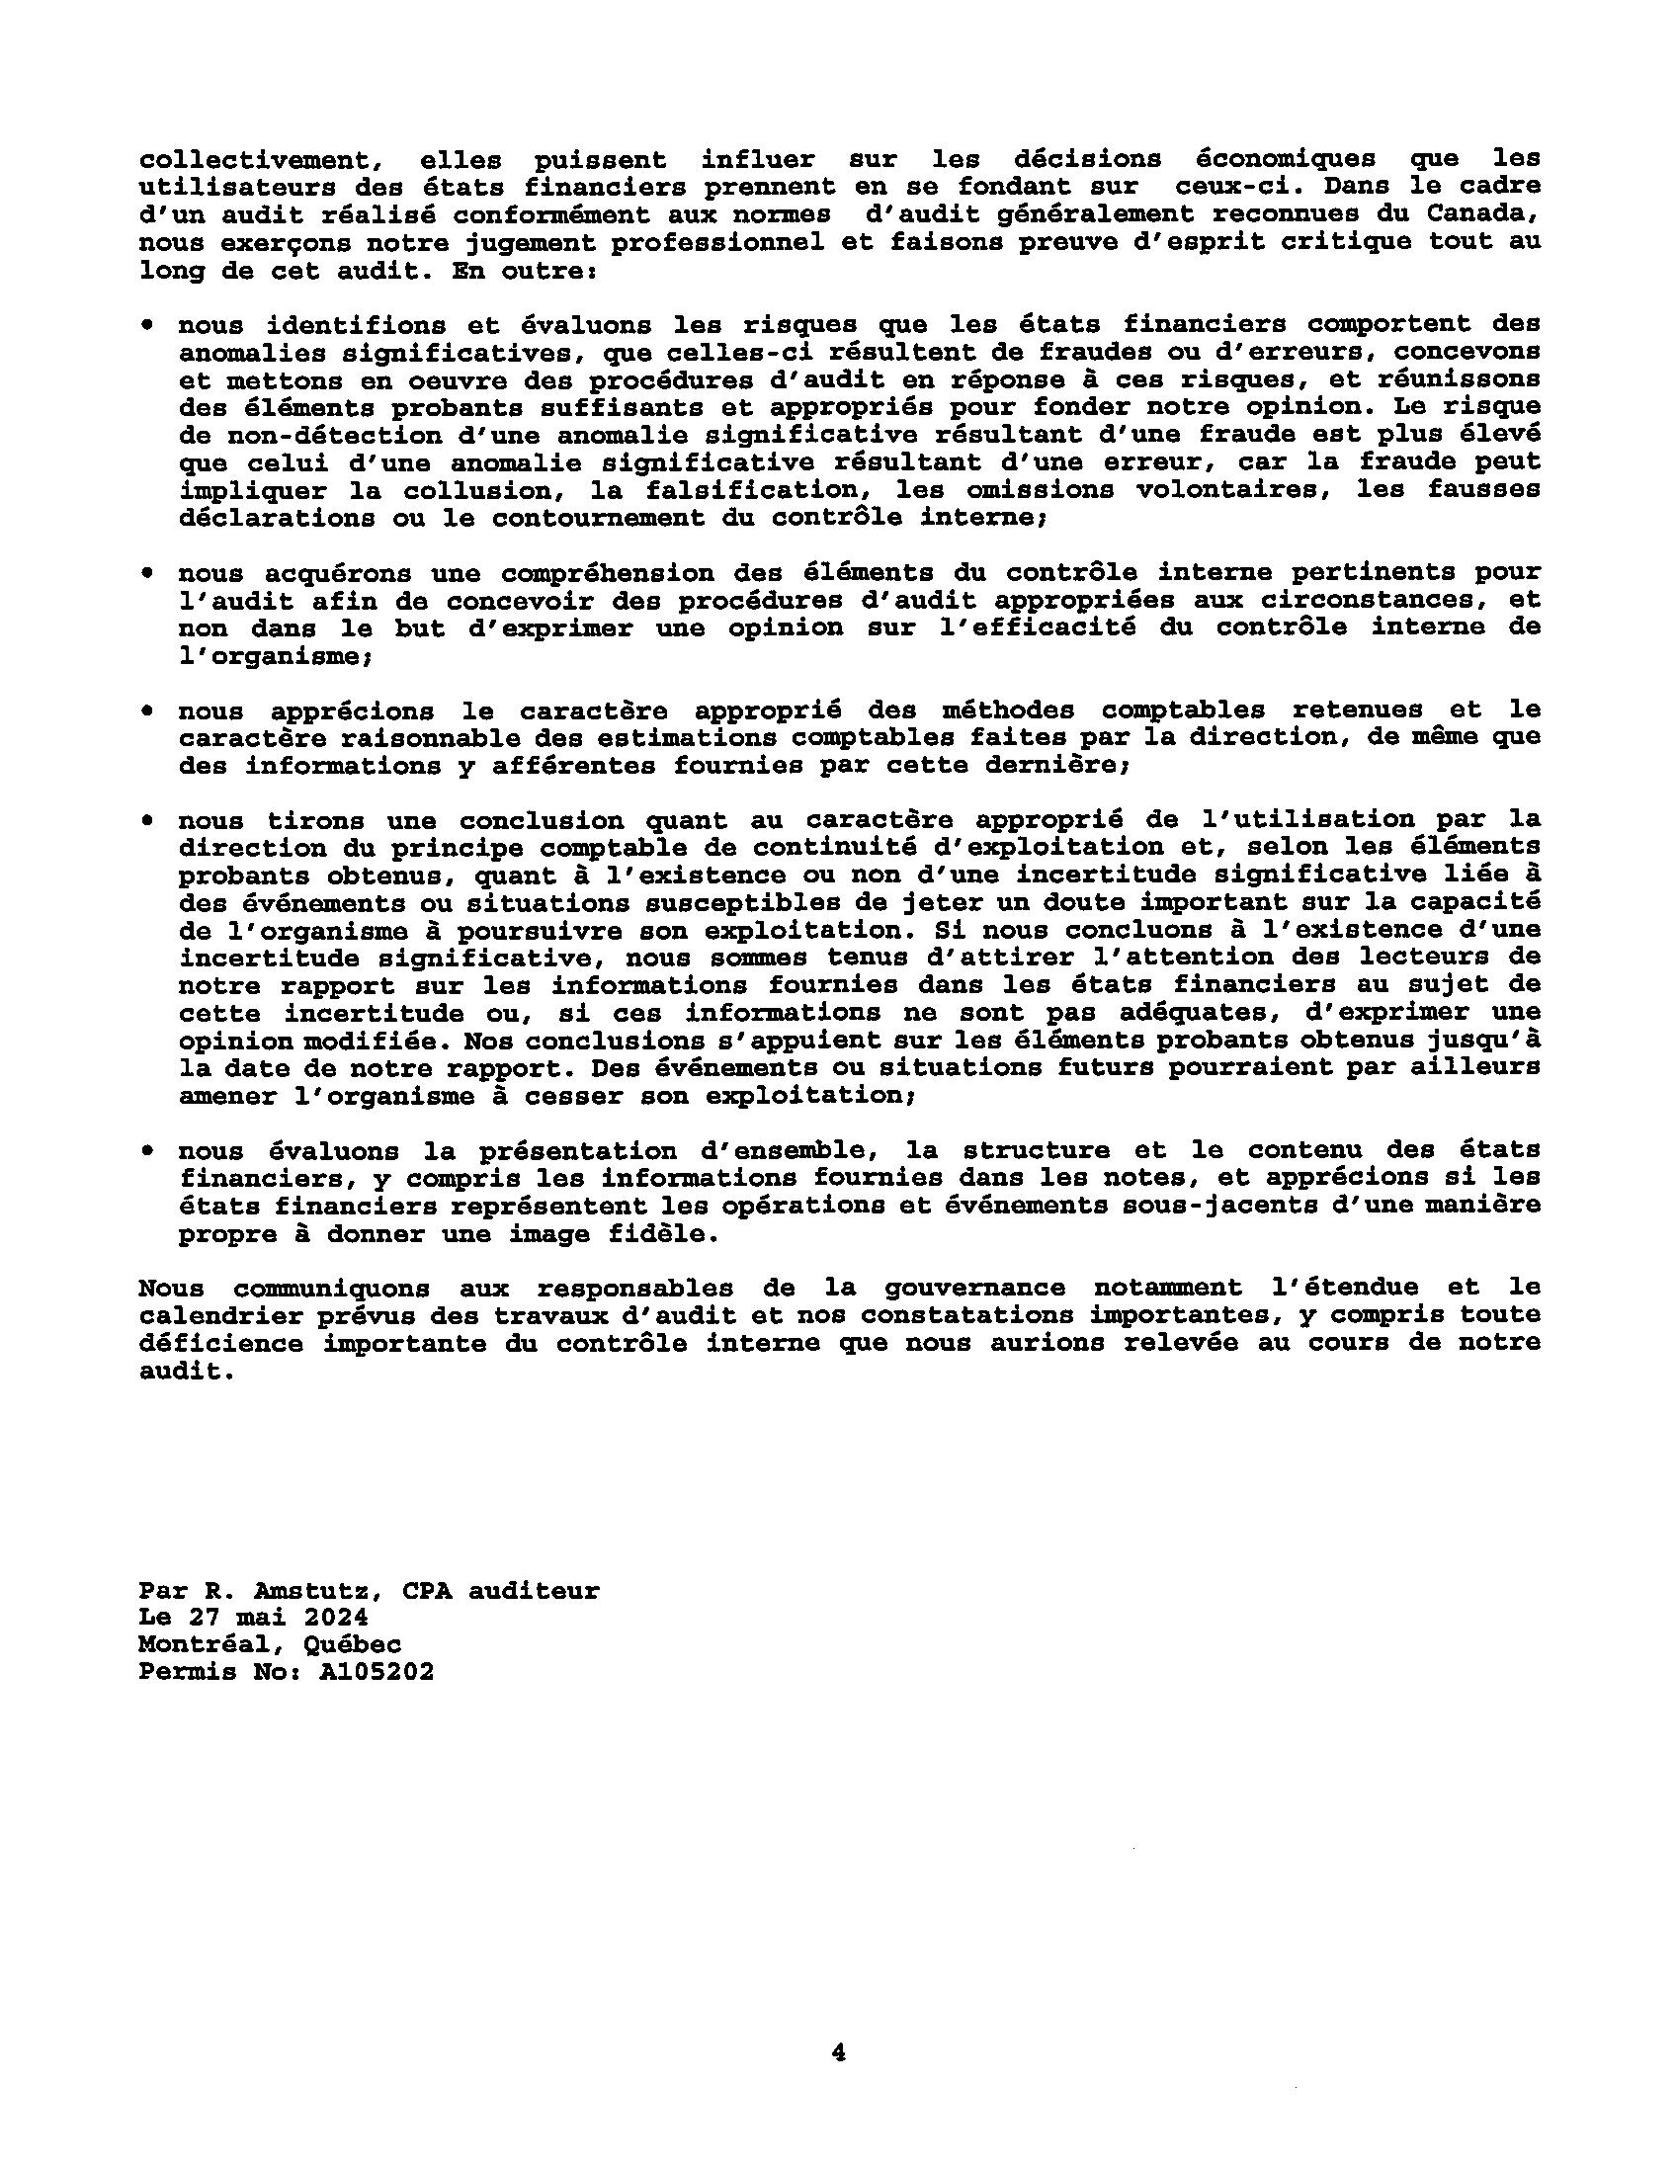
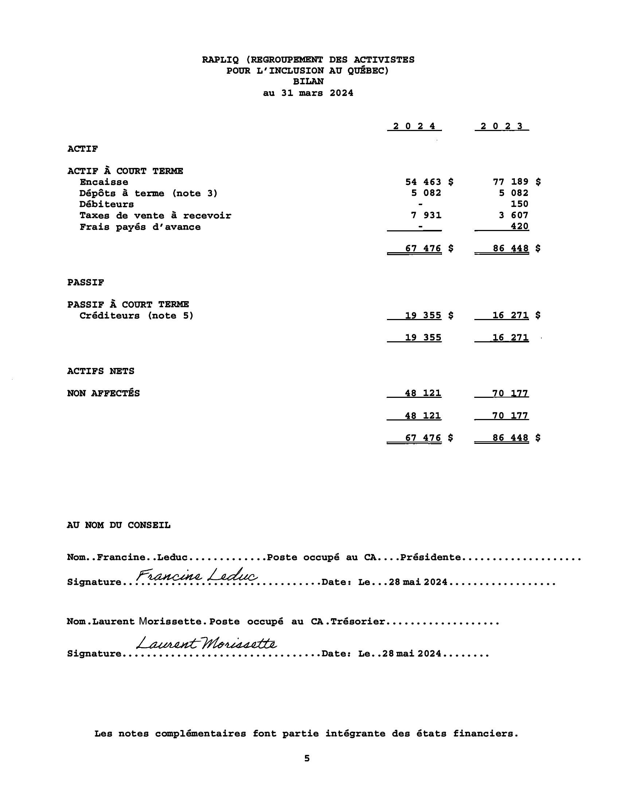
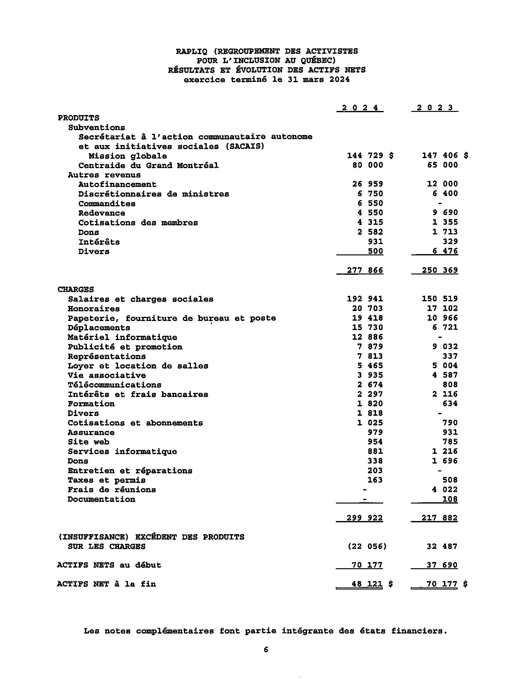
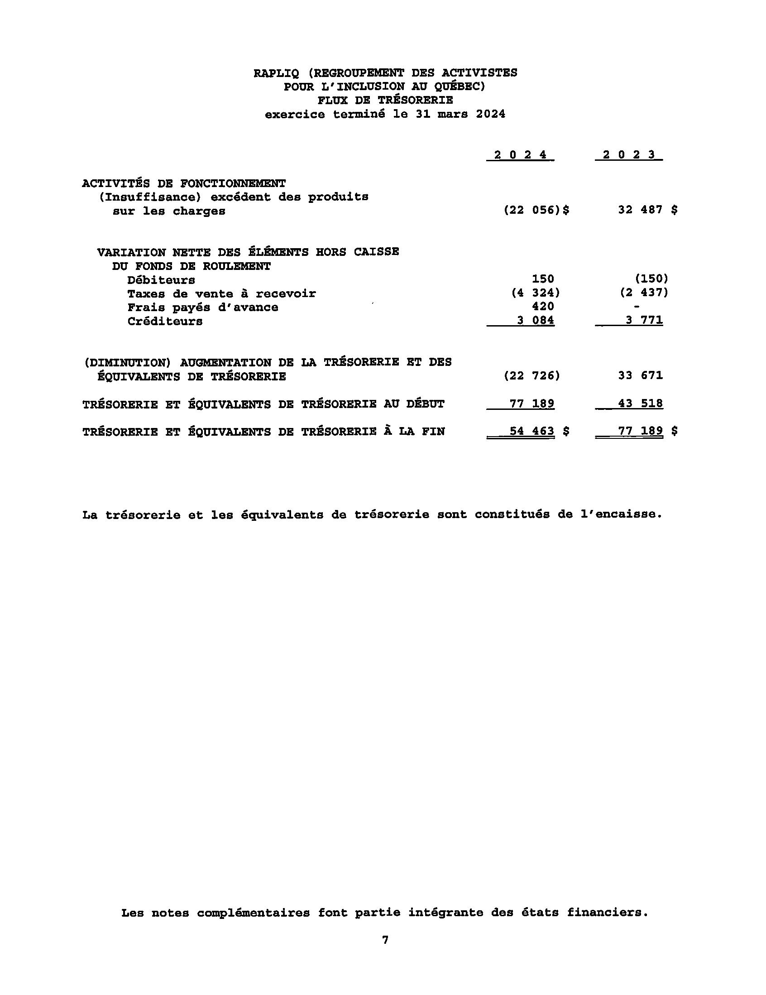
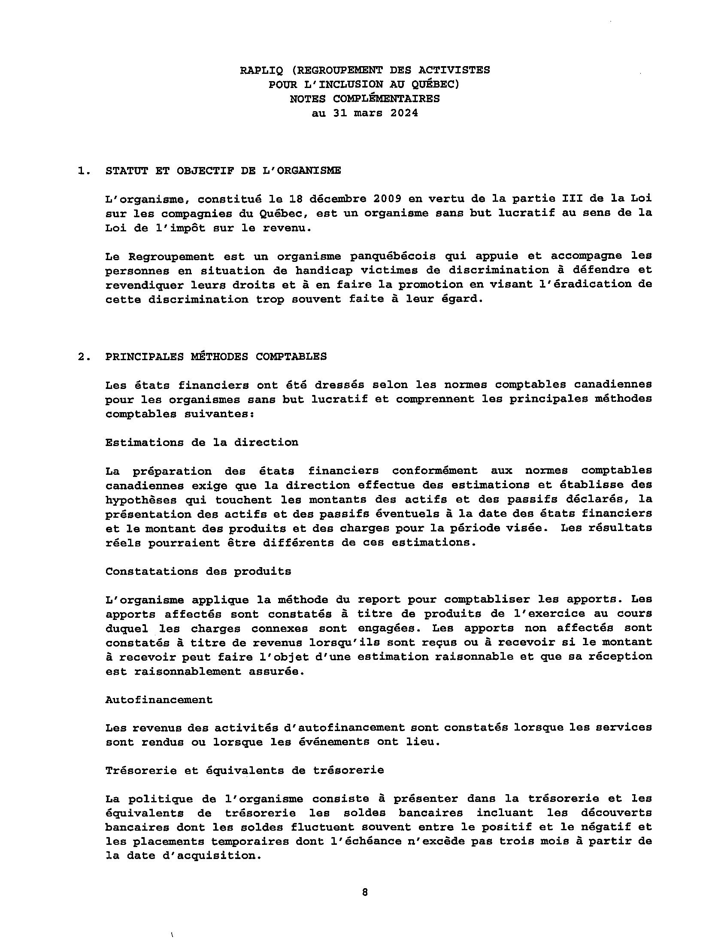
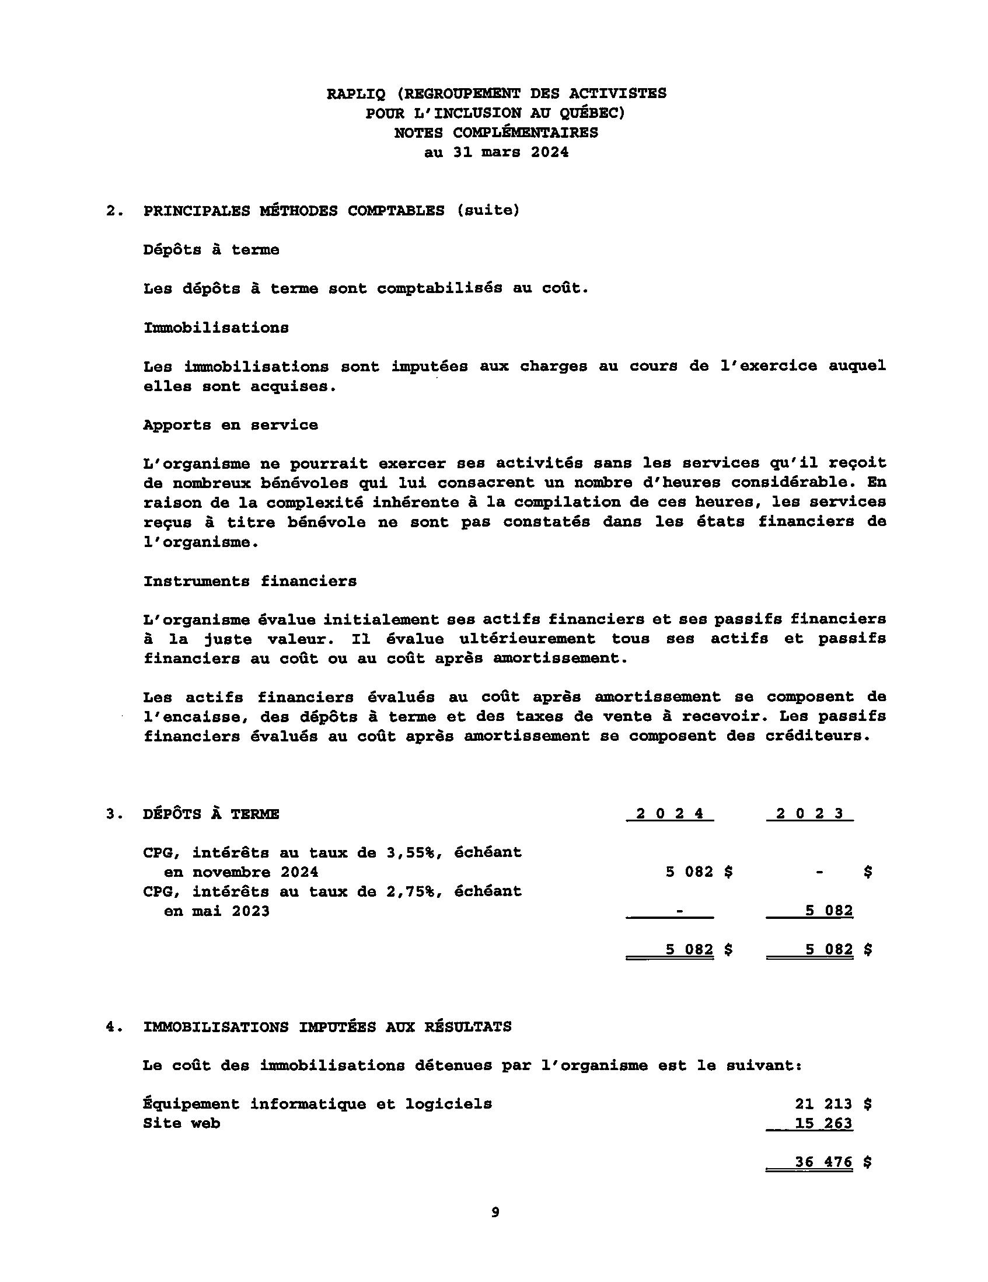
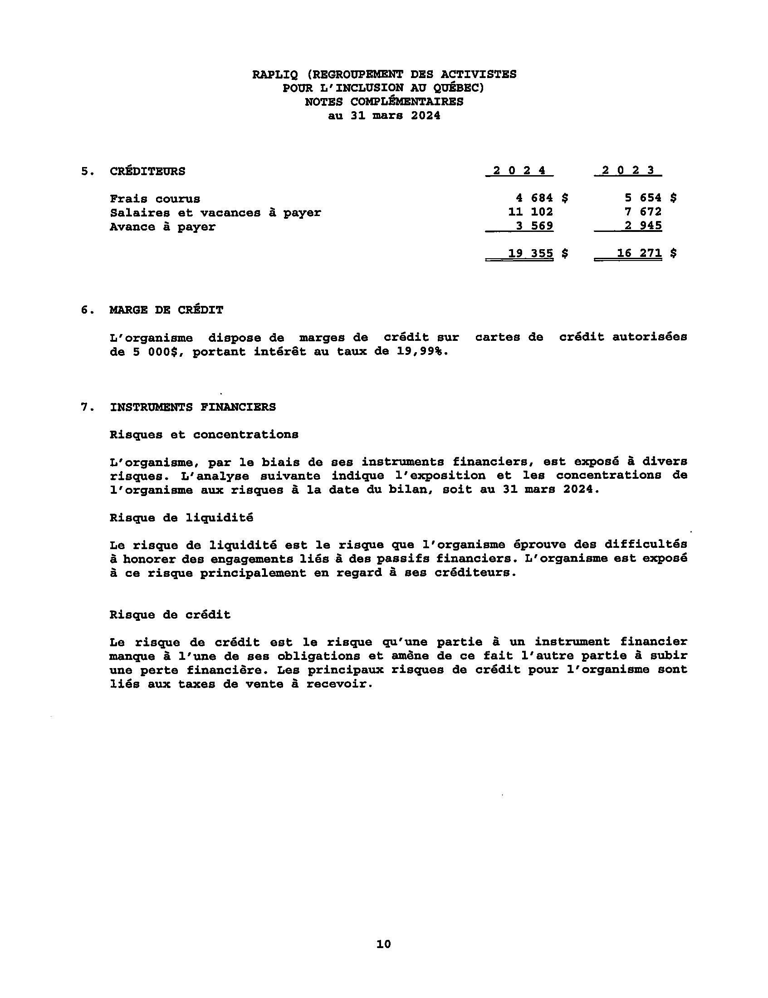

Budget Projections
Revenue Items | Results  2023-2024 | Projections  2024-2025
Grants | 224729,00 | 225414,00
Royalties | 4550,00 | 20722,24
Membership Fees | 4315,00 | 2000,00
Ministerial and Member Discretionary Funds | 6750,00 | 9000,00
Donations | 2581,53 | 2000,00
Sponsorships | 6650,00 | 5000,00
Self-generated Revenue | 26858,79 | 10000,00
Interests | 931,05 | 1000,00
Total Revenues | 277365,37 | 275136,24
Expenses | Results  2022-2023 | Projections  2023-2024
Salaries and Employee Benefits | 189828,96 | 204439,00
Payroll service fees | 1511,30 | 1600,00
Mail and postage | 3029,32 | 2500,00
Office supplies | 916,87 | 500,00
Office and Administrative Expenses | 9980,38 | 7000,00
Professional fees | 9865,30 | 10000,00
Accounting fees | 857,11 | 900,00
Legal fees | 6186,28 | 7500,00
IT expenses | 881,41 | 900,00
Website | 784,80 | 800,00
Media and Press Releases | 0,00 | 0,00
Advertising and Promotion | 7878,87 | 10000,00
Bank Interest and Charges | 380,05 | 350,00
Credir card fees | 305,74 | 300,00
Telecommunications and Internet | 2673,70 | 2700,00
Insurances | 978,82 | 1000,00
Business fees and licenses | 25,00 | 25,00
Taxes and Permits | 137,70 | 140,00
Subscriptions and Memberships | 1025,00 | 1000,00
Association Life and Activities | 3935,41 | 2000,00
Donations (in memoriam and others) | 337,80 | 300,00
Courtesies | 1818,00 | 1000,00
Training, Conferences, and Activities | 1819,51 | 1500,00
Travel expenses | 15730,00 | 4000,00
Representations | 7812,75 | 4000,00
Rent & Room and Equipment Rentals | 5465,41 | 8000,00
Purchase of IT equipment | 13371,57 | 500,00
General Maintenance and Repairs | 203,53 | 200,00
Expenses total | 287740,59 | 273154,00
Surplus | -10375,22 | 1982,24

Our Meetings
Date | RAPLIQ | Person met | Theme - matter
AVRIL
23-04-04 | Linda Gauthier  Steven Laperrière | Marie-Claude Leonard  Eric Allan Caldwell
23-04-11 | Steven Laperrière | COPHAN | Rencontre préparatoire MAT
23-04-13 | Linda Gauthier  Steven Laperrière | Vidéotron | Présentation de la maquette du site web accessible
23-04-13 | Steven Laperrière  Brigitte Nadon  Amélie Allard | Comité du RAPLIQ sur l’assistance sexuelle
23-04-14 | Steven Laperrière | Panel Inclusive Media
23-04-24 | Linda Gauthier  Steven Laperrière | Chantal Rouleau, ministre responsable de la Solidarité sociale et de l’Action communautaire | Cocktail de financement
23-04-26 | Christophe Bedos Linda Gauthier | Lise Roche, Fondation Mirella et Lino Saputo
23-04-27 | Linda Gauthier | CDPDJ | Dossier Ibrahim
MAI
23-05-01 | L’équipe | Manifestation | RRQ
23-05-02 | Francine Leduc  Steven Laperrière | SIECCAN
23-05-02 | Linda Gauthier |  | Atelier sur la sexualité
23-05-02 | Francine Leduc  Steven Laperrière  Martin Dion |  | CPHLSL
23-05-05 | Steven Laperrière | COPHAN | SMA
23-05-05 | Linda Gauthier  Steven Laperrière | Chantal Rouleau, ministre responsable de la Solidarité sociale et de l’Action communautaire
23-05-09 | Steven Laperrière  Brigitte Nadon  Amélie Allard |  | Comité sur l’assistance sexuelle
23-05-09 | Francine Leduc | OMHJ | Lecture de plan
23-05-10 | Francine Leduc  Christophe Bedos | Université McGill | Lancement d’une bande dessinée sur l’accessibilité des soins dentaires
23-05-12 | Steven Laperrière  Michel Bédard | Assemblée nationale | Consultation sur l’évolution de la Loi concernant les soins de fin de vie — Handicap neuromoteur
23-05-15 | Linda Gauthier  Francine Leduc | Centraide | Agir pour le logement
23-05-16 | Linda Gauthier | Vidéotron | Visite d’une succursale pour évaluer l’accessibilité
23-05-23 | Steven Laperrière | COPHAN | Rencontre pour les prix Papillons
23-05-24 | Francine Leduc  Martine Lévesque  Steven Laperrière |  | Journée Clic Déphy
23-05-26 | Linda Gauthier  Steven Laperrière | Chantal Rouleau, ministre responsable de la Solidarité sociale et de l’Action communautaire
23-05-29 | Steven Laperrière | COPHAN | SMA Transport
23-05-30 | Steven Laperrière | COPHAN | Coalition Transport
23-05-30 | Linda Gauthier | Sylvain Sauvageau, agence de Développement durable de Montréal
JUIN
23-06-05 | Steven Laperrière | COPHAN  SQDI | Conférence sur le transport adapté
23-06-05 | Linda Gauthier |  | Consultation groupe de travail accessibilité commerce
23-06-06 | Brigitte Nadon |  | Comité Féministes pour le droit à la ville
23-06-08 | Linda Gauthier  Christophe Bedos | Lise Roche, Fondation Mirella et Lino Saputo
23-06-09 | Linda Gauthier  Steven Laperrière | Assemblée nationale
23-06-12 | Steven Laperrière | ROP03 | Assemblée générale annuelle
23-06-13 | Linda Gauthier  Steven Laperrière | Lise Roche, Fondation Mirella et Lino Saputo
23-06-15 | Francine Leduc | Bécancour | Conférence
23-06-16 | Linda Gauthier  Steven Laperrière | COPHAN | Gala de remise des prix Papillons
23-06-20 | Linda Gauthier  Steven Laperrière | Ville de Montréal | Formation
23-06-21 | Steven Laperrière | COPHAN | TSS
23-06-27 | Steven Laperrière | COPHAN | CSPMD
23-06-27 | Linda Gauthier  Steven Laperrière | UWE | Discussion train
JUILLET
23-07-04 | Linda Gauthier  Steven Laperrière | UWE | Discussion train
23-07-13 | Linda Gauthier  Steven Laperrière | COPHAN | Conseil d’administration
23-07-17  au 23-07-19 | Steven Laperrière | Nations Unies | Forum Politique de Haut-Niveau sur le développement durable
23-07-20 | Linda Gauthier  Steven Laperrière | Annick Brazeau
23-07-21 | Linda Gauthier  Steven Laperrière  Francine Leduc  Laurent Morissette | Me Sophie Mongeon  Frédéric Bérard | Rencontre préparatoire à la décision (dossier RRQ)
23-07-25 | Linda Gauthier  Steven Laperrière | Centraide
23-07-28 | Linda Gauthier  Francine Leduc | REM | Lancement du nouveau service du REM
23-07-31 | Linda Gauthier | Anna Kroll, Réseau pour la paix et l’harmonie
AOÛT
23-08-03 | Toute l’équipe |  | Rencontre d’information sur la décision rendue dans le dossier RRQ
23-08-07 | Steven Laperrière | COPHAN | Aide médicale à mourir
23-08-17 | Steven Laperrière | Stagiaire de Me Sophie Mongeon | Création d’une fondation
23-08-21 | Steven Laperrière | Hotel-de-ville de Montréal
2308-22 | Linda Gauthier | Me Sophie Mongeon
23-08-23 | Linda Gauthier | Martine Musau Muele, Présidente du conseil de ville de Montréal
23-08-24 | Linda Gauthier | Vidéotron | Évaluation
23-08-24 | Steven Laperrière | CDPDJ | Table de concertation
23-08-28 | Steven Laperrière |  | Visite des terrasses à Québec
23-08-29 | Steven Laperrière | Centraide | Prise de parole devant le ministre de l’Environnement
23-08-29 | Steven Laperrière | CDPDJ | Transport
23-08-30 | Linda Gauthier  Steven Laperrière | Me Sophie Mongeon | RRQ
SEPTEMBRE
23-09-06 | Steven Laperrière  Brigitte Nadon |  | Suivi bourse fonds de relance
23-09-06 | Linda Gauthier  Steven Laperrière | COPHAN | Conseil d’administration extraordinaire
23-09-07 | Linda Gauthier |  | Séance de travail recours collectif
23-09-07 | Steven Laperrière | Notio | Infonuagique
23-09-07 | Linda Gauthier |  | Engagement div. TA
23-09-08 | Steven Laperrière | Anne-Marie L’Écuyer
23-09-08 | Steven Laperrière  Brigitte Nadon | Notio | Infonuagique
23-09-08 | Linda Gauthier  Steven Laperrière | COPHAN | Conseil d’administration extraordinaire
23-09-10 | Steven Laperrière | Éric Girard, ministre des Finances  Me Sophie Mongeon | RRQ
23-09-12 | Linda Gauthier  Steven Laperrière | COPHAN | RRQ
23-09-13 | Linda Gauthier | Mathieu Noël, COPHAN | Comité de transition
23-09-15 | Linda Gauthier  Steven Laperrière | COPHAN | Conseil d’administration
23-09-18 | Linda Gauthier | Rafael Provost | Ensemble pour le respect et la diversité
23-09-19 | Francine Leduc | VIArail
23-09-20 | Steven Laperrière | Assemblée nationale | Conférence de presse sur la RRQ
23-09-21 | Steven Laperrière | Fanny Jolicoeur | SAC-UQÀM
23-09-25 | Steven Laperrière | COPHAN | Gestion des médias
23-09-26 | Linda Gauthier  Steven Laperrière | VIArail
23-09-26 | Steven Laperrière  Brigitte Nadon | Centre Saint-Pierre | Planification stratégique
23-09-27 | Linda Gauthier  Francine Leduc | Habitat pour l’humanité | Validation de plans
23-09-28 | Linda Gauthier | Justine Laporta, attachée politique de Ruba Ghazal
23-09-28 | Linda Gauthier  Francine Leduc | Nicolas Deschatelets | REM
OCTOBRE
23-10-02 | Linda Gauthier  Steven Laperrière | STM (TA)
23-10-06 | Linda Gauthier | Louise Harel  Marie-Ève Rousseau | Dictée de l’accessibilité
23-10-16 | Steven Laperrière | DATAide | Bilan de mi-parcours
23-10-26 | Steven Laperrière | Centraide | Prise de parole chez Joddes
NOVEMBRE
23-11-01 | Steven Laperrière | Mathieu Desroches | Formation AI
23-11-06 | Linda Gauthier | Louise Harel  Marie-Ève Rousseau  Justine Laporta | Dictée de l’accessibilité
23-11-07 | Linda Gauthier | Sophie Dalbec, Habitat pour l’humanité
23-11-11 | Linda Gauthier | RBQ | Comité consultatif
23-11-14 | Steven Laperrière | Détail Québec | Colloque
DÉCEMBRE
23-12-02 | Toute l’équipe |  | Dictée de l’accessibilité
23-12-05 | Linda Gauthier | Price Waterhouse | Conférence sur le capacitisme
23-12-12 | Linda Gauthier | Carla Claveau, Ensemble pour le respect de la diversité
JANVIER
24-01-16 | Linda Gauthier | Hugo Meunier, Urbania
24-01-24 | Steven Laperrière | Ensemble pour le respect de la diversité
24-01-29 | Linda Gauthier  Steven Laperrière | Pauline Béchu, SDC Rue Saint-Denis | Accessibilité des terrasses
24-01-31 | Linda Gauthier  Steven Laperrière | Empreintes
24-01-31 | Francine Leduc | VIARail
24-01-31 | Steven Laperrière | Table de concertation CDPDJ
FÉVRIER

24-02-06 | Linda Gauthier  Francine Leduc | Habitat pour l’humanité
24-02-08 | Steven Laperrière | ROP03 | TAQ — services essentiels — RTC Québec
24-02-09 | Francine Leduc Steven Laperrière | Paul-Claude Bérubé | REM
24-02-12 |  | RPHS
24-02-20 | Steven Laperrière | Assemblée nationale | RRQ
24-02-20 | Linda Gauthier | Frédéric Bahl
24-02-20 | Linda Gauthier |  | Festival international des montgolfières de Saint-Jean-sur-Richelieu
24-02-26 | Linda Gauthier | Réseau pour la paix et l’harmonie | Arts et culture
24-02-27 | Steven Laperrière | SQDI
24-02-27 | Linda Gauthier | RISBOD
24-02-28 | Linda Gauthier  Steven Laperrière | Benoit Dorais
MARS
24-03-01 | Linda Gauthier  Steven Laperrière | REM | Couloir Bonaventure
24-03-05 | Steven Laperrière | UQAM — Service aux collectivités
24-03-08 | Linda Gauthier | Réseau pour la paix et l’harmonie
24-03-10 | Linda Gauthier  Francine Leduc | Martine Biron | Brunch avec la ministre
24-03-11 | Steven Laperrière | Comité bailleur de fonds
24-03-14 | Linda Gauthier  Steven Laperrière | Arrondissement Ahuntsic-Cartierville  STM | Débarcadères
24-03-14 | Linda Gauthier  Steven Laperrière | Conseil d’arrondissement Ahuntsic-Cartieville
24-03-17 | Linda Gauthier | Entrevue avec des étudiant·es | Travail sur la discrimination
24-03-20 | Steven Laperrière | PDAU — RTC
24-03-22 | Linda Gauthier  Steven Laperrière | Miloud El Berrhama | Taxi
24-03-27 | Steven Laperrière | Comité SCPMA du RTC
24-03-27 | Linda Gauthier | Arrondissement Ahuntsic-Cartieville | Débarcadères
24-03-29 | Linda Gauthier  Steven Laperrière | Miloud El Berrhama | Taxi

RAPLIQ in the medias

Avril 2023

Le Journal de Montréal — Projet de loi 11 : le groupe d’experts sur le handicap oublie des voix importantes

TVA — Projet de loi 11 : le groupe d’experts sur le handicap oublie des voix importantes

Journal Métro — Farah Alibay et « Fanfreluche » honorées par Montréal

Le Journal de Montréal — Ordre de Montréal : Farah Alibay et Louise Arbour parmi les personnes honorées

NOOVO — DPJ : Québec abolit les « alertes bébés »

Mai 2023

La Presse — Le nombre de places pour personnes handicapées « insuffisant »

CPAM — Entrevue de Steven Laperrière sur les espaces de stationnement et la mobilité

Canal M — Sans détour — Entrevue de Linda Gauthier sur les femmes handicapées victimes de violence conjugale

Juin 2023

France 24—Soutenu par l’opinion, le Québec élargit le recours à l’aide médicale à mourir

Daily Mail—Quebec becomes the world’s euthanasia hotspot, where 7% of all deaths are lethal injections, and officials expand access to Alzheimer’s sufferers and force
ALL hospices to offer assisted suicides

Juillet 2023

La Presse — L’accès aux terrasses est difficile pour les personnes handicapées au Québec

CBC Daybreak—How can terrasses be more accessible?

Handirect — Accessibilité au Québec : le chemin est encore long, très long !

Août 2023

Global News—Montreal music festivals accused of reducing accessibility for people with disabilities

Journal de Québec — « Ça devait être 100 % accessible » : le Réseau express métropolitain déçoit les personnes à mobilité réduite

CTV News—“It’s part of my body”: Montreal man issues plea for help after wheelchair extension was stolen

Montreal Gazette—Can you get to the REM by bus or métro in a wheelchair? Not really.

Global News—Montreal’s REM train network not as accessible as promised, advocates say

CJAD— Disability advocates lament lack of accessibility for buses serving REM stations

CBC— Popular Montreal breakdancer with disability calls out Trudeau Airport for accessibility fail

Septembre 2023

En retrait — Une compassion à géométrie variable

CBC— Camillien-Houde Way on Mount Royal will be closed to traffic, Montreal mayor says

Montreal Gazette—Plan to ban car traffic from Camillien-Houde Way draws criticism

Sans détour—Entrevue de Francine Leduc sur le REM

Octobre 2023

CBC— Montreal’s new “fully-accessible” light-rail network has seen nearly 30 elevator breakdowns

Radio-Canada—Les ascenseurs du REM ont été hors service plus d’un jour sur deux

Montreal Gazette—Plante orders transit agency to improve REM accessibility

CTV News—Wheelchair users say REM isn’t cutting it

Novembre 2023

La Presse — Air Canada promet d’« accélérer » ses mesures

Georgetown Journal of International Affairs—Intimate Partner Violence and Disability: Addressing Systemic Barriers

Autonomia — La promesse de la compagnie Air Canada en ce qui concerne l’accessibilité

CBC— Montreal man fed up with delivery companies ignoring instructions to meet mobility needs

Décembre 2023

Salut Bonjour — Entrevue de Linda Gauthier

UdeMNouvelles — Femmes en situation de handicap et violence conjugale : un parcours semé d’embûches

CBC — Reportage sur le déneigement

CBC Daybreak— The Plateau is asking people to be more mindful about where they lock their bike

Journal de Montréal—Après 7 ans d’attente, elle reçoit enfin sa famille pour Noël dans son logement adapté

Janvier 2024

Journal des voisins — Un manque de stationnement pour personnes handicapées à Ahuntsic-Cartierville

Urbania — L’enfer blanc des gens à mobilité réduite

CBC — Report on online voting in Quebec

La Presse — Aide médicale à mourir — Nouvel échéancier de trois ans pour les personnes atteintes de troubles mentaux

Février 2024

La Presse — Métro Rosemont — « Des enjeux de sécurité » dans le terminus tout neuf
QUB — Entrevue de Linda Gauthier sur l’accès à la station de métro Rosemont

Mars 2024

CBC Daybreak Montreal—Fewer and fewer adapted taxis on the road for people living with disabilities

